Monday 1st February.
- Activity 1 – English
Choose a book to read. Use 4 questions on a page of ‘reading questions’ to talk about the pages you have read.
AND / OR

Complete the ‘read a picture’ activity (based on the Gruffalo)

- Activity 2- English.
We love stories in LSC2!! So, collect 4 pieces of paper and with your family use your imagination to think of as many ideas for new -
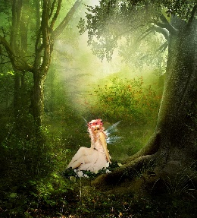
- Characters
- Places
- Events
- Problems / bad events
Give a describing word for each one.
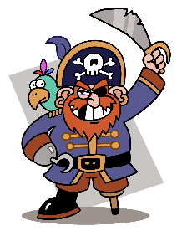
Use your imagination – there are no right or writing answers.

Here are my ideas as an example –
- Characters – a small glittery fairy called Sophie
- Place – the magical secret forest
- Events – the fairy queen’s birthday party!
- Problems – the queen’s birthday cake falls and smashes all over the floor…

Next week, we will use all of these ideas to write a story! :D

