Monday 18th January.

- Activity 1 – English
Read a book / magazine / newspaper article and choose a page from the ‘reading questions’ sheet attached to talk about it.

AND / OR

Complete the ‘read a picture’ activity

- Activity 2- Topic
WALT: make careful observations and sort objects.
Go for a walk or look in your garden, collect some natural objects (flowers, sticks, leaves, nuts, branches, stones, pinecones) and photos of animals / insects
Sort the items into different groups -
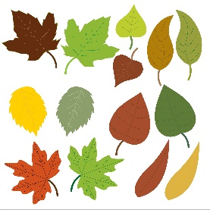
Example –
- Items from a plant Items not from a plant
- Hard items Soft items
- Green items Not green items
- Smooth items Bumpy items
- Heavy items Light items
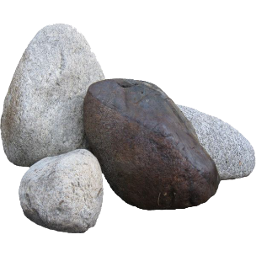
- Living Not living
- Colourful only 1 colour
Or any other way you can think of

