Plan a poster template.
Record some ideas in the table.
Poster heading / title – must be big and colourful!

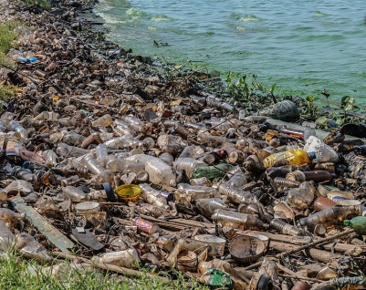
Ocean pollution facts.

How can you and your friends help keep the ocean clean?

How does pollution affect your fact file animal?
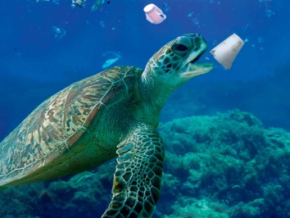

Ideas of pictures to use.

