Early Years Unit - Home Learning – Nursery - wc 15 June and wc 22 June
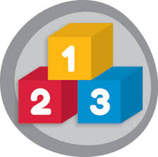
Maths and Numeracy Activities
There are three number activities to work on: 1. Learning all about the Number 6,
2. Fruit Sorting Challenges and 3. Singing number songs.

- Number 6

We are looking at number 6. Help your child to recognise number 6 by pointing it out whenever you see it every day:

- Ask your child if they can see a number 6 anywhere
- In the garden/on your walk, ask them to find you or point to 6 blades of grass, 6 stones and 6 houses
- At home, ask them to find you 6 blocks/lego bricks the same colour and 6 toys of different sizes
- Have a look through this PowerPoint together for more number 6 ideas to try!

Click on the picture to access the PowerPoint: (Choose ‘slideshow’ to view it and be able to interact with the resources and questions).

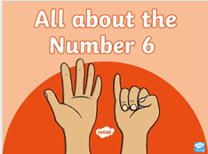

Here is the same file in pdf, in case you can’t access PowerPoint:

- Fruit Sorting
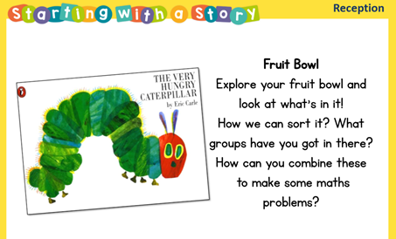
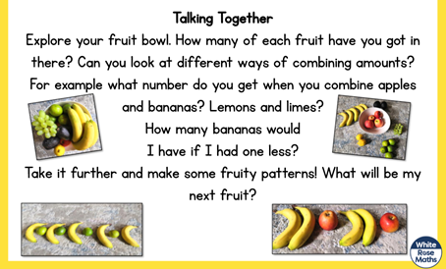

- Number songs
As always, please try to sing some number songs every day with your child to help them learn to count and to recognise numbers and to help them with other maths skills like learning the days of the week and the names of shapes.

In Nursery, we are working on ‘rote counting’ up to 10 and back down again (reciting numbers 1-10 and reciting 10-1) and counting out up to 5 objects from a set. We are learning to recognise number 1-5 and to put them in the correct order. We are also learning to recite the days of the week and to recognise 2D shapes.

Here are some of our favourite number and maths songs:

Days of the Week Songs:
Addams Family Days of the Week
7 days are in the week
Singing Walrus Days of the Week

Shape Songs:
Gentle Shapes Song
Kids TV Shapes Song

Counting Songs:
Teddy Bear Counting to 10
1, 2 ,3, 4, 5, tra la la la la!
Funky 1-10 song
1, 2, 3, 4, 5 once I caught a fish alive
Zero, zero, superhero
5 currant buns
5 little speckled frogs
I can count to 10
5 little monkeys

