Count the number of carriages.
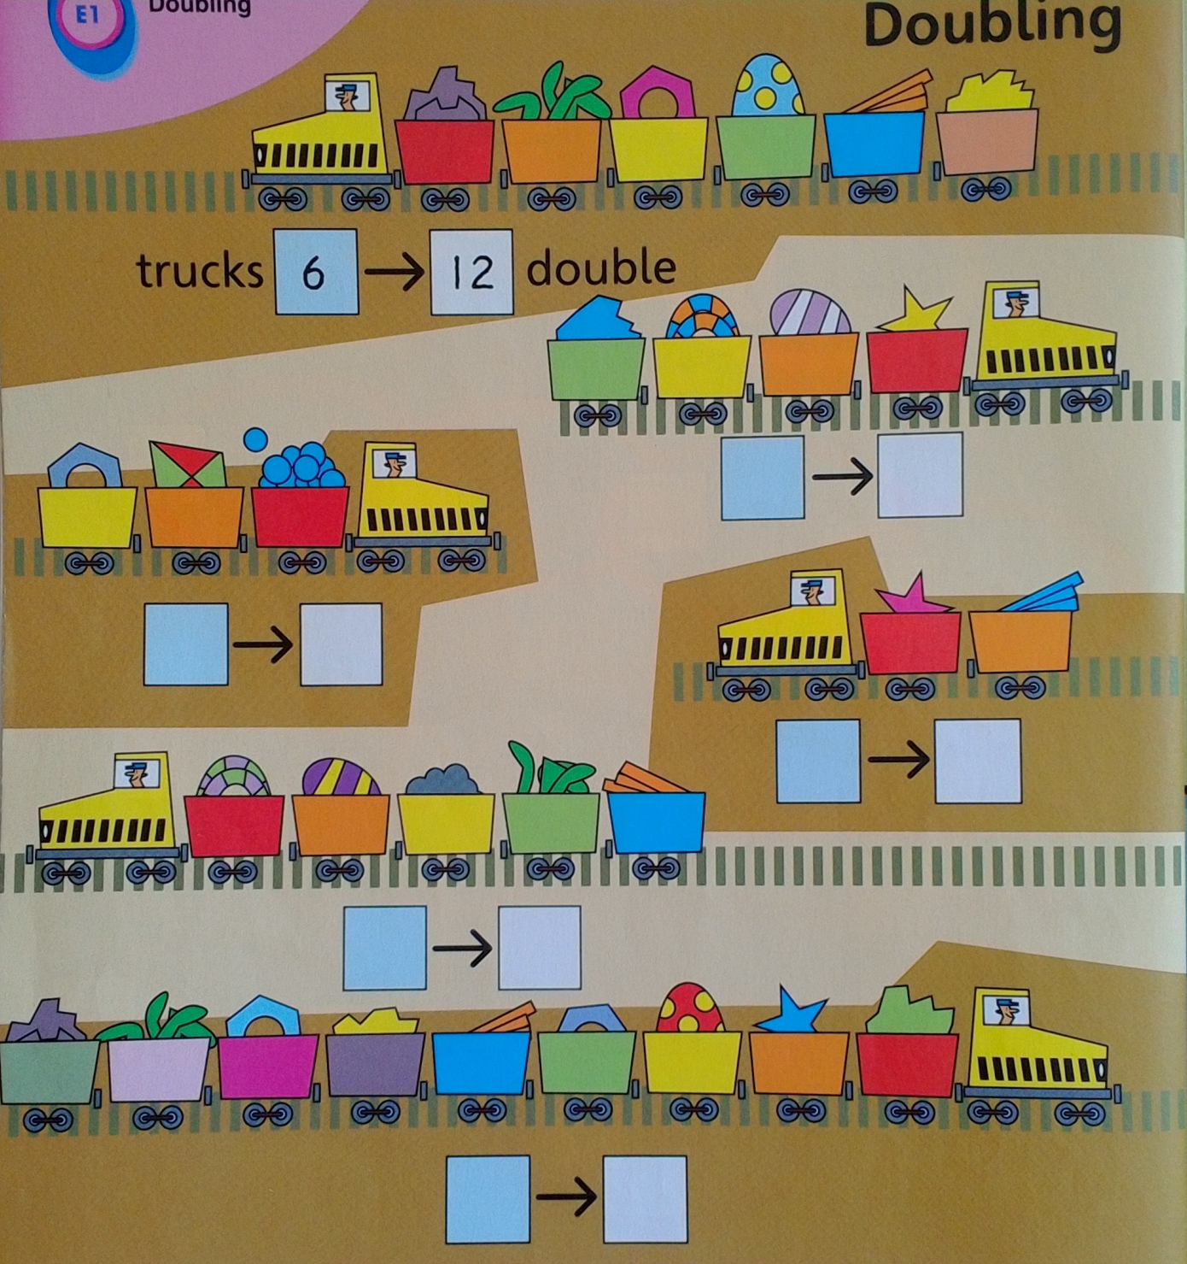
Double the number.

