Parti
Parti, parti, dw i’n dwlu ar fwyd parti.
Parti, parti, rhowch fwy o fwyd i mi.
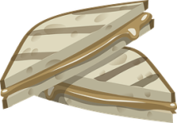
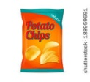
Un pecyn o greision,
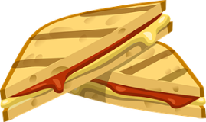
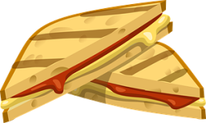
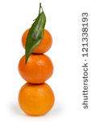
Dwy frechdan ham,
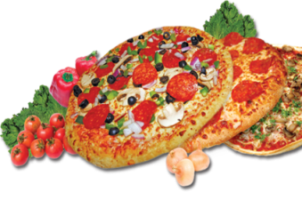
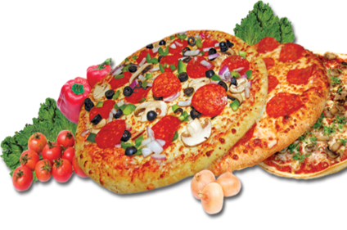
Tair tanjerin
Pedair brechdan jam…
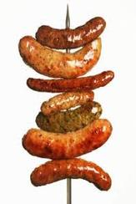
Pum pizza poeth,
Chwe diod hyfryd,
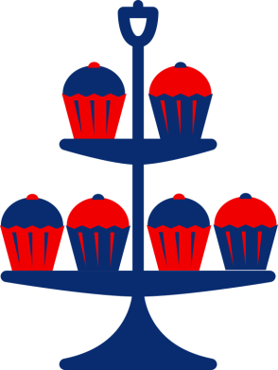
Saith sosej tew-
Dw i’n dal yn llwglyd!
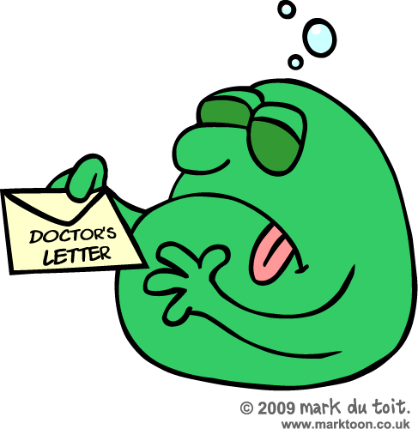
Wyth cacen flasus -
Dw i’n dechrau chwysu,
Naw sgŵp o hufen iȃ.
Deg…
BLYYYYYYYCH!
O na…dw i wedi chwydu!
Aled Richards
Party
Party, party I love party food.
Party, party give me more food.
1 packet of crisps
2 ham sandwiches
3 tangerines
4 jam sandwiches
5 hot pizzas
6 lovely drinks
7 fat sausages
I’m still starving.
8 tasty cakes
9 scoops of ice-cream.
0
BLUURGGH!
Oh no.., Ive been sick!

