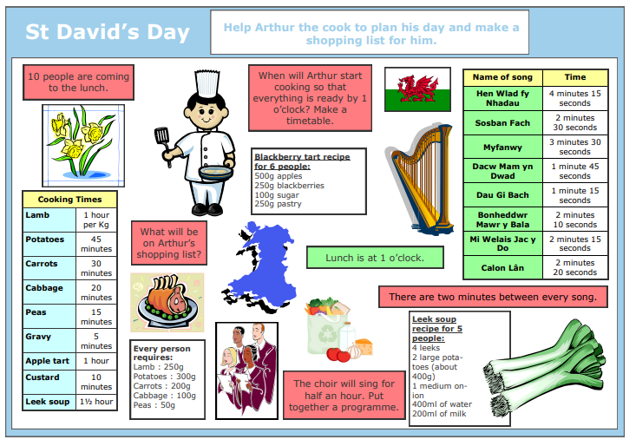
N.B. The blackberry tart recipe above should say for 5 people.
1 star – Work out a shopping list for Arthur. Remember he must cook for 10 people.

2 stars - Work out a shopping list for Arthur. Remember he must cook for 10 people.
Put together a choir timetable. Remember, there are 2 minutes between each song and the choir will sing
for half an hour (30 minutes).

3 stars – Make a plan for Arthur for his whole day including a shopping list, choir programme and cooking timetable.

