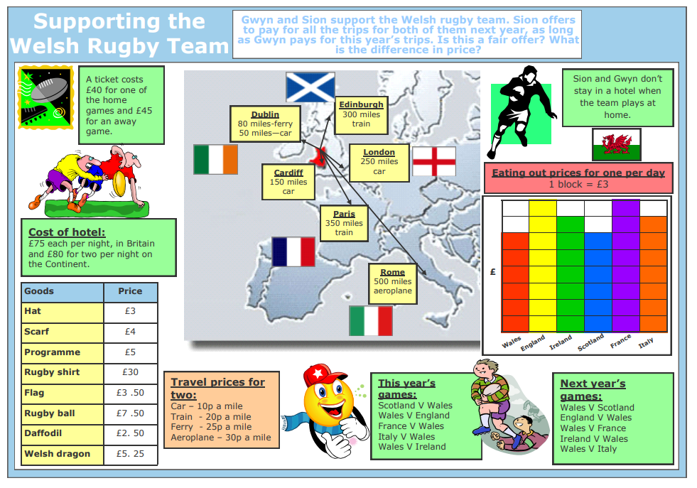
1 star – Only work out how much the tickets costs are for Gwyn this year and for Sion next year.

2 stars – 1. Work out how much the tickets costs are for Gwyn this year and for Sion next year.
2. Work out the total cost of buying a hat, scarf, programme, rugby shirt, flag, ball, daffodil and a Welsh dragon
3. How much will Gwyn pay altogether for the tickets and goods? How much will Sion pay? Who pays the most?
3 stars -

