Subtraction Word problems
Here are some subtraction word problems for you to solve.
- You can draw pictures to help you.
- You can draw a number line to help you.
- You can use a 100 square to help you.

- 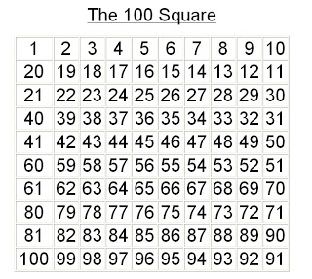

There are 2 levels of word problems using smaller / larger numbers so choose which one you feel is appropriate for your child.

- Miss Jones has 12 socks. She throws 4 away. How many socks does she have left ?

- There are 15 children in the party. 6 children are out of the game. How many children are left in the game ?

- Tom has 20p , he buys some sweets for 15p. How much money does he have left ?

- Mrs George sharpens 19 pencils. There are 15 children in school today. How many pencils are not used ?

- Mrs Thomas makes 16 iced buns. Harry, Isobelle and Dad eat one each. How many iced buns are left ?

- Mr Hawkins loves Hobnobs. There are 18 in the packet. He has 2 biscuits with his cup of tea. How many biscuits are left.

- The farmer has 14 sheep. 7 sheep go into the new field. How many sheep are left ?

- There are 20 children in the class. 12 have school dinners. How many children have a packed lunch ?

- Miss Jones has 42 socks. She throws 12 away. How many socks does she have left ?

2 .There are 25 children in the party. 16 children are out of the game. How many children are left in the game ?

3.Tom has 50p , he buys some sweets for 15p. How much money does he have left ?

4. Mrs George sharpens 29 pencils. There are 15 children in school today. How many pencils are not used ?

- Mrs Thomas makes 30 iced buns. Harry, Isobelle and Dad eat one each. How many iced buns are left ?

- Mr Hawkins loves Hobnobs. There are 28 in the packet. He has 2 biscuits with his cup of tea. How many biscuits are left.

- The farmer has 39 sheep. 17 sheep go into the new field. How many sheep are left ?

- There are 30 children in the class. 18 have school dinners. How many children have a packed lunch ?

