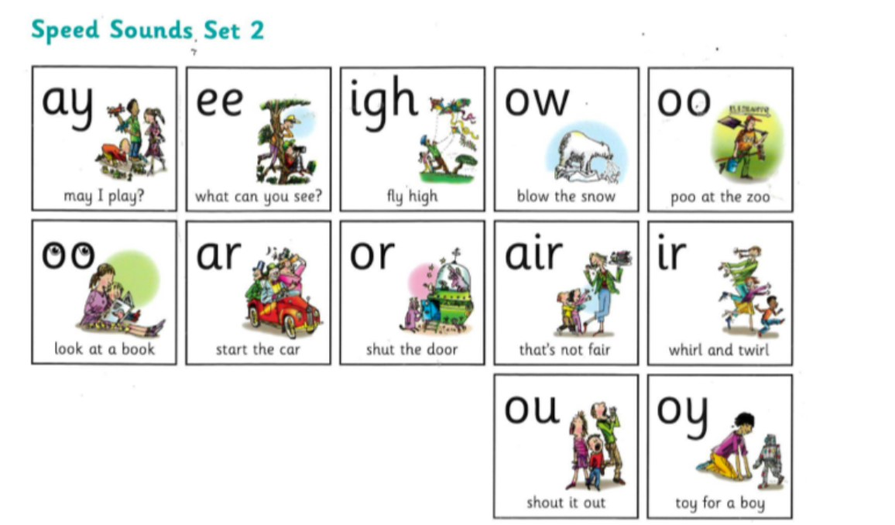Practice reading and writing your words
Here are the set 2 sounds that we have been working on.
Each week we will focus on 1 sound to practice reading and spelling.
ou “ shout it out “
Look Say Cover 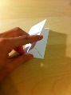 Write Check
Word | Friday | Monday | Tuesday | Wednesday | Thursday
out
shout
about
round
found
said
of
no

