Practice Your Words
Look Say Cover 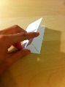 Write 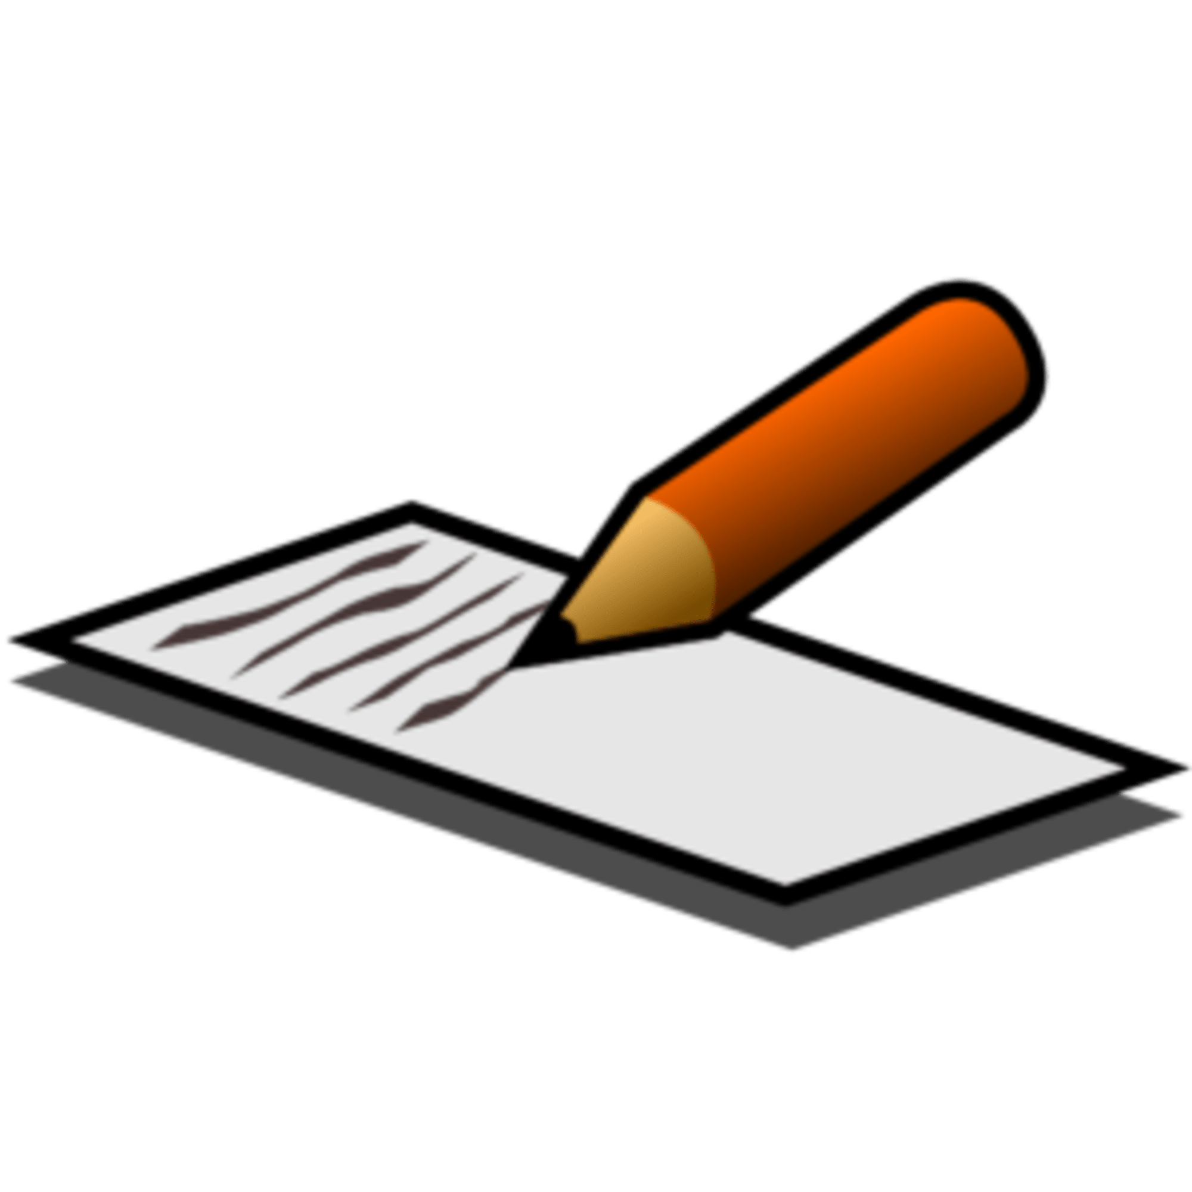 Check
Word | Friday | Monday | Tuesday | Wednesday | Thursday
Brave
World
Shot
Sky
Morning
Flame
Shout
Fight
Show
Cheer

I would now like you make complete sentences using the words above. Try your best to make them interesting!

