WALT – calculate temperature differences.

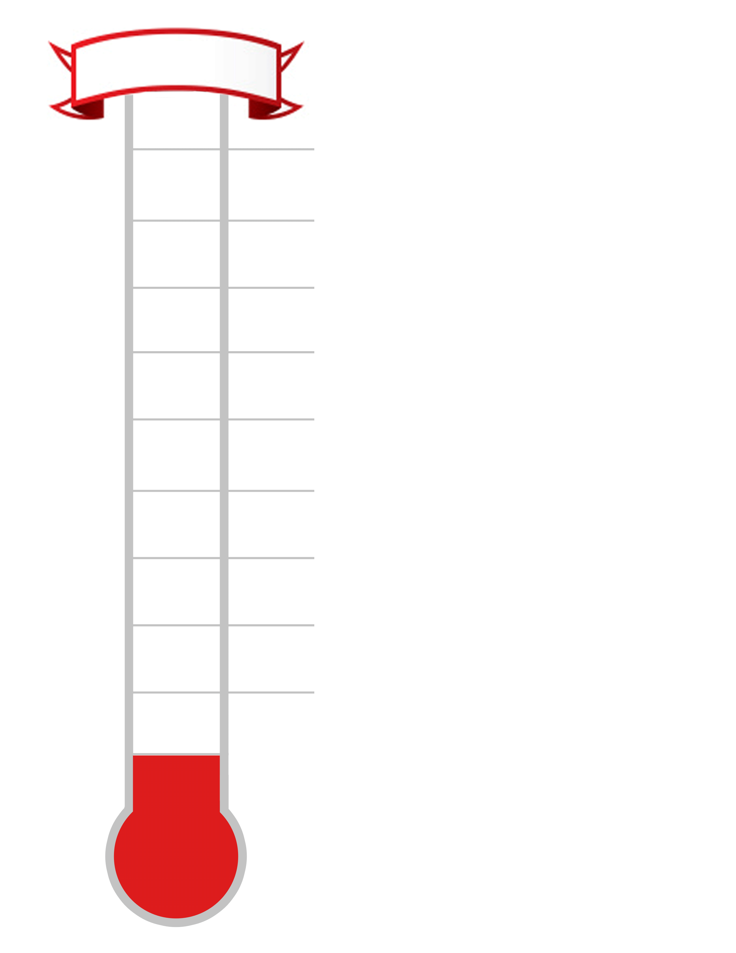
1. Complete the thermometer on the right hand side.
-7ºC
-3ºC
0ºC
9ºC
5ºC

Use your thermometer to help answer the questions
below.

2.
a) What is 4 degrees more than 7ºC? ____________

b) What is 5 degrees less than 3ºC? ____________

c) What is the difference between 9^{O}C and 2ºC?

_____________

d) What is 5 degrees less than 1ºC? ______________

e) What is 9 degrees more than -3ºC? _____________

f) What is 3 degrees less than -2^{O}C? ____________

g) What is the difference between 3^{O}C and -4^{O}C?

_______________

h) What is the difference between 2ºC and -8ºC?

3. The temperatures of 8 world cities are shown below.

Toronto: 9ºC | New York: 10ºC | Harare: 0ºC | Dubai: 11ºC
Auckland: -1ºC | Reykjavik: -9ºC | Tokyo: 6ºC | Helsinki: -2ºC

Use the table and your thermometer to answer the questions below:

a) Which city is the coldest? __________________

b) Which city is 3 degrees colder than Toronto? __________________

c) Which city is 5 degrees warmer than Tokyo? __________________

d) Which city is 13 degrees colder than Dubai? __________________

e) Which city is 2 degrees colder than Harare? __________________

f) Which city is 1 degree warmer than Helsinki? __________________

g) Which city is 7 degrees colder than Tokyo? __________________

