Write a diary as if you are Howard Carter.



**Egyptian Diary**

Dear Diary,

Before I entered the tomb I was feeling

We walked towards the tomb and started to break the seal.

As I opened the door I saw

I felt

I heard

I took a step forwards and discovered

"Can you see anything?" asked Lord Carnarvon. "Yes, wonderful things!" I gasped.

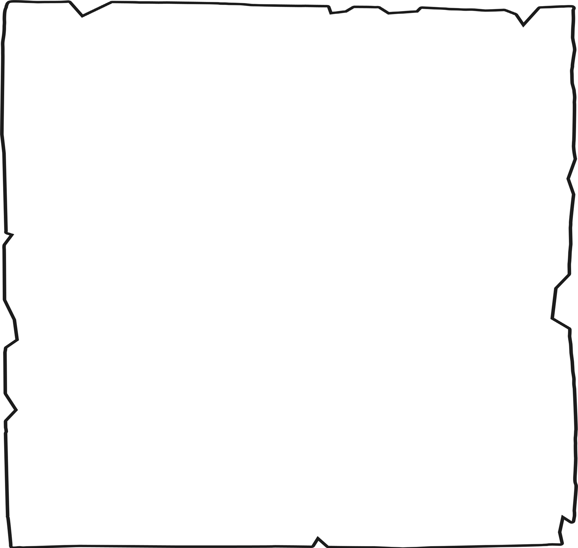

**Egyptian Diary**

Write a diary as if you are Howard Carter. Describe the day the tomb was entered.

1.

2.

3.

How were people feeling before you entered the tomb? How did you enter the tomb?

What did you see there?

Dear Diary,

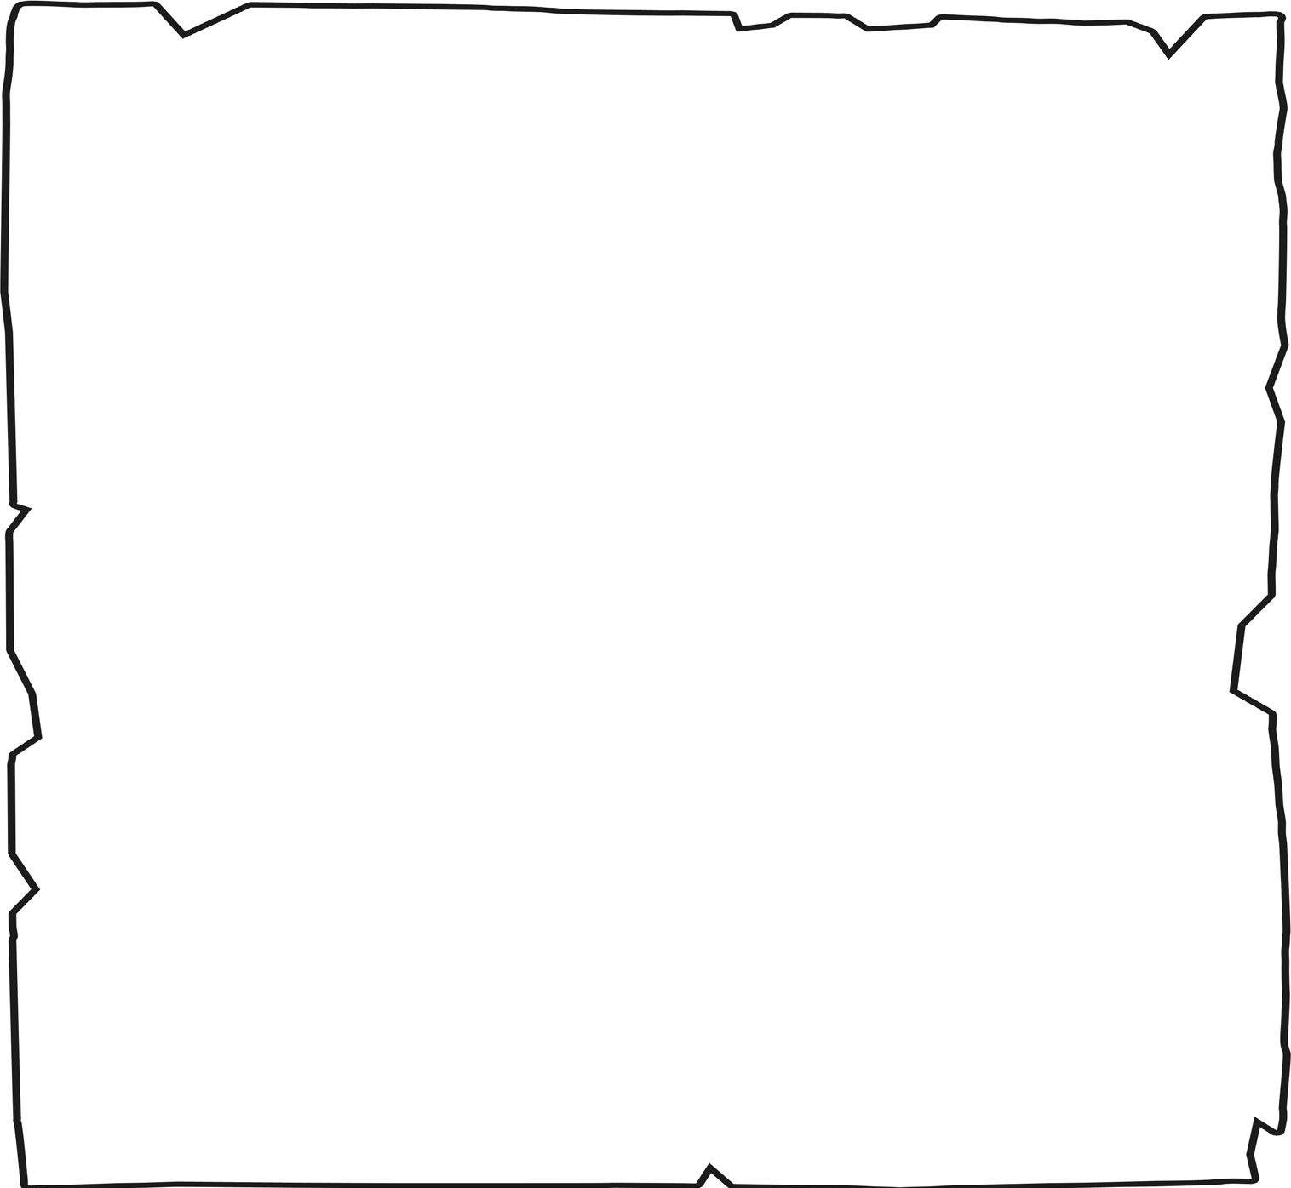

**Egyptian Diary**

Write a diary as if you are Howard Carter. Describe the day the tomb was entered.

1.

2.

3.

4.

Describe the atmosphere - how were people feeling and how could you tell? Explain how you had found out about the tomb.

Describe the reactions to the treasures found.

Why is this discovery so important?

Dear Diary,