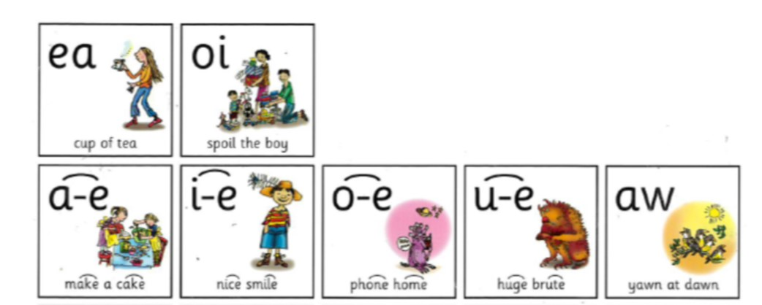

Here are the set 3 sounds that we have been working on.

Each week we will focus on 1 sound to practice reading and spelling.

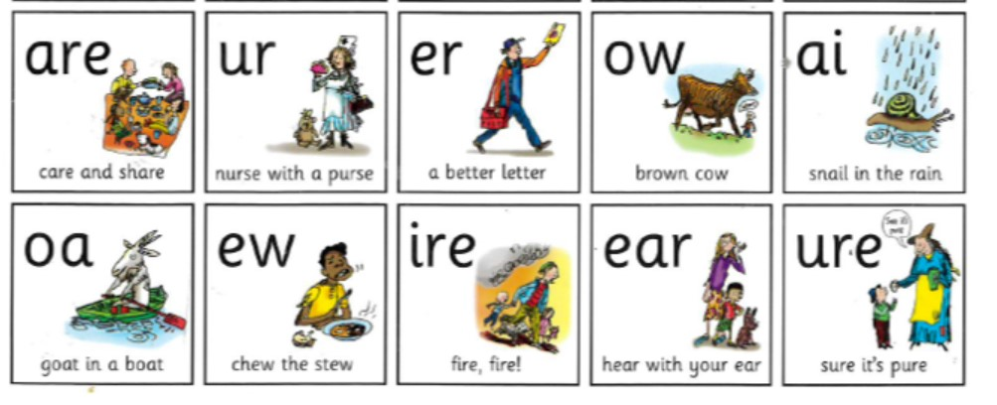

**Practice reading and writing your words**

**ai “ snail in the rain “**

**Look**  **Say**  **Cover**   **Write**  **Check** 

|  |  |  |  |  |  |
| --- | --- | --- | --- | --- | --- |
| Word | Friday | Monday | Tuesday | Wednesday | Thursday |
| rain |  |  |  |  |  |
| pain |  |  |  |  |  |
| nail |  |  |  |  |  |
| train |  |  |  |  |  |
| chain |  |  |  |  |  |
| Spain |  |  |  |  |  |
| snail |  |  |  |  |  |
| with |  |  |  |  |  |
| this |  |  |  |  |  |
| you |  |  |  |  |  |