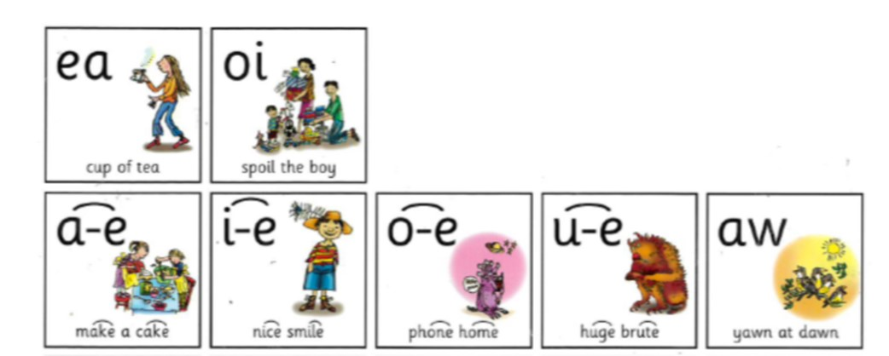
Here are the set 3 sounds that we have been working on.
Each week we will focus on 1 sound to practice reading and spelling.
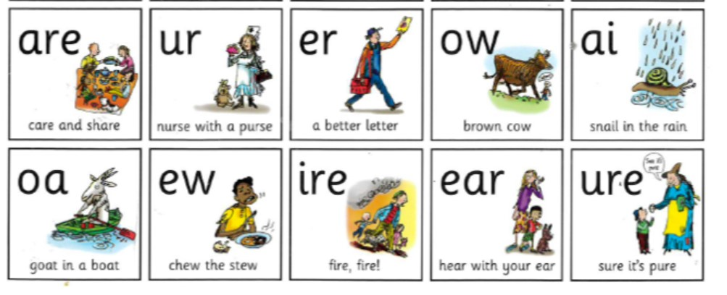
Practice reading and writing your words
oa “ a goat in a boat “

Look Say Cover 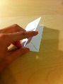 Write Check
Word | Friday | Monday | Tuesday | Wednesday | Thursday
goat
boat
throat
moat
roast
toast
float
said
to
my

