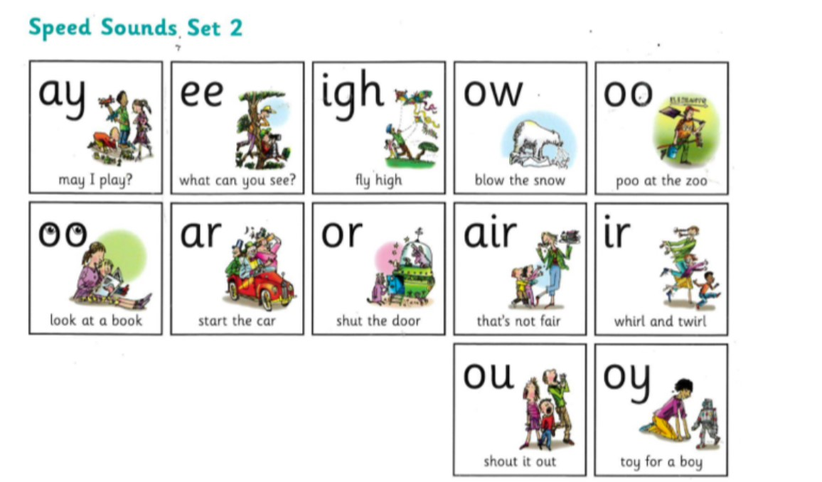Practice reading and writing your words
Here are the set 2 sounds that we have been working on.
Each week we will focus on 1 sound to practice reading and spelling.
ar “ start the car “

Look Say Cover 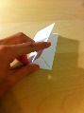 Write 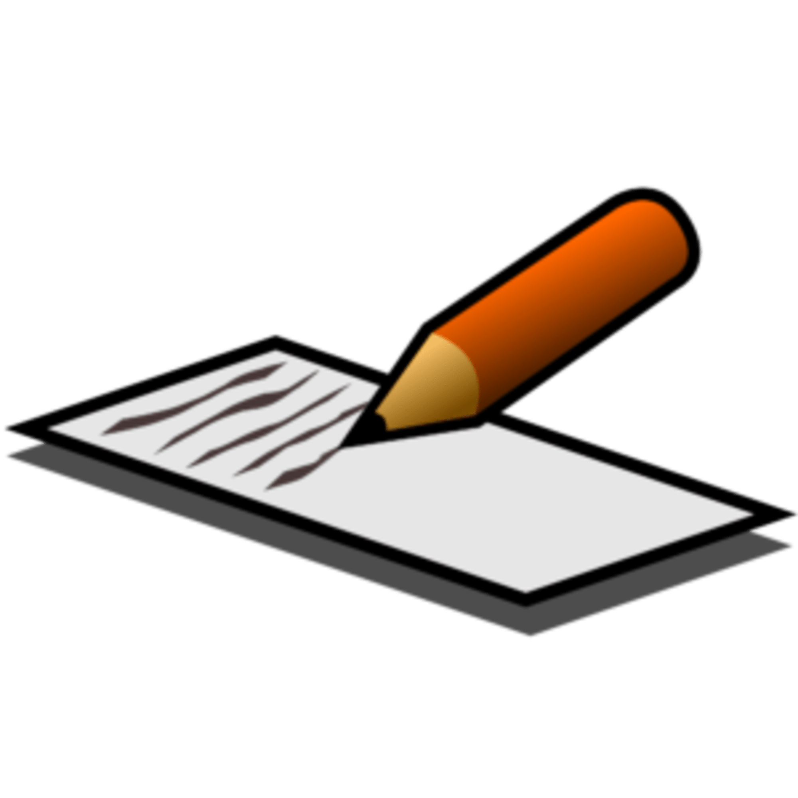 Check
Word | Friday | Monday | Tuesday | Wednesday | Thursday
car
star
start
cart
part
art
said
my
be

