Practice Your Words
Look Say Cover 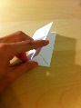 Write 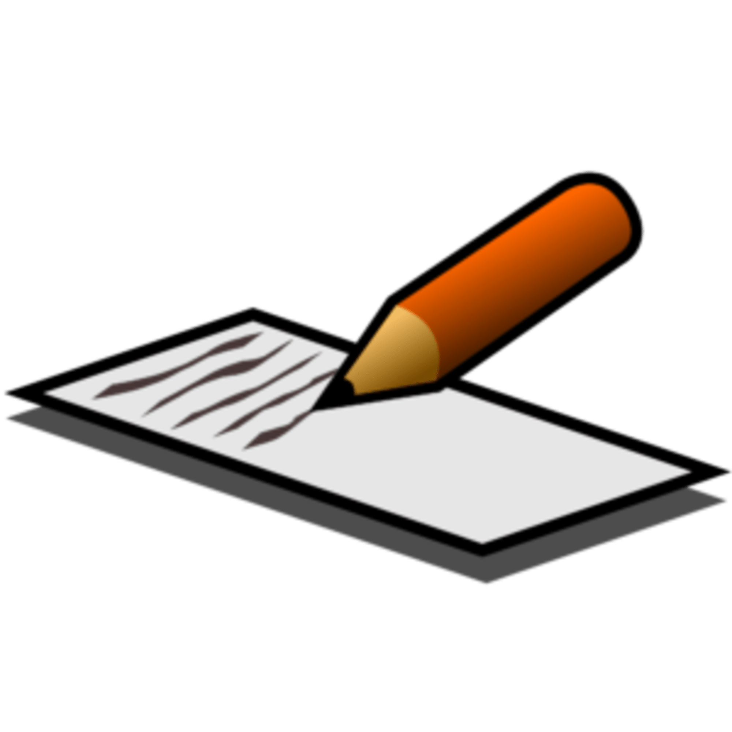 Check
Word | Friday | Monday | Tuesday | Wednesday | Thursday
Very
Time
New
Where
Week
Change
Dark
Cave
When
Early

I would now like you make complete sentences using the words above. Try your best to make them interesting!

