Ancient Pyramid Tours

Suspect Information Pack

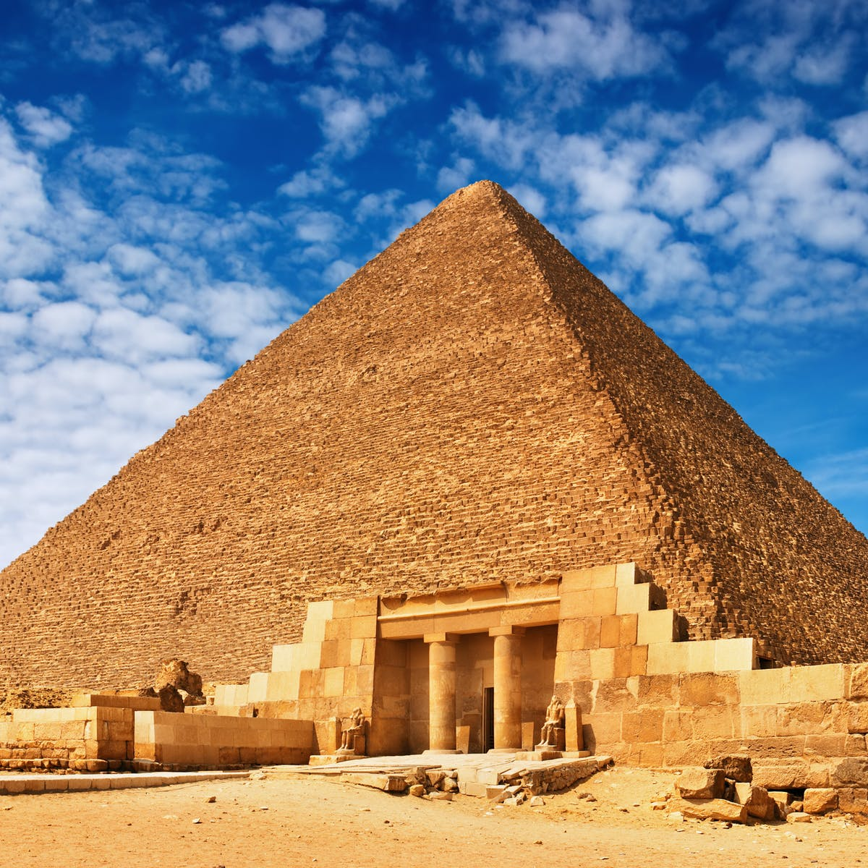

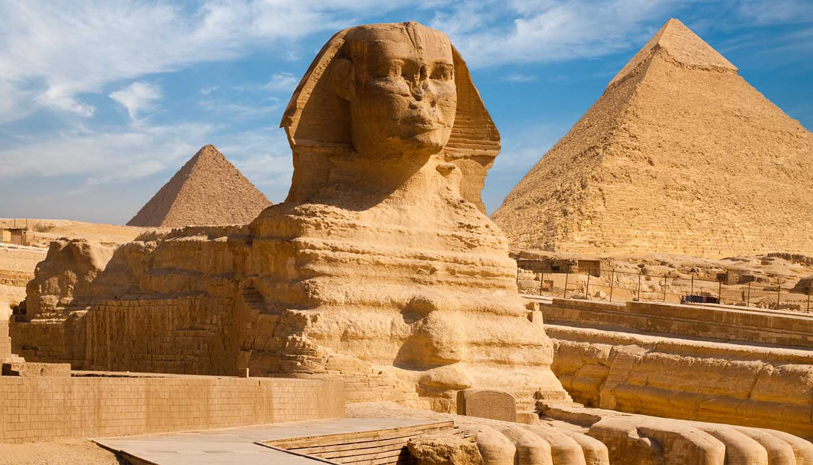
Dear Pupil,

We are Ancient Pyramid Tours (APT) and we are one of the most well-known tourist groups in Egypt. Our job is to take tourists around some of the most sacred pyramids Egypt has to offer. We spend hours explaining the history of each pyramid as well as showing many of the artefacts that go along with them. Some of these artefacts include Tutankhamun’s Mask, Narmer Palette, the Statue of Khufu and most importantly – jewellery! Some of the most expensive jewellery in the world is kept in these pyramids. Or should we say … WAS KEPT!

Last Saturday we held two of our tours, one in the morning and the other in the afternoon. It was only at the end of the day where one of the ATP employees realised that Pharaohs golden bracelet had been stolen! How someone was able to take it without being caught is an absolute mystery! It has an estimated worth of £120 million.

The police have been called to deal with the issue, but we think your help could speed up the process.

Every person that participated in the tours last Saturday (as well as the staff) are listed on the next page. It is up to you to use your code cracking and problem solving skills to find who stole Pharaohs golden bracelet! There are several clues to solve.

Take your time, use all your Maths and Literacy knowledge, and please double check each answer once you have solved the clue. We don’t want to let the person responsible for this get away!

Good luck.
Initials of their name | Gender | Height (cm) | Weight (kg) | Birth Month | Where they have travelled from | Which tour they attended (AM or PM)
DG | M | 156 cm | 82 kg | December | USA | AM
LZ | F | 130 cm | 72 kg | August | China | AM
JZ | M | 142cm | 53 kg | January | China | AM
ME | F | 180cm | 80kg | September | Egypt | PM
RL | F | 151 cm | 69 kg | October | Poland | AM
AR | F | 181cm | 91 kg | July | Egypt | PM
DT | M | 152cm | 78 kg | September | Wales | AM
JB | F | 159 cm | 75 kg | August | New Zealand | PM
BF | M | 178 cm | 78 kg | February | USA | PM
TM | M | 175cm | 67 kg | May | France | AM
KM | F | 171 cm | 73 kg | August | France | PM
XS | M | 190cm | 100 kg | November | Switzerland | AM
KW | F | 152 cm | 60 kg | December | Ukraine | AM
JL | M | 187 cm | 70 kg | July | South Africa | PM
NJ | F | 179 cm | 75 kg | June | Egypt | PM
KP | F | 149 cm | 62 kg | October | USA | PM
AA | M | 165 cm | 60 kg | December | India | AM
NS | F | 146 cm | 57 kg | March | Egypt | PM
KP | M | 150 cm | 67 kg | September | Egypt | AM
RR | M | 149 cm | 56 kg | November | Canada | AM
HN | M | 175 cm | 71 kg | November | Egypt | AM
FT | M | 210 cm | 84 kg | September | Italy | PM
RK | F | 190cm | 51 kg | November | Ireland | PM
Here is the list of every person that entered the sacred pyramids last Saturday. The police have interviewed each person and taken some personal details. Use the information below to help you solve the crime.
Tip:
Once you have solved each clue, come back to this list and cross off the relevant people depending on what the clue says

Clue 1
Use your code cracking skills to solve this clue.
20 8 5

20 8 9 5 6

8 1 19

1

8 5 9 7 20

13 15 18 5

20 8 1 14

6 9 6 20 25 14 9 14 5

9 14 3 8 5 19
Tip
Think of the alphabet!
You may need to convert (this can be done online)
Clue 2
Clue 2
Match the question with the correct answer and fill in the sentence below. Take care because not all numbers in the sentence below are in order!
1) 8² | 2) 4² | 3) 1²
4) 15² | 5) 7² | 6) 2²
7) 12² | 8) 5² | 9) 11²
10) 9² | 11) 10² | 12) 6²
13) 3² | 14) 13² | 15) 14²
R) 49 | N) 100 | I) 144
A) 121 | T) 64 | F) 196
B) 4 | O) 9 | E) 1
H) 16 | D) 25 | L) 169
S) 81 | Y) 225 | C) 36

1 | 2 | 3 | 7 | 5 |  | 6 | 7 | 5 | 1 | 2 | 8 | 9 | 4 |  | 7 | 10 |  | 7 | 11
 | 1 | 2 | 3 |  | 10 | 3 | 12 | 13 | 11 | 8 |  | 2 | 9 | 14 | 15 |  | 13 | 15
Tip
Squaring a number means multiplying it by itself

5
9
3
4

3
2

1
Clue 3
Connect the question with the answer to change each number to a letter. Read the clue carefully before crossing off people from your list!
1) 72 ÷ 8 | 2) 65 ÷ 5 | 3) 105 ÷ 7
4) 216 ÷ 9 | 5) 144 ÷ 4 | 6) 205 ÷ 5
7) 168 ÷ 8 | 8) 204 ÷ 3 | 9) 486 ÷ 9
10) 162 ÷ 6

G) 68 | E) 21 | R) 36
Y) 54 | O) 13 | M) 41
N) 9 | F) 24 | T) 15
P) 27

1 | 2 | 3 |  | 4 | 5 | 2 | 6 |  | 7 | 8 | 9 | 10 | 3

Tip
Remember the bus stop method for division

Clue 4
Calculate the answer to question one and then apply the answer into each next question. Once you have a final number, put it into the sentence below.

- 1.2 + 3.8
- Answer x 12
- Find ¼ of answer
- Answer ÷ 5
- Answer x 11
- Answer x 3
- Answer + 1
- 10% of the answer
- Answer - 4

The thief’s weight is a multiple of _____

Clue 5
Crack the code by seeing what letter each coordinate gives you.
Tip
The first coordinate in a bracket is for the x axes

A | B | C | D | E
F | G | H | I | J
K | L | M | N | O
P | Q | R | S | T
U | V | W | X | Y
4

2

3

5

1

2

5

4

3

1

(5,2) (3,4) (4,4) (5,5) (1,4)

(3,4) (1,5) (4,2) (4,3) (5,3)

(2,1) (5,3) (3,1) (5,5) (2,3) (4,2)

(4,4) (4,3) (5,2) (3,4) (5,5) (4,4) (3,2)

(4,4) (4,3) (4,4) (5,2) (4,4) (1,5) (2,3) (4,2)
Congratulations for reaching this point. You have been using your numeracy and code cracking skills to carefully solve each clue that you have been presented with. Hopefully you have accurately crossed off the correct suspects and should be left with a few remaining on your list.

There are no more clues to solve, so now you must use your problem solving skills. Looking at the remaining suspects, we would like you to write down which one you think stole Pharaohs golden bracelet and why.

I think that _____________________________ stole the bracelet because __________________________________________________________________________________________________________________________________________

We would like to take this opportunity to thank you for your very hard work on this task. It will not go unnoticed.

