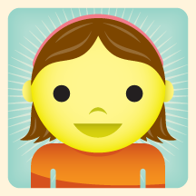

Me
Which colour are your eyes?

I’ve got … eyes

e.g.
blue / green / brown

How old are you?
I’m … years old

What do you like wearing?

I like wearing…
e.g. a shirt, a T shirt,
a polo shirt, a jumper, jeans, a skirt, trousers,
blue / green / red / grey
dark / light / colourful

as well

Why?

because e.g.

it’s colourful

it’s fashionable

What’s your name?
I’m...

When is your birthday?

My birthday is in…
e.g in January, January 22

Which colour is your hair?

I’ve got … hair

e.g.
brown / black /fair / dark

but
I don’t like wearing…
I hate wearing…

school uniform / black clothes

Why?

because e.g.

it’s boring

Me

Eyes?

Age?

Why?

Name?

Like wearing

Birthday?

Hair?

Why?

