Which reindeer should Santa choose?
Santa needs to select the 6 strongest, fittest reindeer to pull the sleigh on Christmas Eve. But how does he choose?

Test 1 – measuring lung capacity
The more air your lungs can hold, the harder you can work with each breath. Santa has two ways he can measure lung capacity with his reindeer.
The balloon test

How many breaths does it take to blow up a balloon? The reindeer with the least breaths has the largest lung capacity.

The volume bag  How many litres of air does each reindeer’s lungs hold? | 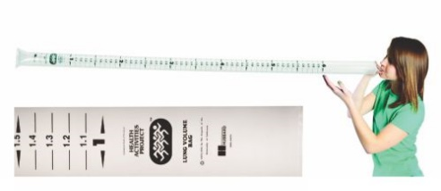
Your job is to trial each method, and say which will give Santa better data, and why.

Test 2 – resting pulse rate
The quicker that your pulse returns to normal after exercise, the fitter you are. Trial Santa’s method for him.
Resting pulse rate test.  - Sit down and take your pulse for 30 seconds. Record the result.  - Dance to a Christmas song – throw in some funky moves. The song should last at least 2 minutes.  - Now sit down and start measuring your pulse. Keep writing down the figure every 30 seconds, starting at 0 each time, until it is the same as before.  - Work how many minutes it took to return to normal. | 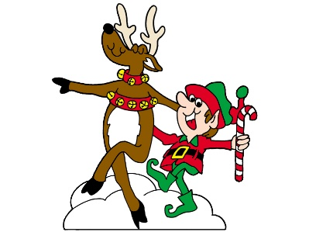

The results
These are the results Santa collected.
Which reindeer should he choose, and why?
 | Dasher | Dancer | Prancer | Vixen | Comet | Cupid | Donner | Blitzen | Rudolf
Lung capacity (l) | 6.5 | 3.2 | 5.7 | 4.5 | 4.5 | 5.9 | 5.2 | 4.2 | 5.7
Resting pulse rate (min) | 1 | 3.0 | 1.5 | 2.0 | 2.5 | 1 | 2.0 | 2.5 | 1.5

Which reindeer should Santa choose?
Santa needs to select the 6 strongest, fittest reindeer to pull the sleigh on Christmas Eve. But how does he choose?

Test 1 – measuring lung capacity
The more air your lungs can hold, the harder you can work with each breath. Santa has two ways he can measure lung capacity with his reindeer.
The balloon test

How many breaths does it take to blow up a balloon? The reindeer with the least breaths has the largest lung capacity.

The volume bag

How many litres of air does each reindeer’s lungs hold?

Your job is to trial each method, and say which will give Santa better data, and why.

Test 2 – resting pulse rate
The quicker that your pulse returns to normal after exercise, the fitter you are. Trial Santa’s method for him.
Resting pulse rate test.
- Sit down and take your pulse for 30 seconds. Record the result.
- Dance to a Christmas song – throw in some funky moves. The song should last at least 2 minutes.
- Now sit down and start measuring your pulse. Keep writing down the figure every 30 seconds, starting at 0 each time, until it is the same as before.
- Work how many minutes it took to return to normal.

The results
These are the results Santa collected.
Which reindeer should he choose, and why?
 | Dasher | Dancer | Prancer | Vixen | Comet | Cupid | Donner | Blitzen | Rudolf
Lung capacity (l) | 6.5 | 3.2 | 5.7 | 4.5 | 4.5 | 5.9 | 5.2 | 4.2 | 5.7
Resting pulse rate (min) | 1 | 3.0 | 1.5 | 2.0 | 2.5 | 1 | 2.0 | 2.5 | 1.5

