Baglan Primary School

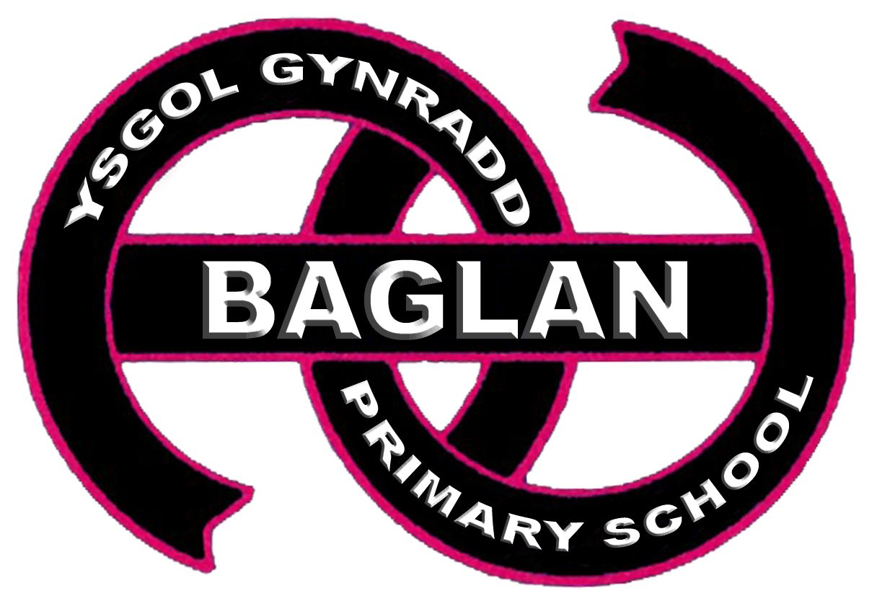

Additional Needs Policy
Summer 2021; Adopted 23.06.2021
Article 23: A child with a disability has the right to live a full and decent life with dignity and, as far as possible, independence and to play an active part in the community. Governments must do all they can to support disabled children and their families.

Chair of Governors: Mr L Rees

Headteacher: Mrs N E Morgan

Review Date: Summer 2022

Baglan Primary School ~ Ysgol Gynradd Y Baglan
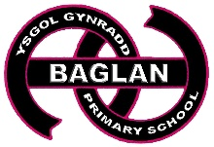

POLICY FOR ALN
Additional Learning Needs Policy

This Additional Learning Needs Policy takes account of the Education Act 1996, The SEN Code of Practice for Wales 2002, the Equality Act 2010, policies and guidelines issued by the Directorate of Education Leisure and Lifelong Learning and the aims of the school as outlined in school documentation.
All children have skills, talents and abilities and as a school we have a responsibility to develop these to the full. At our school we believe that:

- All children are entitled to a broad, balanced, relevant, challenging and high quality education designed to enable individual pupils to participate fully in society and to contribute to and benefit from it;
- Pupils who have additional learning needs should be supported wherever necessary to achieve full access to the whole-school curriculum. This will need to be facilitated through a range of access technologies including skilled staff, specialist equipment and resources, whenever appropriate;
- Pupils may require special programmes designed to maximise opportunities for independent living in preparation for life after school, including work or continuing education.
With regard to these beliefs, the following document outlines the provision available at Baglan Primary School.

Definition:

What are Additional Learning Needs?

The term ALN is much wider in scope than the term ‘special educational needs’ in order to recognise the diverse and complex needs of learners and to reflect a more holistic approach to meeting the needs of individual learners.

ALN include persons who, for whatever reason, require additional learning support because they are struggling to learn in comparison with their peers.

School pupils may therefore require additional learning support if they have difficulty in learning because for example:

- they have special educational needs;
- they have a disability;
- they have medical needs;
- they have gaps in their knowledge or skills due to prolonged absences from the education system e.g. school refusers, school phobics or young offenders;
- they have difficult family circumstances e.g. due to bereavement;
- they access education inconsistently e.g. Gypsy and traveller pupils; or
- their first language is not English or Welsh e.g. asylum seekers/ refugees/children of migrant workers;
- they are looked after by the local authority e.g. a child whose schooling was disrupted before being taken into care or has had frequent changes of school since taken into care;
- they are underachieving due to care responsibilities e.g. young carers; or
- they are pregnant or a young parent;
- they are being bullied by their peers or other persons, due to their sexual orientation e.g. lesbian, gay, bisexual and transgender pupils; or
- they are pupils who perform or who have employment.

Pupils defined as more able and talented are not considered to have ALN unless they have SEN or they have for whatever reason, greater difficulty learning a particular subject or skill in comparison with the majority of persons of the same age who are not able and talented.

What are Special Educational Needs?

The term ‘Special Educational Needs’ is a sub category of ALN and continues to be used for those learners who have a learning difficulty which calls for special educational provision to be made for them.
8. Under the Education Act 1996 (section 312) and the SEN Code of Practice for Wales (2002), a child has a learning difficulty if:

- he/she has a significantly greater difficulty in learning than the majority of children of his/her age; or

(b) he/she has a disability which either prevents or hinders him/her from making use of educational facilities of a kind generally provided for children of his/her age in schools within the area of the LA; or
(c) he/she is under compulsory school age and is, or would be if special educational provision were not made for him/her, likely to fall within the definition at (a) or (b) above.

General Information about the School’s ALN Provision

Baglan Primary School currently has approximately 297 pupils on roll, all of whom are members of one of our eight mainstream classes. There are no special classes or units attached to the school.

Current School Profile

 | Number of Pupils
School Action | 10
School Action Plus | 19
Statemented | 6
No. of children who meet disabilities criteria | 8
Medical needs | 37

The Management of Additional Learning Needs

The ALN Co-ordinator (ALNCo), Mrs Roosmalen has responsibility for the day to day operation of the additional needs policy in liaison with the Headteacher. The ALNCo will:

- Oversee the running of the provision for pupils with additional learning needs including in class, small group and individual pupil support;
- Regularly review and monitor provision for pupils with additional learning needs within the school;
- Maintain the school’s register of pupils with additional learning needs and all the required documentation;
- Ensure the progress of pupils with additional learning needs is regularly monitored and reviewed;
- Liaise with teachers, parents/carers and other professionals. Ensure annual reviews for pupils with statements are completed;

- Organise meetings as appropriate with teachers in respect of additional learning needs issues;
- Identify barriers to learning and provide staff with appropriate strategies where necessary;
- Report on new developments within the field of ALN and provide access to training to meet the current and anticipated needs of the school and individual members of staff;
- Take part in formal meetings with other professionals regarding individual pupils to be assessed.

The ALN co-ordinator is responsible for liaising with the Headteacher regularly regarding the provision for ALN pupils within the school. Teachers are responsible for meeting the needs of all pupils in their class.

Admission Arrangements

The school adheres to the admission policy of the LA. The admission policy is applied equally to all pupils and does not discriminate against any child or young person with additional learning needs. Where a pupil has a statement of educational needs, separate arrangements apply giving priority to his/her school placement.

At Our School we endeavour, in partnership with others, to provide appropriate support for pupils who experience difficulties in:

- Communication and interaction;
- Cognition and learning;
- Behaviour, emotional and social development;
- Sensory and/or physical development;
- Medical conditions.
The school is accessible by ramps and is equipped with a toilet and hand washing facilities for those who have a physical disability.

Inclusion

The school has a School Accessibility Plan which outlines the school’s intentions to improve physical access, access to the curriculum and access to information for disabled pupils and disabled visitors.

Access to the Curriculum

To include pupils who are designated as having additional learning needs, the school provides:

- Teaching assistants to enable appropriate access to the curriculum via in-class, small group or individual support. Individual timetables to include specific needs where appropriate;
- Individual teaching programmes designed to meet the needs of each particular child;
- Specialist equipment as required.
The school aims to include pupils with additional learning needs into all the activities of the school as far as it is appropriate. However, in the best interests of the child, there may be occasions or periods of time when the best solution is withdrawal to access special intensive programmes.

Parents/carers will always be involved in discussion when these situations arise and the pupil’s welfare will be the major factor considered when decisions are taken.

Future Planning

Future planning of provision for pupils identified with additional learning needs takes place in accordance with:

- On-going tracking of pupil progress;
- Annual SEN budget allowance;
- On-going authority and government directives.

Identification, Assessment, Record-Keeping and Review

At Baglan Primary School we adopt a graduated response to meet our responsibilities for identifying pupils with additional learning needs. We follow the guidance as outlined in the documents SEN Code of Practice for Wales 2002, the Authority’s SEN Code of Practice for Wales 2002 Entry/Exit Criteria a Graduated Response and Guidelines for School Requests for Statutory Assessment.

School Action

Identification
The triggers for intervention through School Action could be the teacher’s or others’ concern, underpinned by evidence, about a child who despite receiving differentiated learning opportunities:

- Makes little or no progress even when teaching approaches are targeted particularly in a child’s identified areas of weakness;
- Presents persistent emotional or behavioural difficulties which are not ameliorated by the behaviour management techniques usually employed in the school;
- Has sensory or physical problems, and continues to make little or no progress despite the provision of specialist equipment;
- Has communication and/or interaction difficulties, and continues to make little or no progress despite the provision of a differentiated curriculum.
The gathering of information in respect of identifying the pupil’s additional learning need is done by:
- Liaison with parents/carers;
- Liaising with teachers;
- Liaising with pre-school provision;
- Liaising with other professionals where pupils may have been known to their Services.
Assessment of Need

- Class teacher comments and analysis of progress registered through:
- Literacy and Numeracy tests
- Specific summative assessments tests – Spelling and reading (Autumn and Summer Term), writing (Termly)
- On-going marking/assessment
- Pupils reviews
- Pupil reports
- Pupils referred by teachers as giving cause for concern and therefore meriting assessment and possible inclusion on ALN register
- On-going assessment, review and record-keeping.
Process for Action, Record-Keeping and Review

- Upon consultation with the ALNCo, an assessment of the pupil may be undertaken to identify the nature and severity of the need.
- Appropriate information is gathered from the class teacher, support staff and any other member of staff who may have further information.
- Discussion takes places with parents/carers to gather appropriate/relevant information on the child.
- Individual Play/Education Plan

- From the collated information the ALNCo and class teacher discuss the pupil’s needs where appropriate, issue the first IEP. The support to be provided for the child will be indicated on the IEP. (Where an IEP is not required, the child will continue to be monitored by the class teacher).
- The parents/carers are then invited in to read/discuss the IEP as well as make written comments if appropriate and a signature is required to confirm their agreement of the targets set.
- Review/evaluation; ALNCo and class teacher discuss the child’s progress at the termly review of the IEP’s or sooner if the need arises. Either the next IEP is formulated or it is agreed to remove the pupil from the register maintained for pupils with additional learning needs.
- Class teacher then issues a new IEP and either continues with the cycle or proceeds to ask for advice ALNCo and from other professionals.
- School asks for advice from other professionals in respect of the nature of the additional learning need and appropriate resourcing/possible action to be taken as part of School Action.
School Action Plus

Identification

The triggers for School Action Plus could be that, despite receiving an increased level of support at School Action, the child:

- Is not making ’adequate progress’. This can be defined as progress that matches or betters the child’s previous rate of progress, progress that is satisfactory to the child and the parents or progress which closes the gap between the child and the child’s peers;
- Continues to make little or no progress in specific areas over a given period of time;
- Continues working at National Curriculum levels substantially below that expected of children of a similar age;
- Continues to have difficulty in developing literacy and mathematics skills;

- Has emotional or behavioural difficulties which substantially and regularly interfere with the child’s own learning or that of the class or group, despite having an individualised behaviour management programme;

- Has sensory or physical needs, and requires additional specialist equipment or regular advice or visits by a specialist service;

- Has on on-going communication or interaction difficulty that impedes the development of social relationships and causes substantial barriers to learning.
The gathering of information in respect of the pupil’s continuing progress will be through:

- School Action reviews
- Liaison with teachers and support staff
- Liaison with parents/carers
- Liaison with other professionals.
Process for Action, Record-Keeping and Review

- ALNCo gathers information on the pupil from teachers, parents/carers, and other professionals prior to formulating an action plan of support/provision;
- Individual Play/Education Plan; from the collated information, the ALNCo and the class teacher discuss the pupil’s needs and where appropriate, issue the first IEP. The support to be provided for the child will be indicated on the IEP (where an IEP is not required, the child will continue to be monitored by the class teacher). The parents/carers are sent a copy of the IEP and are invited to discuss the IEP if they so wish;
- Review/evaluation; ALNCo and class teacher discuss the child’s progress at the termly review of the IEP’s or whenever the need arises, if earlier;
- Class teacher issues a new IEP

Statutory Assessment/Statement of Special Education Needs

Identification

As outlined in the Code of Practice, “Where a request for statutory assessment is made by a school to an LEA, the child will have demonstrated significant cause for concern”. The school will provide evidence from:

- The school’s action through School Action and School Action Plus.
- Individual education plans for the pupil.
- Records of regular reviews and their outcomes.
- The pupil’s health including the child’s medical history where relevant.

- Attainment in literacy and mathematics.
- Educational and other assessments, for example from an advisory specialist support teacher or educational psychologist.
- Views of the parents/carers and of the child.
- Involvement of other professionals.
- Any involvement by Social Services or Educational Welfare Services.

Process for Action, Record-Keeping and Review

Following a Statutory Assessment a pupil will either have a note in lieu or a statement of additional learning needs:

- On receipt of a statement the ALNCo will formulate an action plan or support/provision.
- Individual Education Plan:
From collated information and advice from other professionals, the ALNCo discusses the child’s needs with the young person and parents/carers and issues an IEP to staff and parents/carers. The support to be provided is indicated and set within short-term targets. (Where a statement is not issued, the child reverts to School Action or School Action Plus).

- Review/evaluation:
For an interim review the ALNCo collects information from the pupil’s reports and requests staff comments, collates the information, discusses with parents/carers and either the next IEP is formulated to continue until the next review or if necessary an annual review is initiated early.

- Annual Review:
ALNCo collects information from staff, parents/carers, pupil and other professionals and collates the information prior to the annual review. At the annual review, progress is discussed and a decision is made whether to:

- Maintain the statement and revert to 2, a continuation of process within school setting.
- Request an amendment to the statement.
- Request ceasing the statement and revert back to School Action Plus.

Evaluating Success

Record keeping

The school record for pupils with additional learning needs will collate and record the school’s responses at all stages and information collected at review meeting will be included. An appropriate combination of the following information regarding individual pupils will be available in school:

- Description and nature of pupil’s difficulty.
- Strategies to be adopted.
- Child Friendly Individual Education Plans.
- Reviews.
- Records of support requested.
- Reports of all other professionals involved.

More Able and Talented Pupils

The term ‘More Able and Talented’ is used to describe pupils who require enriched and extended opportunities across the curriculum in order to develop their abilities in one or more areas. Ability and talent may be shown in many different ways including academic, practical, creative, social, musical and in sports. By improving the quality of learning and opportunities for more able and talented pupils we raise standards of achievement for all pupils.

A Whole School Approach

Our ethos promotes high self-esteem which aims to meet the needs of all pupils regardless of emotional, social, linguistic, cultural, physical or intellectual differences.

Curriculum Maps have been developed for each area of the curriculum. Lesson planning takes place to enable all pupils to be challenged through differentiated activities and learning outcomes. Work in ability-linked groups is used whenever appropriate. Extension and enrichment work is provided to extend the more able and pupils are monitored and assessed to ensure progress is being made. Our pupils are encouraged to explore different learning styles to develop skills based learning and independent learning skills. These can be particularly beneficial for our more able children.

The school promotes and encourages a range of opportunities and activities which support and extend learning and the development of talents and abilities. These include developing personal skills and social responsibility through our School Council and Eco Committees.

Strategies to enhance opportunities for all pupils which benefit more able and talented pupils

These will vary depending on individual, class and curricular needs but may include the following:
- Classroom organisation and grouping;
- Setting where/if appropriate;
- Opportunities to focus on particular activities to develop knowledge and skills;
- Independent and resource-based learning opportunities;
- Extension and enrichment learning activities;
- Appropriate resourcing including reference materials and ICT;
- Encouraging thinking skills, skills-based learning, creativity and different styles;
- Working with/activities with older pupils where appropriate or feasible;
- Monitoring, assessment and providing feedback; regular reviews to ensure appropriate support is provided.

Monitoring and Review

The school recognises that provision needs to be flexible to meet changing needs. This policy will be reviewed and updated as appropriate in the light of feedback from teachers, pupils and parents

Parent/Carer Partnership

Contact with parents/carers

Parents/carers are partners in their child’s education and are kept fully informed. They will be contacted directly should there be any change in their child’s progress, behaviour or educational provision within a school. The process for contact with parents/carers in respect of pupils who have additional learning needs will be:

- Class teacher liaises with parents/carers to discuss pupil’s placement at School Action and School Action Plus;
- Copy of IEP discussed with parents/carers and copy given;
- Discussion of IEP reviews to take place at scheduled parents’ evenings;

- ALNCo and class teacher to meet with parents/carers where a request of formal assessment is to be made;
- In addition to the reviews and at parents’ evenings, those parents/carers who have a child with a statement of special educational need will be invited to an annual review meeting.
Further to this, the school operates an ‘open door’ school policy where parents are encouraged to request the opportunity for informal discussion or an organised meeting at mutually convenient times. They have the right to access the records relating to their own child and appropriate school documentation at an agreed time. The school will seek to engage
the services of a translator or interpreter where requested by parents or deemed necessary by the ALNCo to ensure partnership and developing strategies to help and individual pupil.

The Role of the Governors

The governor with responsibility for additional learning needs will report to the whole governing body as and when appropriate. The whole governing body has a responsibility to produce an annual report which will state the number of pupils with additional learning needs within the school and comment on the school’s effectiveness in the implementation of the additional learning needs policy in respect of:

- Additional Learning Needs as an integral part of the school development plan;
- Identification and assessment of need;
- Notification to parents/carers of child who is deemed to have SEN;
- Provision of an inclusive environment for all;
- Methods of monitoring, recording and reporting;
- Additional learning needs funding and spending;
- The use made by school of other professionals and support services.
Other Professionals and Support Services

The school works closely with other professionals to focus on the identification and provision for those children who have additional learning needs. All services involved with the school are regarded as being part of a working partnership whose aim is to provide an integrated, high quality, holistic support which focuses on the needs of the child.
The following services/agencies are available to the school:

- Autism Outreach Service
- Child and Adolescent Mental Health Services (CAMHS)
- Education Psychology

- Education Welfare Service
- Emotional and Behavioural Support
- Learning Support Team
- Speech Language and Communication
- Health Services
- Hearing Impairment
- Visual Impairment
- Social Services
- Pupil Parent Support
- School Based Counsellor

Links with Other Schools

The Year 6 teacher and ALNCo meet with Secondary teachers when required and always in the summer term to discuss the IEP of the children who are moving to Year 7 in the new school year. All IEPs and relevant information are passed on in this meeting. Links with EBD provision in the Phoenix Centre.

Queries and Complaints

Parents/carers are partners with the school and are welcome to query decisions made by the school through the schools’ designated channels as laid down in the School’s Prospectus and School Complaints Policy.

If on pursuing complaints the parents are not wholly satisfied with the response of the school they may wish to seek further advice/assistance for the Local Education Authority. If at this point they do not agree with the schools’ and Authority’s decision, they have the right to appeal to the SEN Tribunal for Wales.

Review

This Policy Document will be evaluated and reviewed as and when appropriate as part of the school’s self-evaluation process.

Mrs D Roosmalen
ALNCo

June 2021

Date agreed: 23.06.2021

Headteacher: Mrs N E Morgan

Chair of Governing Body: Mr L Rees

Date for Review: Summer 2022

