Home Learning Activities
Date of Work Set:14.12.2020
Any activities recorded on paper can be shared with class teachers in photo form either as a Dojo message.
Don’t feel like you have to do them all (Max 2/3 a day) – these are just suggestions to continue your child’s learning during isolation if they are well enough. They will be rewarded dojo’s for their efforts.
Speaking and Listening/Wellbeing  Activities | Memory Game – The Elves packed Santa’s sack.  Start with saying to your child a list of 2 gifts e.g. car, doll  They have to repeat it back and add one more thing to the list e.g. car, doll, book  You repeat it back and add another thing to the list e.g. car, doll, book, teddy  See how far they can get. Challenge them set them targets – e.g. I bet you can’t remember 10 items that have been packed into Santa’s sack!  Instructions game  Play ‘can you find?’ ask them to find items around the house for you. ‘Can you find the red bauble at the bottom of the tree?’ Focus on bottom, top, in, on and next to, we have been doing this in school.
Read Write Inc  Phonics  Activities | Recognising letters as sounds:  The children have been learning to recognise set 1 sounds:  m, a, s, d, t, i, n, p, g, o, c, k, u, b, f, e, l, h, sh, ck, r, j, v, y, w, th, z, ch, qu, x, ng, nk,  Please can they practice reading these sounds speedily.  If you wish to print the sounds – hold the control button down and click on the website below or you can make your own flash cards by writing one sound on a piece of paper/card from a cereal box etc  Set 1 Sounds:  http://d6vsczyu1rky0.cloudfront.net/30851_b/wp-content/uploads/2020/03/Set-1-Speed-Sounds-Flashcards.docx  Blending sounds:  Your child is starting to read words by blending individual sounds together to make words.  Here is a list of words they are starting to read – start with 1:1 words, if they read these easily move onto the next line and so on.  Set 1 Green Words:  1:1 words - at mat mad sad dad sat  1.2 words - in on it an and pin pat got dog sit tip pan gap dig top  1:3 words - bed met get bin cat cot can kit mud up cup bad  1:4 words - fan fun fat lip log let had hit hen ship shop fish  1:5 words - red run rat jog jet jam vet yap yes yet yum web win wish wet sock  1:6 words - thin thick this zag zip chin chop chat quiz fox box fix six sing bang thing wing  1:7 words - bell well huff mess think blob brat drip send dress frog gran stamp strop stand ticket robin  If you wish to print the words – hold the control button down and click on the following website or copy and paste it into your web browser:  http://d6vsczyu1rky0.cloudfront.net/30851_b/wp-content/uploads/2020/03/Green-Word-Flash-Cards-1.1-1.7.docx  Reading a Book:  Why not bring all your different reading skills together in order to read a book independently?  Try to read part of an eBook, or a book that you have at home every day.  Click on the link below to read a Read Write Inc eBook online (choose ‘Read Write Inc’ in the ‘Levels’ dropdown menu) or an Oxford eBook:  https://www.oxfordowl.co.uk/for-home/find-a-book/library-page/?view=image&query=&type=book&age_group=&level=&level_select=&book_type=&series=#  Reading book challenge  Choose any book at their level or you can read a more difficult book together.  Before reading the book – discuss its features – title, author, illustrator, blurb (back cover)  Discuss the front cover – what do you think will happen in this book?  Develop your child’s comprehension skills by asking the following questions:  Did you enjoy the story? Why?  What was your favourite part? Why?  What didn’t you like about it? Why?  How did the character feel when….?  Can you name the characters in the story?  Which is your favourite character? Why?  What happened in the beginning/middle/end?
Maths  Activities | Mental Maths Warm Ups (Select 1 a day)  *Daily practice counting forwards to 20 and backwards from 10.  Counting on your fingers – waking them up when counting forwards and sleeping (putting them down) when counting backwards.  - Choose, sing and act out a number song of their choice e.g. 5 little speckled frogs, 5 little ducks, 10 green bottles, 5 little monkeys jumping on the bed, 5 current buns in a bakers shop, 5 little snowmen standing in a row  - Play snap, pairs or dominos  Christmas related math’s activities:  Choose 4 activities from the booklet at your child’s level to complete  https://content.twinkl.co.uk/resource/fa/44/t-t-2566897-eyfs-christmasthemed-maths-activity-booklet-english_ver_1.pdf?__token__=exp=1608025463~acl=%2Fresource%2Ffa%2F44%2Ft-t-2566897-eyfs-christmasthemed-maths-activity-booklet-english_ver_1.pdf%2A~hmac=eb0318d9a290b697261fde69bb88f02c7c726f9a433f221173013bd69bbc941c  If you are unable to print this off:  Bake or decorate cookies for Santa – involves children in weighing the ingredients and to count sweets/chocolate buttons onto the top.  www.bbc.co.uk/food/recipes/christmasbiscuits_93733  Count how many houses in your street have Christmas lights.  Count with your child how many days until Christmas day using their advent calendar.
Writing  Activity | Spelling your name  (Keep doing this activity until your child can confidently spell their name)  Ask your child to practice writing their name (if they can spell their first name ask them to practice writing their full name)  Your child may find it easy overwriting or tracing over their name. In school we use a yellow pen and the children trace over the top using a pencil – don’t be afraid to help them by holding their writing hand and guiding them – remember repetition is the key (practice makes perfect!)  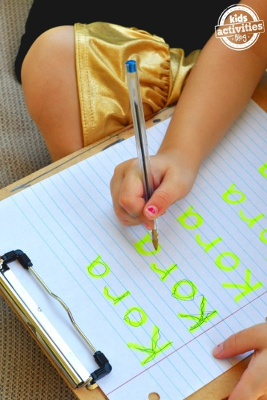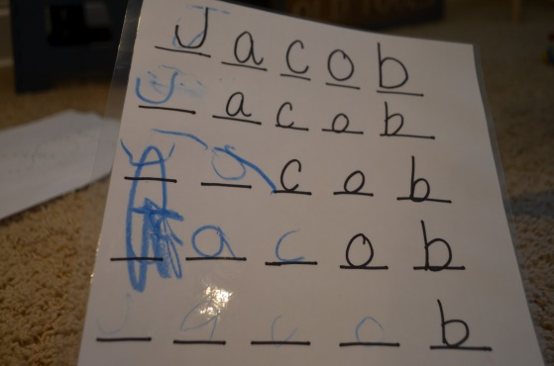  Multisensory writing- they could copy their name using lots of things you have around your home. E.g. in salt, using lego, playdough, cars and paint ...  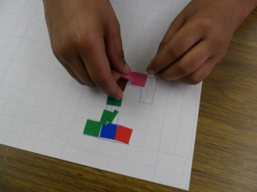  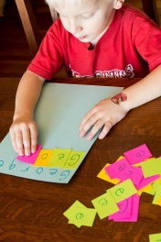
Skill building Activities | Physical Activities  Choose 1 of the following:  - Practice cutting skills (cut out old cards/newspapers/magazines)  - Build create models using playdough, building blocks, lego, tin cans.  - Play a board game or complete a jigsaw  - Children can practice getting dressed themselves  - Make pasta or cheerio necklaces  - Make an obstacle course  - Practice throwing and catching  - Make up a Christmas dance  - Help make lunch e.g. butter the sandwiches  Creative Activities  Choose one Christmas decoration and make it for your home.  - Design and create a Christmas wrapping paper – you might like to print potato’s  https://www.redtedart.com/paper-plate-christmas-tree-whirligig/  https://www.gathered.how/arts-crafts/christmas-crafts-for-kids/  Useful Websites (free – no sign up required)  - www.twinkl.co.uk a range of free resources  - www.topmarks.com lovely interactive eductaional games  - www.activityvillage.co.uk – lots of lovely crafts  - Numberblocks and Alphablocks on BBC iPlayer - CBeebies  Useful Educational Apps:  - Hairy letters  - Glitter draw  - Twinkl alphabet cards and letters  - BlobbleWrite  - Meet the number blocks  - Number blocks hide and seek  - Number blocks card fun

