Year 3 and Year 4 Home Learning Tasks
Week Beginning: 6th July 2020
This week’s continent is: South America.
Choose a country within South America to complete your tasks.

Subject/Area of Learning | Weekly Tasks
Daily Tasks | These are tasks that you do every day in school, try to make sure you are still doing them at home.  - Read for at least 10 minutes. You can read a book, comic or an article online.  - Practise your times tables for the week (you could recite them, sing a Percy Parker song or play on TT Rockstars/J2Blast).  - Ask your family a question in Welsh. (Sut wyt ti heddiw? Sut mae tywydd heddiw? Ga i … os gwelwch yn dda? Beth wyt ti’n hoffi fwyta/chwarae/gwisgo? Oes gyda … ti? Ble mae …?)  - Watch Newsround on CBBC.
Read Write Inc | In school you have RWI sessions every day because it is very important to practise your sounds to help you read and spell well. You should try and watch these videos every day – they don’t take long!  YOUTUBE SPEED SOUNDS LESSON SCHEDULE  Daily lessons can be found on YouTube (click on the link below), for the sounds and corresponding green words that you are learning. New films will be released at the times shown Monday to Friday. Each film is approximately ten to fifteen minutes long and will be available on YouTube for 24 hours. Remember to only watch videos for the set of sounds that you are learning – Set 1, Set 2 or Set 3.  Timings of daily lessons:  Set 1: Time (AM)  Speed Sounds 9.30  Word Time 9.45  Spelling 10.00  Set 2:  Speed Sounds and Word Time 10.00  Spelling 10.15  Set 3:  Speed Sounds and Word Time 10.30  Spelling 10.45  https://www.youtube.com/channel/UCo7fbLgY2oA_cFCIg9GdxtQ  Speed sound lesson videos to be shown on YouTube this week:  Set Mon 6th July Tues 7th July Wed 8th July Thurs 9th July Fri 10th July  1 sh th ch qu ng  2 ee igh ow oo (poo in the zoo) oo (look at a book)  3 er ow ai oa ew  Reading Longer words oy/oi ay/a-e/ai igh/i-e ow/o-e/oa oo/u-e/ew  (2 Dojos will be awarded for evidence of daily sound)  Additional Speed Sounds Resources:  If you wish to further practise your child’s set of speed sounds, the sounds can be found as flashcards by clicking on the links below:  Set 1 Sounds:  http://d6vsczyu1rky0.cloudfront.net/30851_b/wp-content/uploads/2020/03/Set-1-Speed-Sounds-Flashcards.docx  Set 2 Sounds:  http://d6vsczyu1rky0.cloudfront.net/30851_b/wp-content/uploads/2020/03/Set-2-Speed-Sounds-Flashcards.docx  Set 3 Sounds:  http://d6vsczyu1rky0.cloudfront.net/30851_b/wp-content/uploads/2020/03/Set-3-Speed-Sounds-Flashcards.doc
English/  Literacy | Task 1 (1 Dojo)  A lot of South America is made up of Rain Forests which are sadly being destroyed by humans. Can you design a poster that raises awareness of the issue? Include -  - a catchy title  - at least 4 facts  - Pictures illustrating the problems  - People who are trying to help  There is an example below to help you.  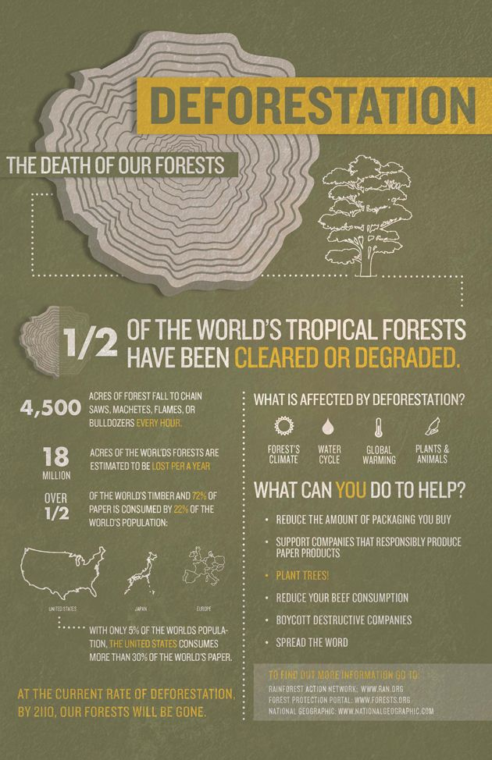  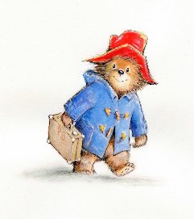Task 2 (1 Dojo)  Paddington Bear comes from deepest darkest Peru in South America. Have you watched the film or read a book about Paddington Bear? Can you write a review on it? Give it a star rating and discuss what happens.  Include -  - Main characters  - Plot outline  - Your opinion  - Favourite part  - Least favourite part.  Below is a link to a cartoon if you are not sure who Paddington Bear is  https://youtu.be/qxL_1bvPGkw  Complete your review using JiT or J2Write.  Task 3 (1 Dojo)  Research what native animals are common in the country of your choice? Create a fact file or a non-chronological report about one native animal.  Challenge! (1 Dojo)  Endangered Species – Research if there are any endangered species in your country of choice. This task will be ongoing until the end of term and will be added to weekly. Create an ongoing PowerPoint presentation or a paper-based information booklet to raise awareness of these endangered species. Research what can be done to help and protect these animals.  Extra Challenge (2 Dojos)  Can you write these 5 red words in 3 different ways? For example using pebbles or stones or sticks or if you’re on the beach in the sand. Be as imaginative as you can! Take photos and send them to me so I can award you extra Dojo points!  Walk  Wear  Above  Everyone  My
Maths/  Numeracy | Weekly Times-Table Focus: Revise x10  Click on the link below to listen to a fun 10 times table song.  https://www.youtube.com/watch?v=8yxMJUHBslY  Practice recalling the 10 times-table starting from 1 x 10 up to 12 x 10. How fast is your recall? Try timing yourself. Can you beat your time?  Practise counting forwards and backwards in steps of 10 eg:  10, 20, 30, 40 etc …  120, 110, 100, 90 etc ...  Ask a member of your family to test you using random questions such as: 10 x ... = ... x 10 = How many 10’s are in ...?  Upload a video of yourself practising your times-tables for 1 extra Dojo point.  Task 1 – 2D Shape - Identifying 2D shapes (1 Dojo Point)  2D shapes are flat shapes.  Regular 2D shapes have equal sides and equal inside angles.  Irregular 2D shapes have sides and angles of any length and size.  - Use your research skills to find out and record the names and properties of:  - a 9-sided 2D shape and a 10-sided 2D shape.  - Draw a regular 9-sided 2D shape and a regular 10-sided 2D shape.  - Draw different examples of irregular 9-sided and irregular 10-sided 2D shapes. How many can you come up with?  - Present your work in a format of your own choice: eg: on paper, JiT, power-point, using natural materials, etc... Remember to upload a photo of your work if you present it on paper or use natural materials.  Task 2 – Topic Numeracy Challenge (1 Dojo Point)  This task links in with your topic work about Countries and Cultures.  This week you are on the continent of:  South America.  Your task is to create a mini fact-file about your chosen country by researching the following information:  - Country size  - Population  - Currency  - Average temperature in Summer (in °C)  - Average temperature in Winter (in °C)  - Position on map of _______________  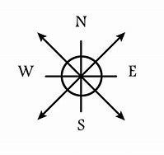  Task 3 – Time – Daily Routine (1 Dojo Point)  The minute hand and the hour hand on an analogue clock tell us what the time is.  Click on the link below to watch a short video clip to learn how to tell the time on a clock. Then practice telling the time with the activity and quiz below the video.  https://www.bbc.co.uk/bitesize/topics/zhk82hv/articles/zcmdwxs  There are 24 hours in one day, but the day can be measured by splitting it into two halves. The first 12 hours of the day - from midnight to midday - are called AM, and the next twelve hours are called PM.  Click on the link below to watch a short video clip to learn how to tell the time on analogue and digital clocks. Then complete the activity and quiz below the video.  https://www.bbc.co.uk/bitesize/topics/zkfycdm/articles/zcrmqty  We have now been in lockdown for 14 weeks. You have probably noticed that your normal daily routine has had to change to what you are used to.  - Create a ‘timetable’ to show your daily ‘lockdown’ routine. You can present your work in a format of your own choice, or you can use the ‘Editable Time Resource Sheet’ attached.  - You need to write down at least 8 different activities that you usually do throughout the day.  - Record the time of each activity on an analogue clock. Remember the minute hand is longer than the hour hand on an analogue clock (see the example below).  - Under the analogue clock, write the time in words eg: ‘quarter to seven’  - Then record the digital time eg: 06:45.  Extra Challenge:  - Work out how long you spend doing each of your activities (approximately).  Click on the link below to play a fun, interactive telling the time game to develop your skills further.  https://mathsframe.co.uk/en/resources/resource/116/telling-the-time
Topic Work | Each week the children will be learning about a country from one of the seven continents. The following tasks will remain the same every week. This will enable them to develop their knowledge and understanding of different countries around the world and to make comparisons between them.  Task 1 – South American Country Flags Chili Challenge (1 Dojo Point)  What does your chosen country’s flag look like?  Mild Chili Challenge – Draw a picture and colour your chosen country’s flag and upload a photo onto your Hwb account.  Spicy Chili Challenge – Use the paint tool on Jit5 to draw your chosen country’s flag.  Hot Chili Challenge – Use anything crafty or recycled to create a 3D picture of your chosen country’s flag.  Task 2 – Create a Top Trump card (1 Dojo Point)  The aim is to create a collection of Top Trump Cards for different countries over the next coming weeks. You may present/organise your information in any way you wish but make sure to save it or upload a photo.  You need to include the following sub-headings to organise your information:  - Capital city  - Population  - Spoken language  - Currency  - Famous landmarks  - Traditions  - Bordering countries  - Famous people  - Popular activities/sports  Task 3 – (1 Dojo Point)  Geographical features of your country of choice -  First click on the link below to learn about geographical natural and human features.  https://www.youtube.com/watch?v=RkHsBvjcYRk  Next, save an image of your country on a map and upload it onto a Jit document.  Then find out about three human and three natural features from your chosen country. Upload images of these features and label them.  For a bonus Dojo point, find out some interesting facts about each of these features. You could present your work on Jit (Mix), PowerPoint or on paper.
Creative/  Physical | Task 1 – Famous Artists or Artwork 1 Dojo Point  Does the country of your choice have indigenous art or famous artists? Find examples and create your own piece of artwork in the style. You can do this on paper or on Jit.  Task 2 – Traditional Music and Musical Instruments 1 Dojo Point  Research what music and musical instruments are traditional in your chosen country. Use recycled materials to make a musical instrument that represents your country of choice.  Task 3 – Popular Sports or Dances 1 Dojo Point  Popular sports/dances in your country of choice – Research what sports or dances are traditionally performed in your chosen country. Upload a 15 second video of you performing your activity linked to your country of choice!
ICT | Task 1 – Google Translate 1 Dojo Point  What language is spoken in your chosen country? Can you use Google Translate to find out how to say ‘Hello’, ‘Goodbye’, ‘Please’ and ‘Thank you’? Record this on a Jit document or on paper.  Task 2 – Branching Databases 1 Dojo Point  You are going to create a branching database about animals found in your chosen country. First, click on this link for a refresher about how to make a branching database: https://www.j2e.com/help/videos/datags3  Next, go to Jit and then click on ‘Branch’ at the top. Create a branching database about animals found in the country of your choice.  Task 3 – Internet Research and saving images 1 Dojo Point  Global Cuisine – Research what foods are eaten in your country of choice. Create a menu which showcases these foods. You must include a starter, main course, dessert and a drink. Use illustrations to decorate your menu. 2 Bonus Dojo points awarded if you cook one of the dishes in your home!

