Reception Home Learning Activities
Date of Work Set:
8th June 2020
The activities and links to resources for this week can be found in the table below.
Each week, literacy (Read Write Inc), and numeracy activities will be set as a ‘DAILY MUST’. We have named these activities a ‘Daily Must’ as they are vitally important to ensure that your child’s academic skills do not significantly decline during these uncertain times (these activities will be mostly revision of topics already covered). As well as the ‘Daily Must’ activities, we are setting a topic work, creative, outdoor and ICT tasks which your child can complete if they so wish.
. Activities can be recorded online using ‘Jit’ or on paper. Any activities recorded on paper can be shared with class teachers in photo form either as a Dojo message or a photo uploaded to Hwb using ‘My Files’ within ‘Just2easy’.
Daily  Must  Speaking and Listening | 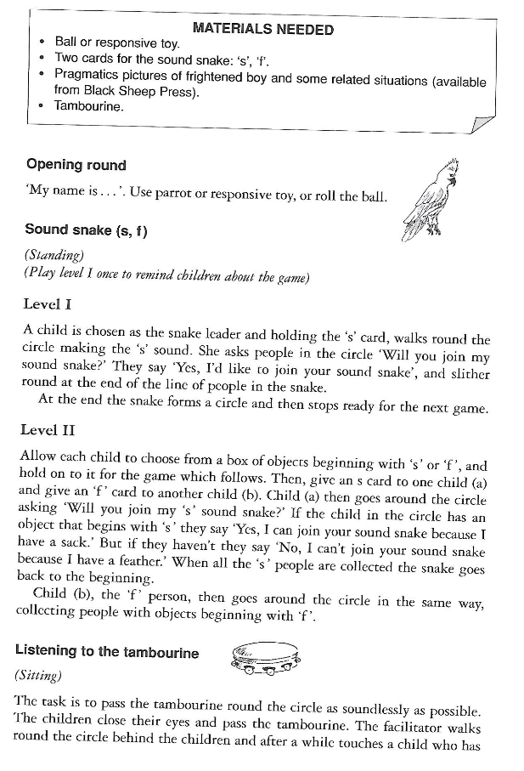  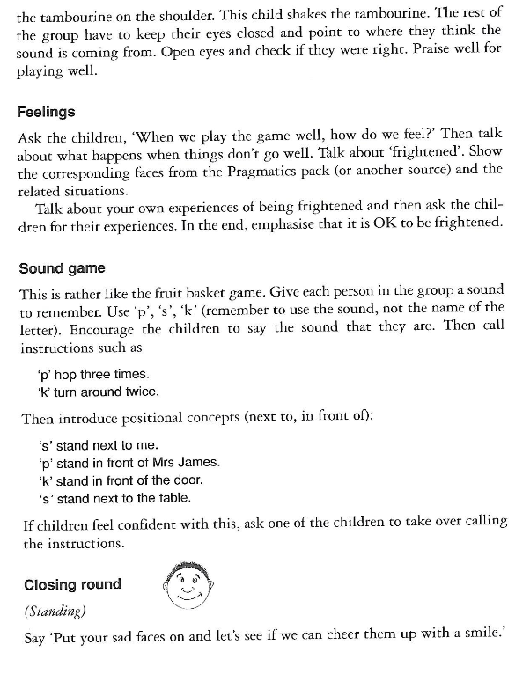
Daily  Must:  Literacy:  Read Write Inc | Activities:  Speed Sounds and Green Words  Daily practise of the sounds at speed and reading the ‘Green’ words using ‘Special Friends - Fred Talk - Read the Word’ strategy. The sounds and words are available as daily lessons on YouTube or can be taught using the flashcards (see links further on).  YOUTUBE SPEED SOUNDS LESSON SCHEDULE 1st June –17th July Information  https://www.youtube.com/channel/UCo7fbLgY2oA_cFCIg9GdxtQ  Daily lessons can be found on YouTube (click on the link above), for the sounds and corresponding green and red words that your child is learning.  Remember to only watch videos for the set of sounds that your child is learning – Set 1, Set 2 or Set 3.  All films will now be released at 9.30am from Monday to Friday. Each film is approximately ten to fifteen minutes long and will be available on YouTube for 24 hours. So that lessons are not repeated, from June 1st, Set 2 and 3 Speed Sounds lessons will include new words for reading and spelling.  *New daily films *  (All films will be in separate categories on the YouTube channel):  - Read Red Words 1: for children who are reading Red, Green, Purple, Pink and Orange Read Write Inc.Storybooks.  - Read Red Words 2: for children who are reading Yellow, Blue and Grey Read Write Inc.Storybooks.  - Read and Hold a Sentence 1 (from 15thJune): reading and writing practice for children reading Green, Purple, Pink and Orange Read Write Inc. Storybooks.  - Read and Hold a Sentence 2 (from 15thJune): reading and writing practice for children reading Yellow, Blue and Grey Read Write Inc. Storybooks.  - Read longer words: for children who can read Set 3 sounds and words confidently.  See https://www.ruthmiskin.com/en/find-out-more/parents/  for information about Read and Hold a Sentence and Red Words. This site also includes useful films for parents/carers showing how Read Write Inc teaches children to read and write.  Speed sound lesson videos to be shown on YouTube this week:  Set Mon 8th June Tues 9th June Wed 10th June Thurs 11th June Friday 12th June  1 i n p g o  2 oo - look at a book ar or air ir  3 u-e aw are ur er  3 – Reading longer words oo/u-e/ew or/aw air/are ir/ur/er ou/ow  (2 Dojos will be awarded for evidence of daily sound and corresponding green word work)  Additional Speed Sounds Resources:  If you wish to further practise your child’s set of speed sounds, the sounds can be found as flashcards by clicking on the links below:  Set 1 Sounds:  http://d6vsczyu1rky0.cloudfront.net/30851_b/wp-content/uploads/2020/03/Set-1-Speed-Sounds-Flashcards.docx  Set 2 Sounds:  http://d6vsczyu1rky0.cloudfront.net/30851_b/wp-content/uploads/2020/03/Set-2-Speed-Sounds-Flashcards.docx  Set 3 Sounds:  http://d6vsczyu1rky0.cloudfront.net/30851_b/wp-content/uploads/2020/03/Set-3-Speed-Sounds-Flashcards.docx  Additional Green Word Resources:  If you wish to further practise reading and spelling the ‘Green Words’ used in the Read Write Inc programme, all of the words can be found as flashcards by clicking on the link below:  Set 1 Green Words:  http://d6vsczyu1rky0.cloudfront.net/30851_b/wp-content/uploads/2020/03/Green-Word-Flash-Cards-1.1-1.7.docx  Set 2 Green Words:  http://d6vsczyu1rky0.cloudfront.net/30851_b/wp-content/uploads/2020/03/Green-Word-Flash-Cards-Set-2.docx  Red Words  Daily practise of reading and spelling the ‘tricky’ words set for your child’s RWI colour group and then carry out a spelling test on these words on Friday. Remember that your child only has to learn the red words for their RWI colour group.  Click on the link below to find the ‘Red’ word spellings to be learned this week:  https://sandfields-primary-school.j2bloggy.com/blog/read-write-inc-red-word-spelling-lists-for-week-beginning-20-4-2020/  If you wish to further practise your child’s set of ‘Red Words’, all red words and the full list of red words for different RWI groups can be found by clicking the links below:  Red Words  Red Words Spellings for Different Read Write Inc Groups  Reading a Book  Why not bring all your different reading skills together in order to read a book independently?  Try to read part of an eBook, or a book that you have at home every day.  Click on the link below to read a Read Write Inc eBook online (choose ‘Read Write Inc’ in the ‘Levels’ dropdown menu) or an Oxford eBook:  https://www.oxfordowl.co.uk/for-home/find-a-book/library-page/?view=image&query=&type=book&age_group=&level=&level_select=&book_type=&series=#
Daily  Must:  Numeracy  For  Reception and Mrs Pugsley’s group | Daily Warm Up  *Daily practice counting forwards to 20 and backwards from 10.  Counting on your fingers – waking them up when counting forwards and sleeping (putting them down) when counting backwards.  - Choose, sing and act out a number song of their choice e.g. 5 little speckled frogs, 5 little ducks, 10 green bottles, 5 little monkeys jumping on the bed, 5 current buns in a bakers shop (see useful resources)  Activity 1 – Number bonds to 10  Ask your child to explore different ways of making 10 on a tens frame (See resources) using two different coloured counters or any loose parts with two distinct groups e.g. two sets of different coloured buttons, painted pasta, stones or shells.  For Example:  To support them you could partly fill the 10 frame and ask how many more items are needed to fill the whole frame?  Please take photos or your child could draw the different combinations - 2 dojos will be rewarded for the completion of this task.  Activity 2 – Memory Game  Print out tens frame cards showing numbers 1-10 (see resources)  If you do not have a printer you could draw them.  Place the cards upside down so your child cannot see the dots. You and your child take it in turns to turn over 2 cards. When a pair adds up to 10 who ever turned them over keeps the cards. The player who collects the most cards wins.  2 dojos will be rewarded for photographic evidence provided  Activity 3– Create a number bonds to 10 poster/artwork  Create a rainbow cloud from any materials you have at home. Or draw, colour and cut out a cloud and strips of colours. Write on each strip of paper a different way to make 10.  See the example 1:  OR  Create a simpler poster just by drawing around your child's hands and cutting them out:  You may like to put this up in your child’s bedroom or on the fridge so every time they see it you can test them, as Number bonds need to be learnt off by heart.  For example: Ask them what do you need to add to 6 to make 10? Encourage them to look at their artwork or ask them to fold 6 fingers down. How many are left standing (answer is 4) Say 6 + 4 = 10 and get them to repeat it back to you.  (2 dojos will be rewarded for the completion of only one of the above posters)  Activity 4 – 10 hunt  Hide 10 items (action figures, play food, cuddly toys, flowers) around your home or garden.  Chalk a tens frame outside or use string or masking tape to map out a tens frame on the floor in your home. Ask your child to find the items and place them into the tens frame. How many have you found? How many are still hiding?  Here are some different ideas of making a 10’s frame:  10’s frame created with sticks Drawn on cloth  Created with electrical tape  Remember to take photos – 2 dojos will be rewarded for the completion of this task.  Activity 5 – Number bonds to 10 activity booklet  The booklet to be completed over the next 3 weeks.  2 dojos will be rewarded for each activity completed in this booklet NOT for each page completed (dojo rewards are highlighted in the booklet)  If you are unable to print this activity just choose one or two activities to copy or please let the class teacher know and they will advise an alternative activity if you wish.  Activity 6 - Online game  For 2 Dojo’s choose 1 game to play:  https://www.nctm.org/Classroom-Resources/Illuminations/Interactives/Ten-Frame/  OR  https://www.twinkl.co.uk/go/resource/T-GO-01-number-bonds-1-to-10
Art Project | Famous Artists  To be completed over 3 weeks  (Dojo points will be allocated by your teacher depending individual efforts)  Look at different artists work (see resources) and choose one that you really like.  A list of suitable Artists:  Claude Monet  Van Gogh  Andy Goldsworthy - (Great for using natural materials)  Mary Lloyd – Jones (Welsh artist - fantastic for younger children to recreate)  William Morris  Leonardo Da Vinci  Pablo Picasso  Henri Matisse  Frida Kahalo  Piet Mondrain  Andy Warhol  Jackson Pollock (great for younger children – splatter paintings)  Georgia O-Keefe  Giuseppe Arcmboldo (used food)  Wassily Kandinsky  Salvador Dali  (you do not have to choose from this list)  Useful websites:  https://thecraftyclassroom.com/crafts/famous-artist-crafts-for-kids/  https://www.bbc.co.uk/bitesize/topics/zdgrd2p/resources/1  https://www.coolkidfacts.com/famous-artists/  https://www.123homeschool4me.com/famous-artists-art-projects-for-kids/  https://www.youtube.com/watch?v=BQm5zQI8BBc  Activity 1 – recreate a piece of famous artwork  Recreate one of your favourite masterpieces from your chosen Artist using materials of your choice e.g.  Pencils, pens, paint, chalks, collage materials, playdough or computer –hwb - JIT – paint tool. Here are some examples:  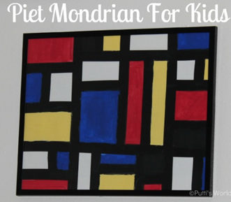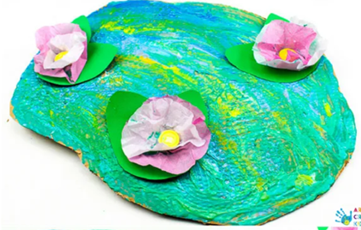  A recreation of Piet Mondrain’s painting A recreation of Claude Monet’s Water Lillies  (using masking tape/black card and paint) (using chalks, crayons, paint, card and cake paper cases)  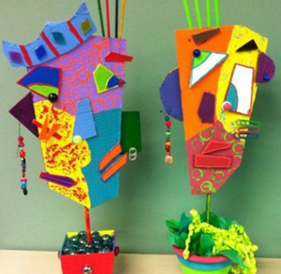  A child’s representation of Picasso using collage materials  Or  Recreate your favourite masterpiece using items found around your home and take a photo.  Here are some examples:  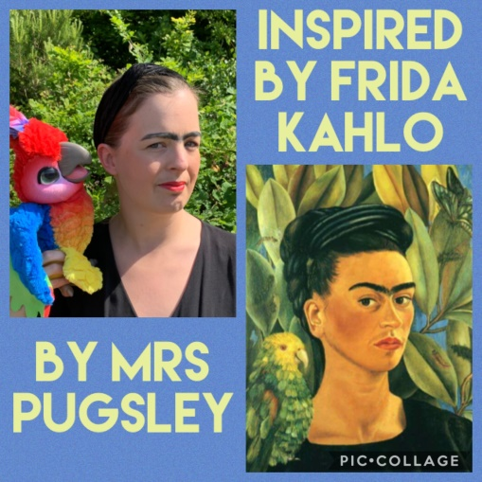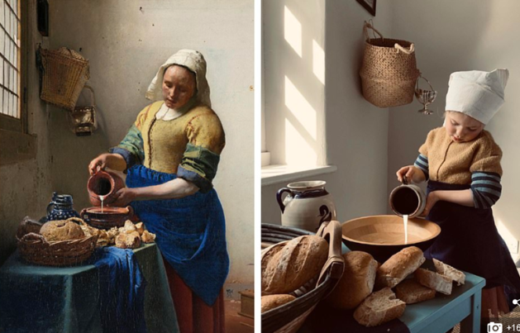  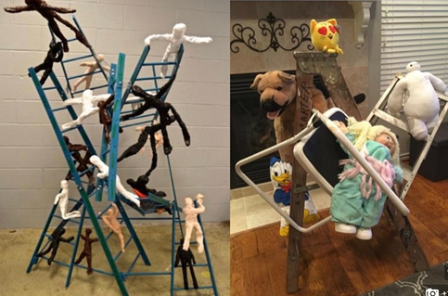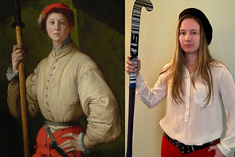  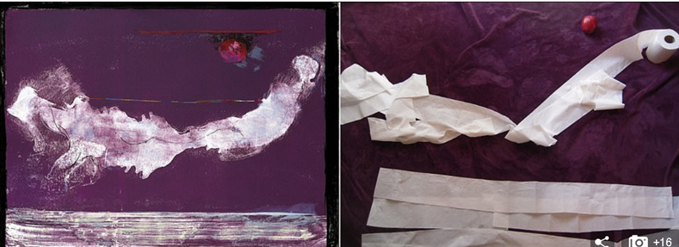  Or  Recreate your favourite masterpiece using natural materials.  Here are some examples:  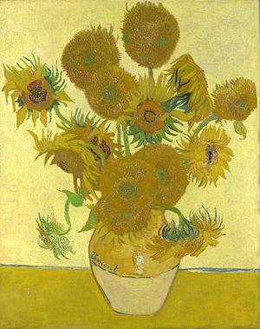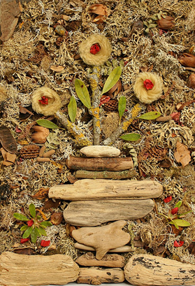  Van Gogh The Sunflowers A Child’s representation  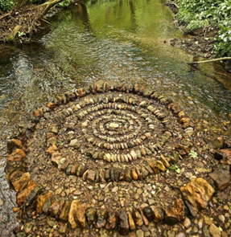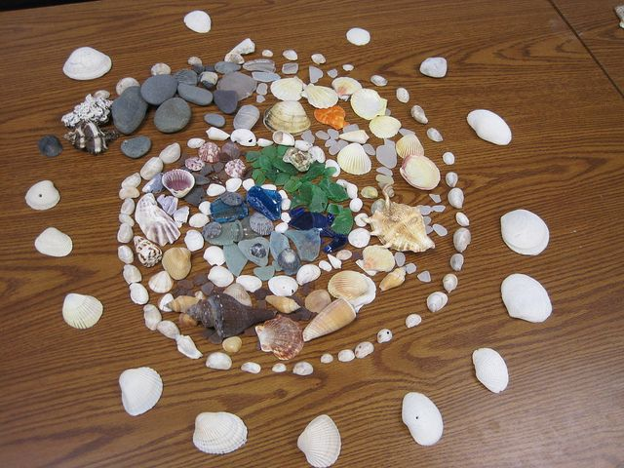  Artwork by Andy Goldsworthy A child’s representation  Why not try all three ideas?  Activity 4 – Evaluate  Ask a grown up to record you saying one thing that you like about the artists masterpiece and one thing you do not like using an i-pad or phone or they can scribe for you.  Why not evaluate your own piece of work too!
About me  Project | All About Me Project  To be completed over 3 weeks  (Dojo points will be allocated by your teacher depending individual efforts)  Over the next three weeks, can you produce a project based on yourself? Your project will be shared with your teacher and other children when you return to school.  It is totally up to you how you create and present your project whether it be written on paper, presented within a scrapbook, poster, collage or created in digital form.  Below you will find a list of possible ideas to use, however, you can be as imaginative and creative as you want.  Possible pages you could include:  - Your name, age and date of birth  - Your appearance  - Where you live - your address and who you live with (you could use Google Maps to find your house)  - Any pets you may have  - Details of your home, e.g. semi-detached house with six rooms and a garden (possibly describe your bedroom)  - You family and friends - you could draw portraits/make a collage of people who are special to you  - What hobbies/interests you have - sports/creative etc  - Your favourite things, e.g. colour, food, animal, place etc.  You could add some Welsh details to your project using the patterns below that you are familiar with:  Pwy wyt ti? … dw i.  Sut wyt ti? Dw i'n …

