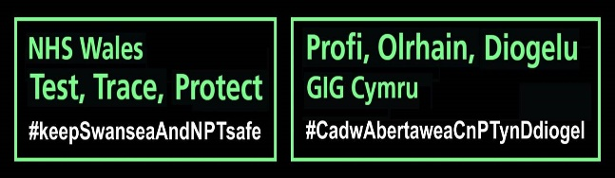

Dear Sir/Madam

I hope this letter finds you well. We are contacting all schools in Neath Port Talbot area to provide information on what you can expect from the NHS Wales Test, Trace and Protect service from the start of the September term. As you may be aware, the service aim is to help reduce the spread of coronavirus by providing advice to confirmed cases of COVID 19 and their contacts.

We are urging school to raise awareness of the service amongst employees /parents/ guardians/pupils as part of efforts to prevent the spread of the virus.

Please see attached a document entitled ‘TTP Information for Schools’ which is specifically for the attention of staff members and parents/guardians of pupils. It focuses in on what they can expect should they receive a phone call from our team. We urge the dissemination of this information as a part of our collective efforts to prevent the spread of the disease.

We are aware that you have been made aware of an abundance of guidance, including the following which are useful links and updated regularly. Please retain for reference and refamiliarisation:

1. <https://gov.wales/education-coronavirus>
2. <https://gov.wales/keep-education-safe-operational-guidance-schools-and-settings-covid-19>
3. <https://www.gov.uk/government/publications/covid-19-decontamination-in-non-healthcare-settings/covid-19-decontamination-in-non-healthcare-settings>

By following and implementing the controls you have identified, it is hoped that your individual systems work well to prevent any issues from arising.

However, there is always a possibility of **cluster** of cases linked to a school setting. Should this happen at your school, the following is some information about what you can expect to happen.

In the event that you become aware of cases of staff/pupils at the school you need to contact us via [trackandtrace@npt.gov.uk](mailto:trackandtrace@npt.gov.uk) or 01639 686932 (to leave message)

A member of the Regional TTP team will contact the Head of the school to request assistance with the investigation. The type of information that we will need will relate to:

1. Information specific to the school e.g. number of sites/buildings; number of children and arrangement of ‘bubbles’ etc.; staff information; any vulnerable adults/children.
2. Arrangement regarding social distancing, use (if any) of PPE. Compliance with all relevant guidance.
3. Confirmed and possible cases in children and which small group or cohort (classes, groups and year groups etc.) they attend; include symptomatic children awaiting testing and any known to have been hospitalised.
4. Confirmed and possible cases in staff (to include symptomatic staff awaiting testing and any known to have been hospitalised); their roles and groups they interact with, including checking whether staff move between sites if applicable
5. Onset dates of cases and symptoms of cases (dates of test where asymptomatic)
6. Any family members of cases who also attend the setting
7. Potential number of contacts meeting contact definitions; including visitors (e.g. parent, governors, professional visits, supply teachers) in the relevant time period may be contacts
8. The operational impact on the educational or childcare setting thus far of cases and self-isolation of contacts and likely impact of any new self-isolation.
9. Communication with parent/guardians thus far, with information on what has been sent out to date

The above is not an exhaustive list, obviously each situation will be different, so there may be other/different information that we need your assistance with.

We will also be available to assist with any questions or queries you may have and will help you as much as we are possibly able to.

By working together we’ll be able to play our part in enabling the Welsh Government to ease lockdown restrictions and encourage economic recovery in our communities, and together we’ll help keep Swansea and Neath Port Talbot safe.

If you wish to discuss anything in this letter further, please contact the Regional TTP team on: [trackandtrace@npt.gov.uk](mailto:trackandtrace@npt.gov.uk)

Yours faithfully

**NHS Test Trace Protect Team**

**Encl**: Test, Trace and Protect (TTP) Overview: Information for Staff/Parents /Guardians.