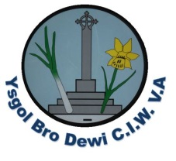
Weekly Letter Ysgol Bro Dewi
Please see the table below outlining activities/events for the week beginning 2nd July 2018
NO afterschool clubs – 3pm finish for all pupils.
Monday/Dydd Llun | Year 5 Solva pupils visiting Bro Dew.  Mrs Lewis – Brass and Recorders
Tuesday/Dydd Mawrth | Swimming this week for year 6 and Reception
Wednesday/Dydd Mercher | PE for years 3,4,5 & 6  PE for nursery.
Thursday/Dydd Iau | New nursery part time pupils’ trial morning.
Friday/Dydd Gwener | Rugby for selected pupils at Fishguard.
Thursday 5th July Yr 6 pupils – YDS Transition Day
Friday 6th July Fun rugby festival
Wednesday 11th July Sports Day and BBQ lunch
(Nursery/reception 10-11am) Rest of school 1.15pm
Monday 16th July Folly Farm trip for all full time pupils
Tuesday 17th July Music Assembly 9.30am
YDS Summer concert- selected pupils
18th – 19th July Exhibition of work for the community
Wednesday 18th July Football and Netball at Roch school
Thursday 19th July Cathedral Service – 10am (School closure service)
Friday 20th July Disco and party for all pupils. School finishes
Diolch Mrs S Osborne

