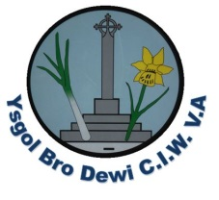
Weekly Letter Ysgol Bro Dewi
Please see the table below outlining activities/events for the week beginning 30th April 2018/Wythnos dechrau yr 30 o mis Ebrill.
Monday/Dydd Llun | Urdd rugby for selected boys and girls at Neyland RFC. Arrive in school 8.40, return before the end of the school day.
Tuesday/Dydd Mawrth | Cricket for years 1-4  Book Fair arrives - Pupils can buy books during school time.  3.00 - 4.15 (If anyone is available to help to sell books please let us know)
Wednesday/Dydd Mercher | National Tests begin.  Book Fair - Pupils can buy books during school time and after school - 3.00 - 4.15  PE for years 3,4,5 & 6  PE for nursery.
Thursday/Dydd Iau | National Tests  Book Fair after school 3.00 - 4.15  Woodwind instruments.  Brass Instruments & recorders.  String Instruments.  *MEETING FOR PARENTS - About Ysgol Penrhyn Dewi 4.30pm - our school hall.
Friday/Dydd Gwener | National Tests
National Test Dates – 3rd to 9th of May. We would appreciate you not booking appointments during this time.

Please see our School Twitter feed celebrating the success of our pupils throughout the term.

Monday May 7th Bank Holiday Monday - Enjoy!
May 14th to 18th – year 5&6 residential week at Llanion Cove.
Attendance leaders and school council say
‘Aim for 100% attendance and 300 Dojo points this term!’

Diolch

S Osborne

