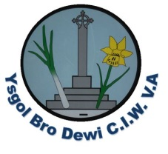
Weekly Letter Ysgol Bro Dewi

Please see the table below outlining activities/events for the week 26th February 2018
Monday/Dydd Llun
Tuesday/Dydd Mawrth | Criw Cymraeg visiting Holy Name, Fishguard
Wednesday/Dydd Mercher | PE for year 3,4 5 & 6.  PE for nursery.
Thursday/Dydd Iau | St Davids Day – Service in Cathedral 10.00 am  Woodwind instruments  Brass Instruments & recorders  String Instruments  Area Orchestra 3.45 – 4.45 pm
Friday/Dydd Gwener | World Book Day Activities
Saturday | Dragon Parade – 11.00 am Oriel y Parc

St Davids Day – Schools service with YDS in the Cathedral at 10.00 am for full day pupils only. Junior pupils to wear full school uniform. Infant pupils to wear either National Costume or full school uniform.
World Book Day – children will not be dressing up this year but there will be a range of activities linked to the occasion throughout the day.
Book Fair – this has been booked for the week commencing 5th March.
National Tests for years 2-6 May 2 – 9th 2018. We would appreciate it if you did not book a holiday or appointments for this week.

School Council say -
‘AIM FOR 100% ATTENDANCE’

Diolch Mrs S Osborne

