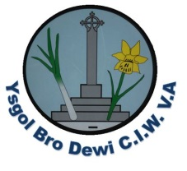
Weekly Letter Ysgol Bro Dewi

Please see the table below outlining activities/events for the week beginning 22nd January 2018/Wythnos dechrau yr 22ain o Ionawr.

Monday/Dydd Llun
Tuesday/Dydd Mawrth
Wednesday/Dydd Mercher | PE for years 3&4  PE for nursery.  YDS Pantomime for years 5&6 (Returning 3.30)  (Consent letter to follow)
Thursday/Dydd Iau | Woodwind instruments  Brass Instruments & recorders  String Instruments  Area orchestra.
Friday/Dydd Gwener

Foundation Phase would be grateful for any clean junk material please.

Diolch

S Osborne

