Pen Afan Primary School

is committed to

Safeguarding and Promoting the Welfare of Children and Young People

Feeling Safe…………………………………..………….

……………………………………….Feeling Secure



CHILDREN – *Please tell an adult if you have any worries – no matter how small*

STAFF – OUR PROMISE

WE WILL **LISTEN**, WE WILL **SUPPORT**, WE WILL **TAKE ACTION**

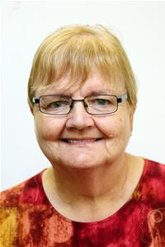 **Our Safeguarding Team:**

**Miss R. Gierat Lead Learner**

**Mr R. Appleby Head Teacher**

**Mrs. M. Goodridge Chair of Governors**

**Cllr J. Jones LEA Governor**

**Mrs. J. Jones Lead Learner**

**Lead Learner**