**‘PLAY BOX'**

@ Cymmer Library

2.00pm – 3.15pm

**\* Free Themed fun sessions (including; Crafts, Music Time, Sensory Play, Story Time, Tap Tap Box etc.) \***

**\* For children aged 1-year + parents/carers & extended family welcome \***

**\* If you require any further info please ring Gill (Flying Start) 07580 983089☺ or just pop along and join us on a Thursday☺ \***

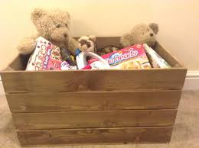

Ct