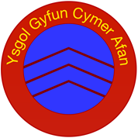

ASD Coffee Morning for Parents
Who can attend?
All parents of children in the Cymer Federation area (Primary School and Secondary School age) who have a diagnosis of ASD or are going through the diagnostic process are invited.
What is it about?
You will have the opportunity to meet the Neath Port Talbot Education Advisory Team for Children with ASD who will give information about training and set a future agenda based on your needs.
Where is it?
Cymer Afan Comprehensive School, 9 Brytwn Rd, Cymer, SA13 3EL

When is it?
Thursday 23rd May from 9.30 - 10.30a.m

Contact your school for further information

