Llangynidr Primary School
2017 Calendar
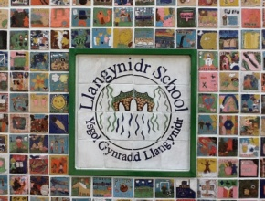
Handmade and Produced by
Dosbarth y Bryn

Name: .................................................
How Many Copies: .........................
Contact Number: .............................
Amount Paid: ...................................

