Getting to know you!
Dod i’ch ‘nabod
To help us to get to know your child quickly, please fill in this questionnaire and return it to school on their first proper visit on Wednesday 1st September.
Child’s name/Enw’r plentyn: ______________________

Has your child attended a playgroup/nursery/childminder?
Ydy’ch plentyn wedi mynychu Cylch, meithrinfa neu gofalwr plant?
___________________________________________________________
Did he/she enjoy the experience?
Oedd e/hi wedi mwynhau’r profiad?
___________________________________________________________
___________________________________________________________
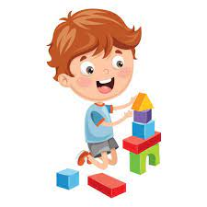
What does your child enjoy doing by himself/herself at home?
Beth mae eich plentyn yn mwynhau gwneud ar ei ben ei hun/ar ei phen ei hun gartref?
___________________________________________________________
___________________________________________________________
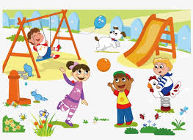
What does your child enjoy doing with others?
Beth mae eich plentyn yn mwynhau gwneud gydag eraill?
___________________________________________________________
___________________________________________________________

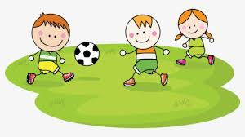
Does your child like to play outside? What does he/she like doing outside?
Ydy’ch plentyn yn hoffi chwarae tu allan? Beth mae’n hoffi gwneud?
___________________________________________________________
___________________________________________________________
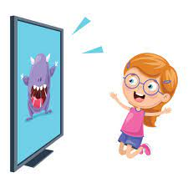
What’s your child’s favourite TV programme?
Beth yw hoff raglen deledu eich plentyn?
___________________________________________________________
___________________________________________________________
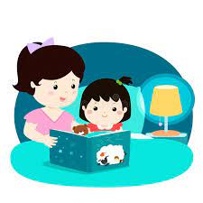
What’s your child’s favourite book or story?
Beth yw hoff lyfr neu stori eich plentyn?
___________________________________________________________
___________________________________________________________
What’s your child’s favourite toy?
Beth yw hoff degan eich plentyn?
___________________________________________________________
___________________________________________________________

Does your child mind being apart from you?
Ydy’ch plentyn yn poeni os nad yw e/hi gyda chi?
___________________________________________________________
Does your child worry about anything in particular?
Ydy’ch plentyn yn poeni am unrywbeth arbennig?
___________________________________________________________
___________________________________________________________
___________________________________________________________

Does your child have any hearing, sight, speech or physical difficulties?
Oes gan eich plentyn unrhyw anawsterau clyw, golwg, lleferydd neu gorfforol ?
___________________________________________________________
___________________________________________________________
___________________________________________________________
Does your child have any special dietary requirements?
Oes gan eich unrhyw ofynion bwyta?
___________________________________________________________
___________________________________________________________
___________________________________________________________

Does your child have any experience of another language?
Oes gan eich plentyn brofiad o iaith arall?
___________________________________________________________
___________________________________________________________
___________________________________________________________

Do you or your partner speak another language?
Ydych chi neu eich partner yn siarad iaith arall?
___________________________________________________________
___________________________________________________________
___________________________________________________________

Is there anything else you would like to tell us about your child?
Oes unrhywbeth arall yr hoffech ddweud wrthym am eich plentyn?
___________________________________________________________
___________________________________________________________
___________________________________________________________

Thank you for completeing this questionnaire.
Diolch yn fawr am gwblhau’r holiadur yma.

