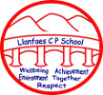
Busy Bodies
Summer 2017

Ambitious,
Capable learners.
Ethical, informed citizens of Wales and the World.

Enterprising
Creative contributors.

Healthy,
Confident individuals.
Health and Wellbeing.
Food Technology, P.S.E. and P.E.
* Performing dances using a range of stimuli
* Ball skills / Introduction to athletics
* Sports Day practice
* Special places inc. school & church
* Local places of worship
* What makes a good friend
* Feelings & emotions
* Healthy eating
* Dental hygiene
* Team building / self esteem building
* People who help us
* Kerbcraft – road safety training
Maths and Numeracy. Maths.
Role Play shop – using money
Rich Task – “Are people with bigger feet are always taller ?”
* Number – counting in 2’s, 5’s & 10’s, odd & even numbers, addition & subtraction
* Measure – comparing capacity using variety of containers
* Halves & doubles
* Using money – including role play area
* Block graph of eye / hair colour
* Maths games & investigations
* Abacus Maths scheme / Apex maths
Expressive Arts. Art, Drama and Music.
* Colour mixing
* Painting a self-portrait from observation
* Portraits of famous people
* Computer programme to draw faces (showing different emotions)
* Collage – healthy dinner plate
* Design & make a healthy fruit salad / kebab
* Printing
* Feel & keep a steady beat
* Listen & respond to different styles of music
* Sing a song in time & in tune
* Natural objects artwork – faces, patterns etc.
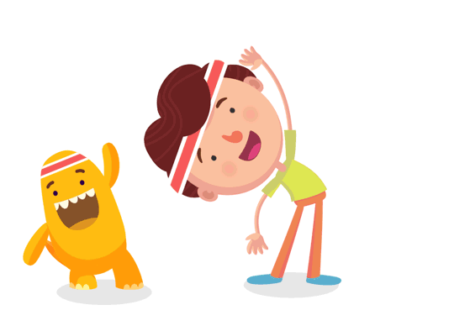
Language, Literacy and Communication. English and Welsh.
* Visit to Brecon Library? Rich task – “Are people with bigger feet always taller?”
* Letters & Sounds (Phases 4 & 5)
* Recount of personal events & experiences
* Personal descriptions
* Senses poem
* Story maps
* Develop writing using “Cornerstones for writing” programme (Genre - * Instruction writing * Non-chronological report * Fantasy story)
Welsh – greetings & personal information
* Tywydd a dillad (weather & clothes)
* Y Teulu (family ) * Y Fferm (farm) * Lliwiau (colours) * Ar lan y môr (At the seaside)
* Rhannau’r corff (Parts of the body) * Bwyd (food)
Science and Technology. Science, D.T. and I.C.T.
Making puppets – wooden spoon / sock puppets (Design, make & evaluate)
Marble Maze – using Lego / building blocks
Design & make a Lego car – test how far it travels on different surfaces
Programmable toys – Beebots / electronic toys
* Word processing skills * Block graphs & pictograms * Maths / language games * RM Colour Magic / 2simple2paint – creating animal pictures * I-pad Apps for literacy & numeracy
* The human body
* Teeth / bones
* The 5 senses
* Healthy bodies and how to stay healthy
* Mini beasts revisited
Humanities. History and Geography.
* Mini beasts revisited (in our locality)
* Our locality compared to another locality
* Using maps & globes
* Signs of Spring

Visit to “Camp Cynrig”, Cantref - forest trail / signs of Spring / promoting “Healthy living & eating”



