  A Bridge to Learning  A Bridge to Learning  Llanfaes C P School  Pont at Ddysgu | Ysgol Llanfaes  Llanfaes School  Newsletter June 2014 |  | 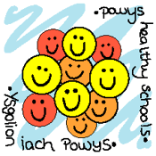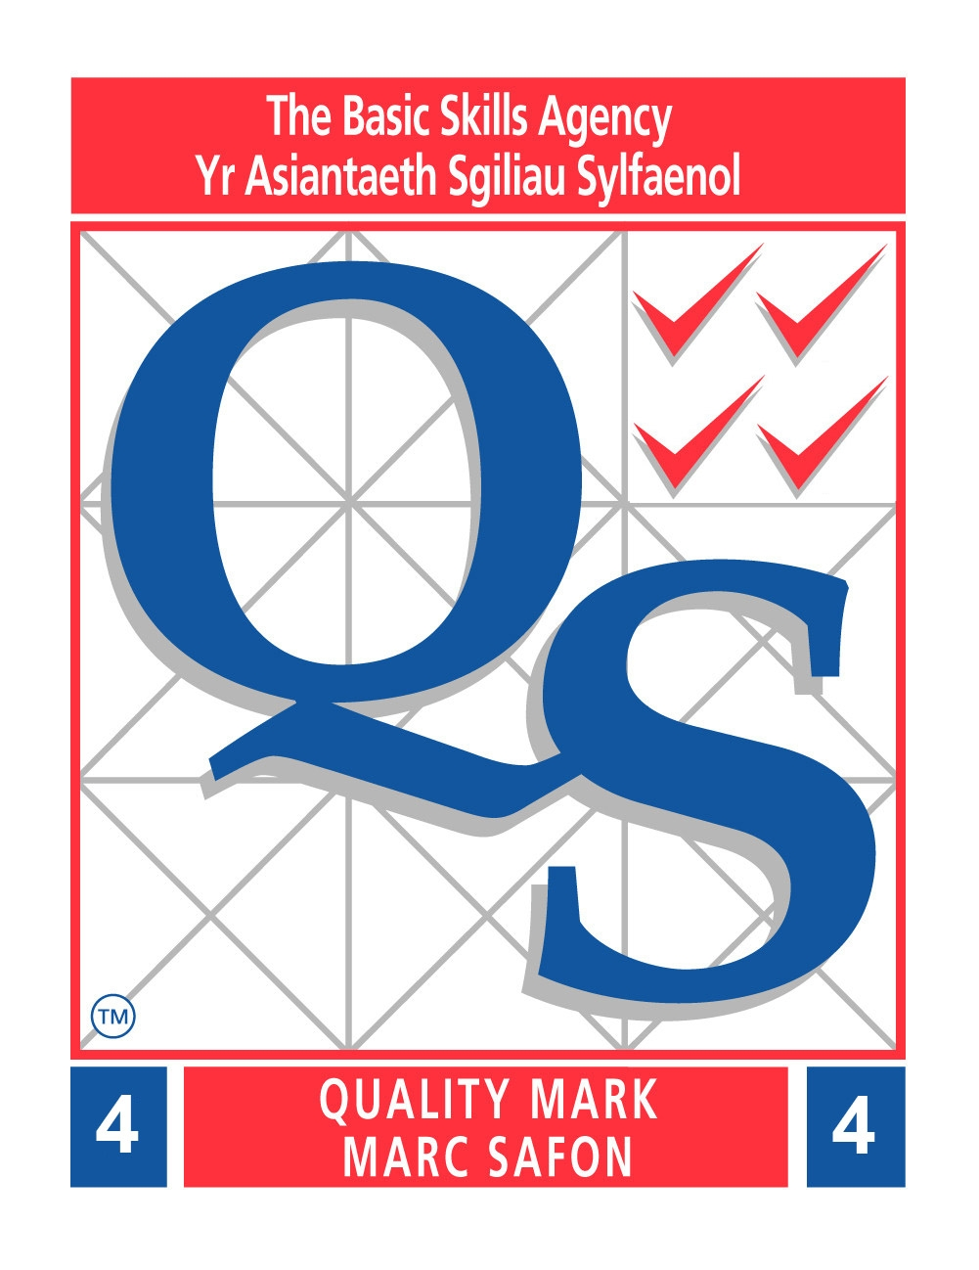
Diary Dates  June  4th – Class photograph Nursery & Y6 only  5th – Track & Field event Year 4  11th – Walking Bus 10 am  23rd – 27th HEALTHY LIVING WEEK  24th – School Grounds Day  26th – Sports Day  27th – Provisional Sports Day  30th – 2nd July – Y5 Staylittle  July  4th – School reports sent home  8th – Class Welcome meetings  11th – Transition Day – BHS and in school  15th - Y6 Leavers’ Concert 6pm  17th – Y6 Leavers’ Assembly 2pm  18th – End of year service 1.15 pm  School breaks for Summer Holidays  Autumn Term begins - Wednesday September 3rd |  | Reception visit to Garwnant  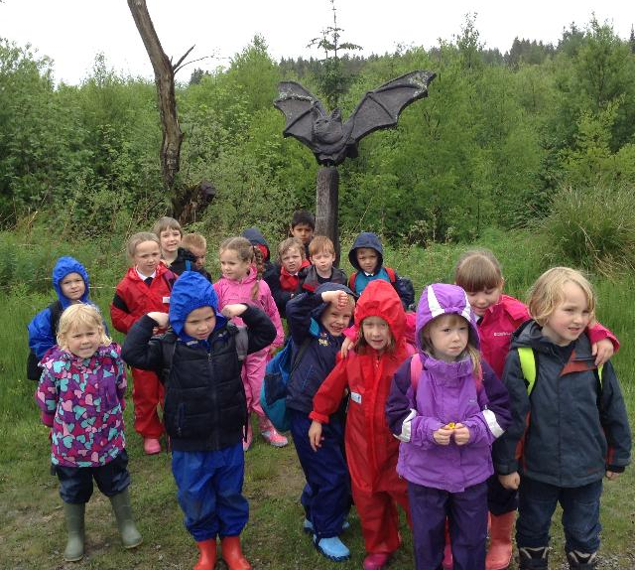  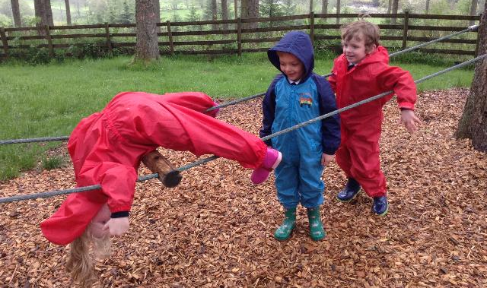  Reception battled the elements with wellies and waterproofs and walked the nature trail looking at all the animal sculptures. They then had a lovely time playing in the adventure playground on the zip wire and over the assault course. Thank you to the helpers who came making the trip possible.
Llanfaes After School Club  We are very pleased to let you know that our After School Club is now registered with CSSIW and will therefore be available until 5.30 pm. If you want to use the Club please contact Ms Jarman or the office. |  | Friends of Llanfaes -PTA    School Summer Bingo Evening  Many thanks to those who attended the bingo evening before half term or provided raffle prizes for the evening. Although numbers were low, good fun was had by all there with Mrs Williams, Chair of Governors, educating and entertaining everyone with her bingo calling. The evening raised £ 185.00.  Next fund raiser – SPORTS DAY  Can you help????    The ‘Friends’ will be holding both an adult and children’s raffle on Sports Day. Donations for either raffle will be very gratefully received. If you are able to help on the day to sell tickets or ice cream please let Lisa, Michelle or Mrs Hellard know.

Swimming Gala
The Key Stage 2 swimming gala took place before half term. The children competed in a variety of events throughout the morning, cheered on by their peers and families. The overall winners were
Brychan!
Congratulations to everyone who took part.
NB – YEAR 2 WILL BE SWIMMING THIS TERM NOT YEAR 6.
New Llanfaes Tots Sign  The staff and children in Tots are very grateful to the Friends of Llanfaes for purchasing their new sign – completing the improvements. Diolch yn fawr. |  | Healthy Schools News    This week the children are facing the challenge of improving the amount of water they drink. As a school, we comply with Appetite for Life, and the drinking of water during the day is part of this. Our SNAG group and Eco Committee are fully involved and have collected data to judge which class (or classes) have made the most improvement. We’ll let you know! How many glasses a day do you drink?  Athletics – Year 4  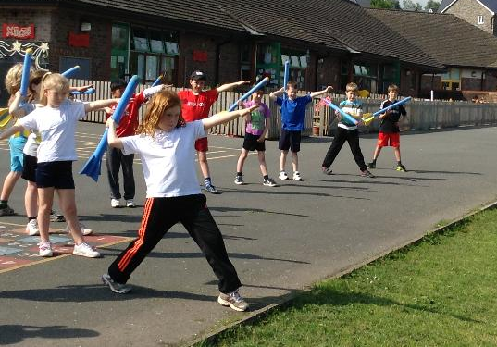  Year 4 recently took part in an athletics taster session, during which they were given tips on how to improve their techniques. We look forward to seeing the results when they attend the meet up at Penlan later this month.  Hay Festival Visit  Year 5 and 6 visited Hay Festival before half term, where they saw Sarah Lean who uses dogs in heroic roles in her stories, poet and guitartists James Carter and Rob Eastaway who tried to convince everyone that maths is magical and magic is mathmatical! The pupils thoroughly enjoyed the event gaining inspiration.
Beginning of Day Reminder
Please remember that children should be in school no earlier than 8.50 am as there is no supervision on the yard before this time.
REMEMBER BREAKFAST CLUB IS FREE FROM 8.00 AM. NO BOOKING REQUIRED. Pupils can join at any time before 8.50 am.

HENNA TATTOO WARNING
Sadly, one of our children has suffered an allergic reaction to a henna tattoo which was done whilst abroad on holiday which may result in permanent scarring. The parents have asked us to inform everyone about this to act as a warning.
FREE SCHOOL MEALS ENTITLEMENT  If any families think they may be entitled to free school meals for their children, application forms are now available in the school office.  * This newsletter is available on the school website www.llanfaes.powys.sch.uk |  | Hockey Team Matches News  Hockey teams from Years 3-6 recently played against Mount Street Juniors. All pupils showed great attitude and sportsmanship, once again being great ambassadors for our school.  The ‘Lions’ team played against both Mount Street’s teams losing 2-0 to the A team, winning 6-0 to the B team. Scorers for the Lions were Nia, Patrick, Carys and Kelsey.  The ‘Leopards’ lost to the A team 3-0 and drew 0-0 against the B team.  Our Year 3 & 4 team played against a team of years 3,4 & 5 and won 2-0, Luis scored both goals.  A mixed Year 3, 4 & 5 played against a year 3, 4, 5 & 6 team from Mount Street and lost 1-0.  Nia, Max and Eva captained their respective teams and led by example. Well done to all who took part.
St Fagan’s Trip for Year 1
At the beginning of May, Year 1 visited St Fagan’s. They spent the morning helping Beti Burt washing her clothes. They used a scrubbing board, wash tub, dolly and mangle. It was hard work!!! In the afternoon the pupils looked at houses from long ago. It was a fun day. A huge thank you to the ‘ Friends’ of the school who contributed £200 towards the cost of the trip. Thanks also to the parents and grandparents who went along to help.

