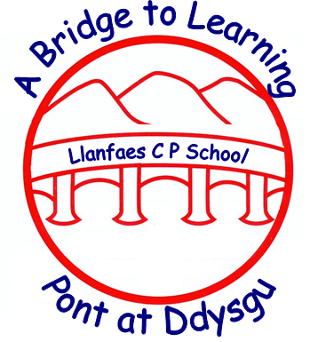 | Ysgol Llanfaes  Llanfaes School  Newsletter February 2018 | 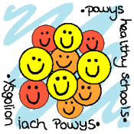

^{Diary Dates}  ^{February}  5th – Rags to Riches collection day  ^{Y6 Museum workshop}  ^{6th – Safer Internet Day}  8th – Class Assembly Y2 9.15 am Parents are invited into class after to look at the pupils work.  ^{9th – Break up for half term}  ^{19th – School returns}  ^{20th – Swimming Y3 & 4 begins}  ^{26th – 2nd March – Welsh Week}  28th – Y5 & 6 Band of the Welsh Guards @ theatre 2 pm  ^{March}  ^{1st – Eisteddfod}  2nd – ‘Blanket & Book’ World Book Day  12th – 16th – Parent Consultation Week  12th – Y3 & 4 Theatre am ‘The Lost Box’ performance.  ^{23rd – Break up for Easter}  ^{Friend’s Valentine Disco}  Thursday, 8th Feb – 6 – 7.30 pm  ^{Entry - £1.50}  Wear something RED if you want to!  Please remember all children must be accompanied by an adult.  Any donations for the raffle can be left with Mrs Hellard in the office. Thank you.  Summer Term begins on April 10th Swimming  Years 3 & 4  Swimming lessons will begin for Years 3 & 4 on Tuesday, 20th February. There is a voluntary contribution of £1.50 towards the cost of the bus.  Please remember the following rules set by Freedom Leisure who run the sessions:-  - No long swimming trunks  - All long hair must be tied back  - All jewellery must be removed.  - If a child needs to wear goggles a letter from a parent or guardian must be sent in.  CLUBS FOR THIS TERM  The following clubs are beginning week commencing 5th February  Rugby – Mondays Y3-6 (3.15 – 4.15)  Netball – Wednesdays Y3-6 (3.15 – 4.15)  Thursday – Hockey Y3-6 (3.15 – 4.30)  Choir, football and homework club will continue also.  Nut Free School  Please can we remind everyone that we are a nut free school due to a number of pupils having nut allergies. We ask that you are vigilant about what you put in your child’s packed lunch each day. Thank you. | You may have seen on the news that the National School Categorisation has been published. We are pleased to inform you that :-  Llanfaes is a Green School!!  As you are aware, Welsh Government published the categorisations of all schools in Wales this week. All primary and secondary schools have been given a colour categorisation for support following a review of their attainment performance over 3 years together with their capacity to improve. Schools have been put into one of four categories ranging from Green to Red.  We are very proud to be Green A category which reflects the sustained hard work and commitment to improvement shown by everyone connected to our school. A Green School is defined as:-  - Highly effective  - Track record in sustaining a high level of learner outcomes  - Demonstrate resilience at all levels  - Challenged to move towards or sustain excellence.  - Able to give effective school to school support.  We recognise fully the role played by pupils, staff, governors and parents in this achievement and would like to sincerely thank you all. Please visit www.mylocalschool.wales.gov.uk, type in the postcode of the school (LD3 8EB) for more information.  The theme for the Safer Internet Day 2018 is :-  CREATE, CONNECT & SHARE RESPECT!  Our Digital Directors have been meeting to plan various activities for the day for all year groups linked to internet safety. These will focus on keeping safe on line and how being online makes children feel. They will be using green screen facilities to express feelings and making internet safety pledges amongst other things. In addition, older Digital Directors help with activities in the younger classes for part of sessions. Look out for more information including an invite to join your child for part of the day.  DIGITAL DIRECTORS TOP TIP – DO YOU MONITOR YOUR CHILD’S USAGE OF ONLINE DEVISES? CHAT WITH YOU CHILD ABOUT HOW BEING ON LINE MAKES THEM FEEL.  YEAR 3 TURN INTO CELTS FOR A DAY!  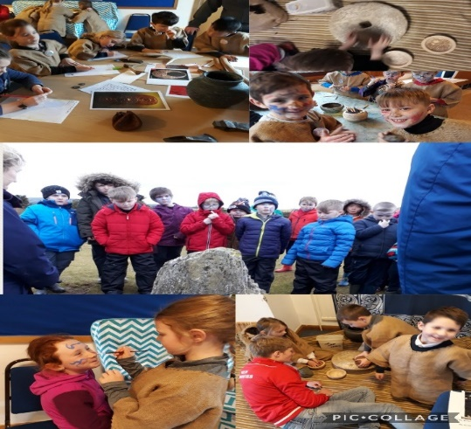  Year 3’s WOW day saw them spend a day experiencing life as a Celt. On a windy and wet morning they set off with great enthusiasm to the Mountain Centre. During the morning they dressed as Celts, made pots, ground wheat into flour and much more. Following this it was time to put on their war paint before battling the invading Romans! Here are a few quotes from the pupils after the visit:-  “It was good fun. I liked it when we were Celts attacking the Romans.” Ioan  “The workshop was brilliant, we looked at artefacts, sketched them and tried to work out what they were used for.” Oscar  “I really loved walking up the mountain, it was cold and really windy! We saw a standing stone which the Celts used as a calendar.” Eden  “We were allowed to paint ourselves using face paint. The Celts did this too using wood.” Molly  You can tell from the children that this was a fantastic day with much learning taking place! As always the pupils were wonderful ambassadors for our school too.  YEAR 5 BECOME AUTHORS!  This term our topic has been about the life of Robert Jones, VC. We visited the Royal Regiment Museum to find out what life would have been like for a Victorian soldier and the Battle of Rourke’s Drift. We worked with Uschi Turoczy, an artist, to use our knowledge from the visits to write letters, poems and create pictures about different stages of Robert Jones’s life after joining the army. All these exciting activities were funded by the Heritage Lottery Fund and The Friends of the Royal Regiment Museum. We are very excited as all of our work will be published in a proper book!! Here are just a few examples of our writing:-  “My new adventure is beginning, however I am missing you dearly. The islands around Africa look so orange and acacia trees are so beautifully sculptured.”  “During the last firing formation, I actually thought I was going to die, so did my fellow soldiers. The sight of so many Zulus being shot will haunt me forever.”  “The beautiful sky was a blue and purple explosion, Trees like umbrellas, a burnt orange roaring flame.” Year 5
This newsletter is available on the school website at www.llanfaes.powys.sch.uk. Alternatively, scan this code and it will take you straight to the website. (You will need a qr reader to do this).
Do you follow us on Twitter? @LlanfaesSchool – take a look!

