  A Bridge to Learning  A Bridge to Learning  Llanfaes C P School  Pont at Ddysgu | Ysgol Llanfaes  Llanfaes School  Newsletter December 2015 |  | 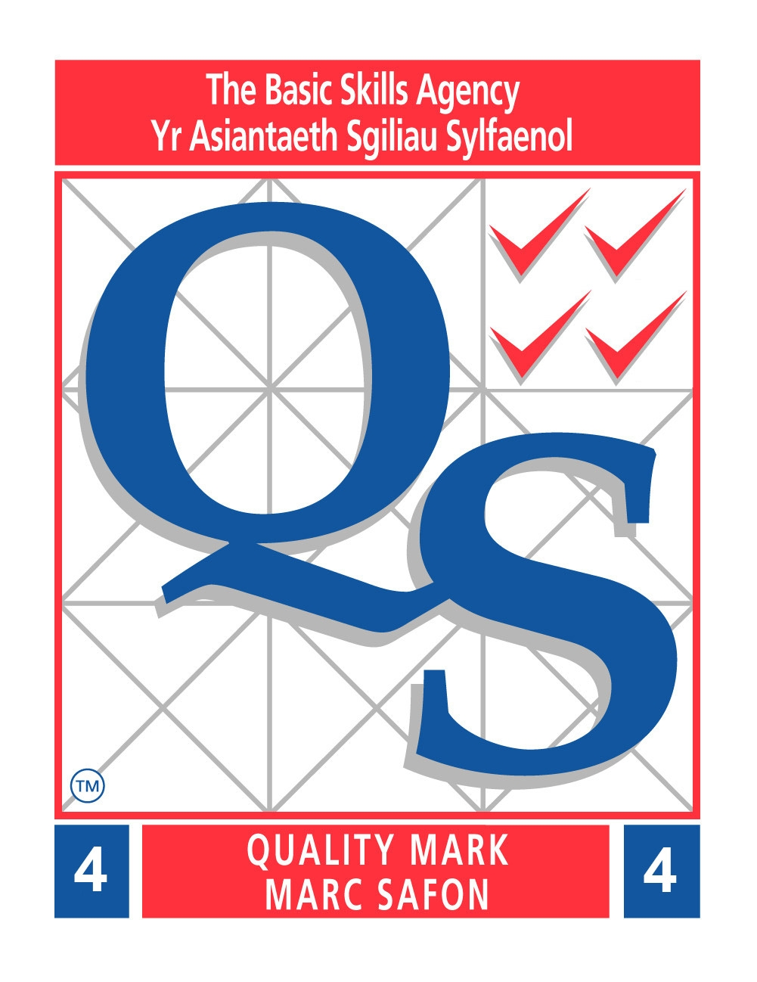
Diary Dates  3rd December – Pantomime Robinson Crusoe  – Christmas Fayre 6pm  8th December – Dementia ambassadors to Cardiff pm  9th December – Christmas Dinner  10th December – Dress rehearsal Christ College 1.30 pm  - Concert 5.30 pm  11th December – Tots Nativity 1.30 pm  - Concert 5.30 pm  16th December – Elf day – Alzheimer’s Support Day (more info to follow)  Tots, PSSC & Links Christmas Party 9-11 am  - 1-3 F Ph Parties  - KS2 party and disco 3-5 pm  17th December - Choir Cathedral rehearsal 5.30  - Cathedral concert 6.30 pm  18th December –National Christmas Jumper Day  -Christingle service 1.15 pm  - School breaks up  Spring Term  4th January – School returns |  | Year 6 London trip  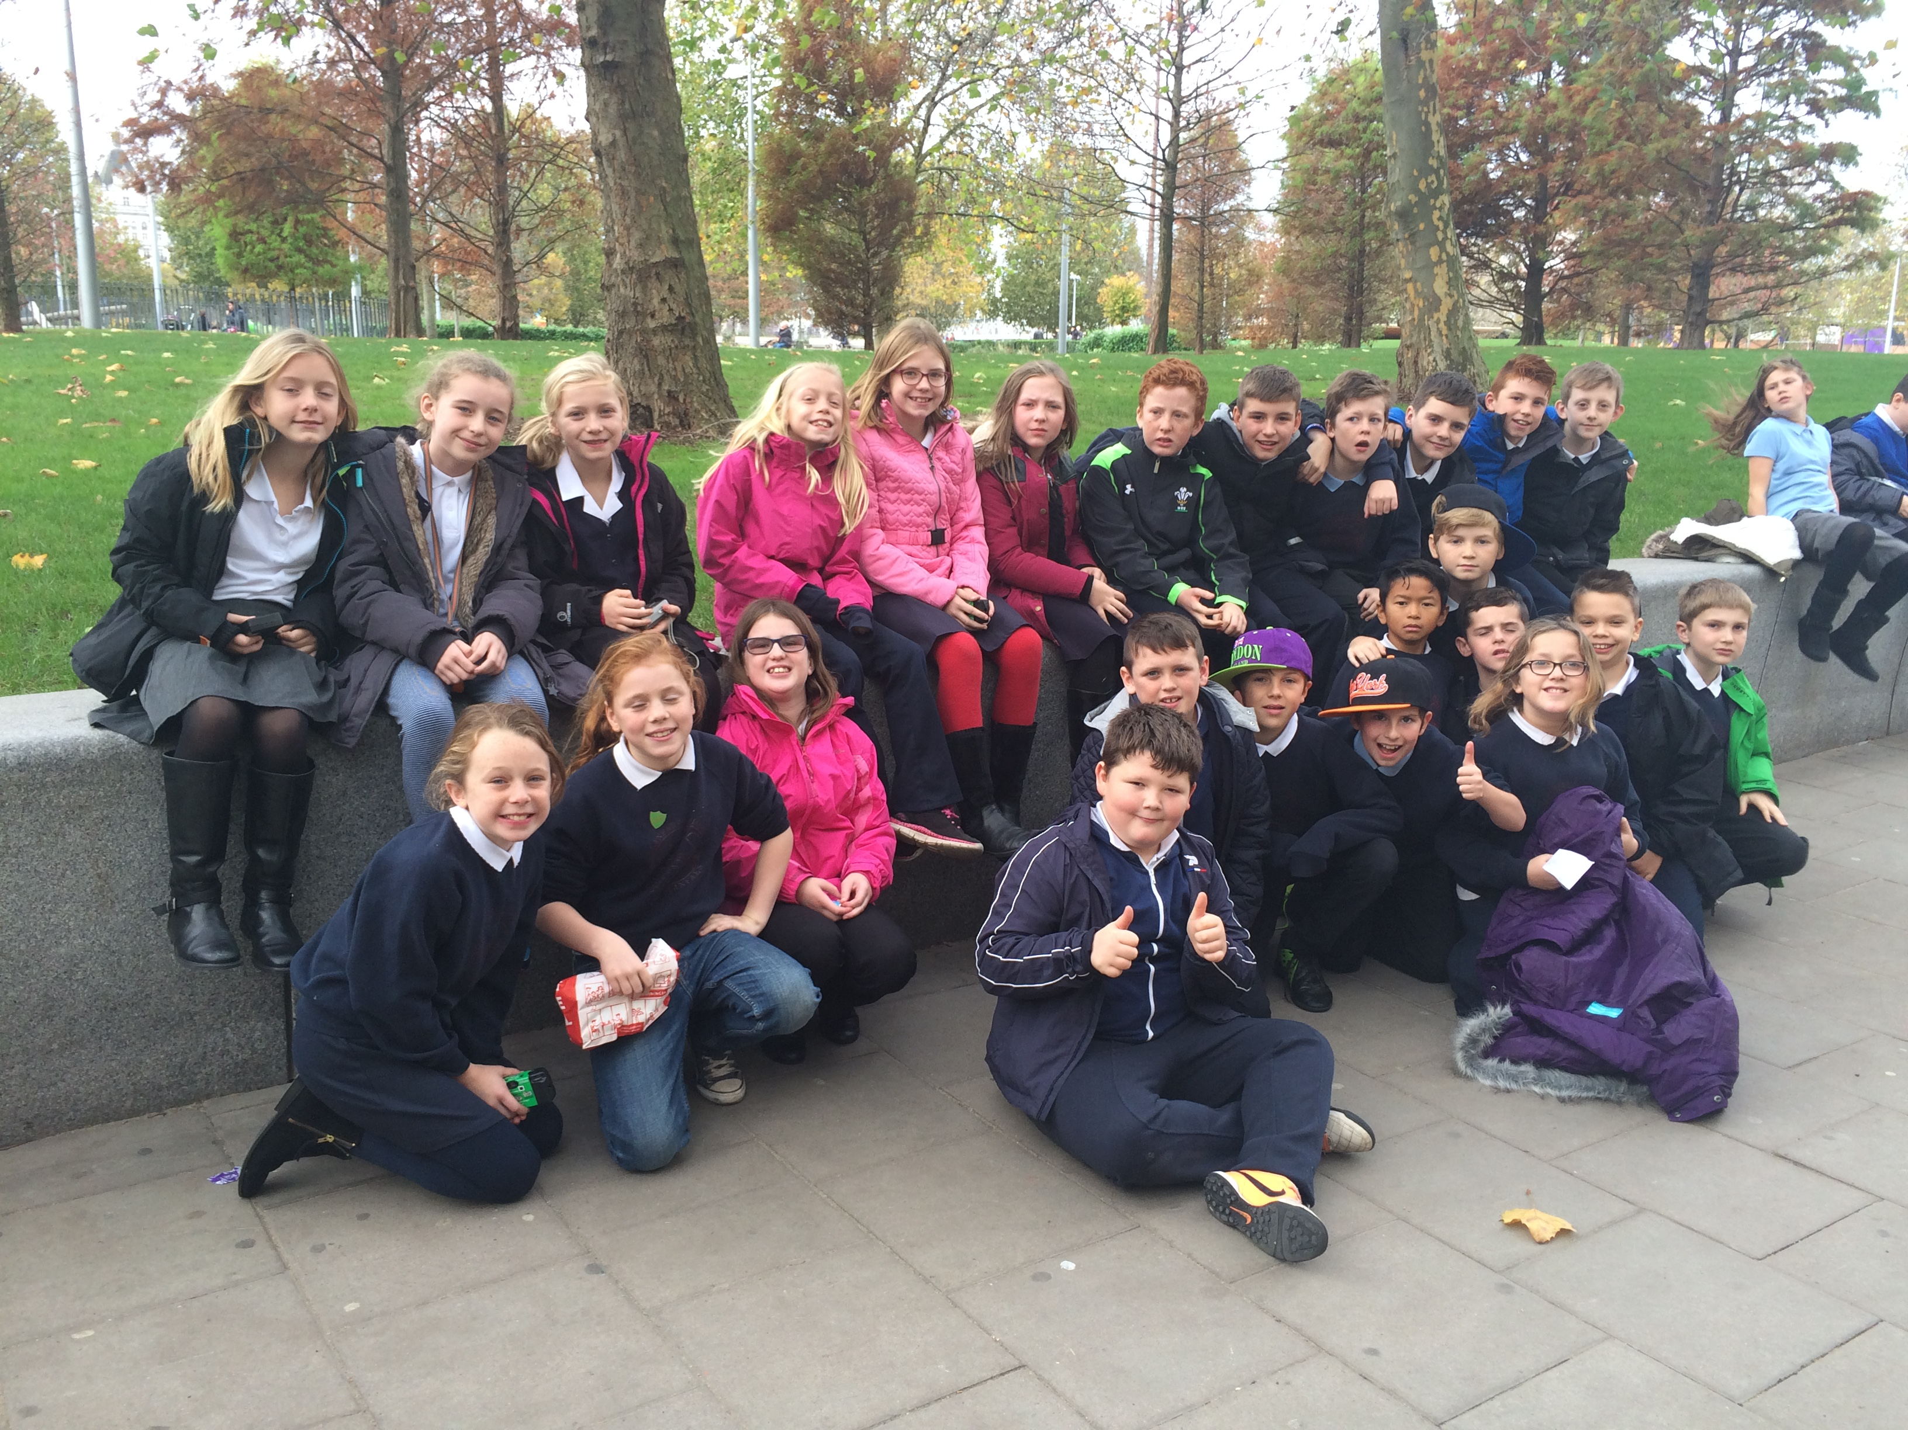  After an early start, Year 6 arrived at Trafalgar Square in time for lunch, before a guided tour of the National Art Gallery. The next stop was the Science Museum where an enjoyable time was had using the interactive displays. It was then time to unload our bags at Baden Powell Hostel, our base for the next two nights. The evening meal was followed by the Royal Albert Hall walk around the surrounding area. Day two began with a visit to the Natural History Museum. The dinosaur exhibition was amazing! From there we took a walk around the Royal residences and Horse Guards Parade then enjoyed a picnic in St James’ Park. After lunch we visited St Paul’s cathedral, taking in the amazing architecture before climbing firstly to the whispering gallery, and then to take in the breathtaking views from the top. A surprise evening meal at Pizza Hut on the Strand came next, followed by watching Matilda in the West End. The third day began with a visit to the Tower of London where we saw, amongst other things, the crown jewels. After a quick shopping spree, it was time for lunch before arriving for our flight on the London Eye. Year 6 were a pleasure to be with, truly a credit to themselves and our school.
ELF DAY – DECEMBER 16TH    As a school working to become dementia friendly, we have decided to participate in the Elf Day for Alzheimer’s Society. This was instigated due to the Elf musical deciding to support the Society this year.  Children are encouraged to join in by dressing as an elf on the day. We are not asking for donations, unless you feel you would like to. Eight pupils from Year 6 are travelling to Cardiff Arms Park next week to give a presentation to the National Alzheimer’s Society about the work we do in school and the community to raise awareness of dementia. We will let you know how it goes! |  |   Friends’ Christmas Fayre  Our school Christmas Fayre will be held Thursday, 3rd December, starting at 6pm.  This event will use the items donated on ‘Colour Day’, filled jars, raffle prizes etc to raise funds for the benefit of the children. Please make every effort to join us; there are a number of stalls and games, and of course the chance to see Santa.  Please bring in cakes and bottles for the stalls on the day of the fayre.  Pupils will be awarded a house point for each jar donated for the jar stall, which can be bought in any time from now onwards.  The school choir will be singing too.
Growing Up Resource
As a school we will be using a resource called ‘ Growing Up’ to support our Personal and Social Development lessons and Sex and Relationships Education. If you would like to view the resources please contact school.
  Christmas Jumper Day 18th December  This year, the date for National Christmas Jumper Day coincides with our last day of school. The day supports the national charity for Save the Children. Due to the fact that we have raised substantial money already this term for various charities locally and nationally, we will be supporting the day through the wearing of jumpers but not asking for any donations. We would encourage the children to wear any Christmas attire on the 18th to enter into the spirit of the day. There will be no collection made however it is just for fun! |  | School Readiness Programme at school  In November, Miss Jarman and Mrs Gerrish ran the ‘Incxredible Years Schools Readiness Parent Prograamme.’ This is a 4 session course designed for parents of children who are about to start school, or who may have already just done so. The programme was open to all parents from Tots and Nursery classes.  The sessions included exploring a variety of things including:-  - how parents can support children’s play  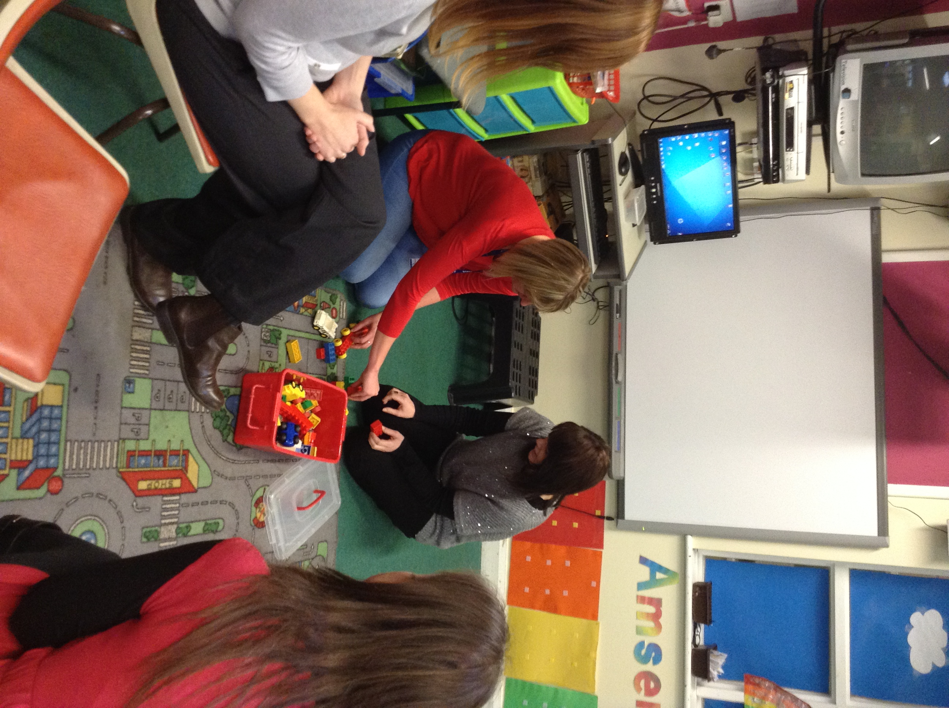  - how parents can support children’s learning and exploring  - ways to introduce children to books.  The programme will run again in the Summer Term. If you are interested in attending please see Miss Jarman.  “ The programme made me realise the value of playing with my child and the importance of focusing on praising the good behaviour.”
 |  | Illness Absence Information    At this time of year there are often more illnesses around. Please find below a useful table which indicates the absence period recommended by the Health Protection Agency for some common diseases.  You can obtain further information from the Health Protection Agency.
  DISEASE | ABSENCE PERIOD
  Chickenpox | 5 days after rash appears
  Conjunctivitis | None
  Diarrhoea and Vomiting | Until 48 hours after the last episode
  Hand, foot and mouth | None
  Hepatitis A | Young children – 7 days after onset of jaundice. there is no need for older children with good hygiene to be absent, provided they are well enough to attend school.
  Impetigo | Until lesions are crusted or healed.
  Measles | For 5 days after rash appears.
  Mumps | For 5 days after onset of swollen glands
  Whooping cough | For 5 days after commencing antibiotics
  Ringworm | Until treatment is started.
  Rubella (German measles) | For 5 days after the onset of the rash
  Scabies | Until treated
  Scarlet fever | For 5 days after commencing antibiotics
  Threadworms | None
  Tuberculosis | Medics will advise on necessary action
This letter is available on the school website at www.llanfaes.powys.sch.uk.


Alternatively, scan this code and it will take you straight to the website. (You will need a qr reader to do this).


May we take this opportunity to thank you all for your continuous support throughout the year, it is always very appreciated. Nadolig Llawen.

