5th September 2016.

Dear Parents and Carers,

Welcome back to a new school year, one which brings the proposed abandonment of our school closure and is a just reward to the strength of community shown by everyone who supported the school. I am sure it is your commitment to education here that has brought this about. We just wait now for the council to agree the proposal later this week.

I wish to extend my thanks to everyone for their warm welcome to the school and I look forward to the challenge ahead and know we will work hard to achieve the best for everyone in the school. I feel as though I have been here a long time yet as I write this I haven’t taught a lesson in school yet.

I have seen and been made a part of a great community here in Llanbister, a community that is supporting the school through fundraising and freely giving time to provide for the young people in our care. I feel the school is the hub of any small community and I want to keep it having a full and active role in all that we do.

I like to adopt an open door policy that allows all parents to approach the school freely with whatever concerns they may have, it is often better to air any problem or misunderstanding quickly to find solutions rather than allowing them to grow, so please contact the school if any assistance or clarification is required, we will endeavour to see you then or make an appointment if staff are committed teaching.

Thank you once again for your support and I look forward to our time together.

Yours Sincerely

Mark Hulin-Taylor.

THANK YOU TIAG….

**Thanks to the TIAG group who held a promise auction recently and raised over £12000 pounds to support the pupils in the school. It was a fantastic result and a credit to all the hard work and support put in. The funds will have a big impact on the provision we can make for the children in school. Also not forgetting the fundraising for Ti a Fi and Teme valley Tots with the animal man. Fantastic work and a great time had by all.**

SWIMMING STARTS TOMORROW, 6th

DON’T FORGET YOUR KITS.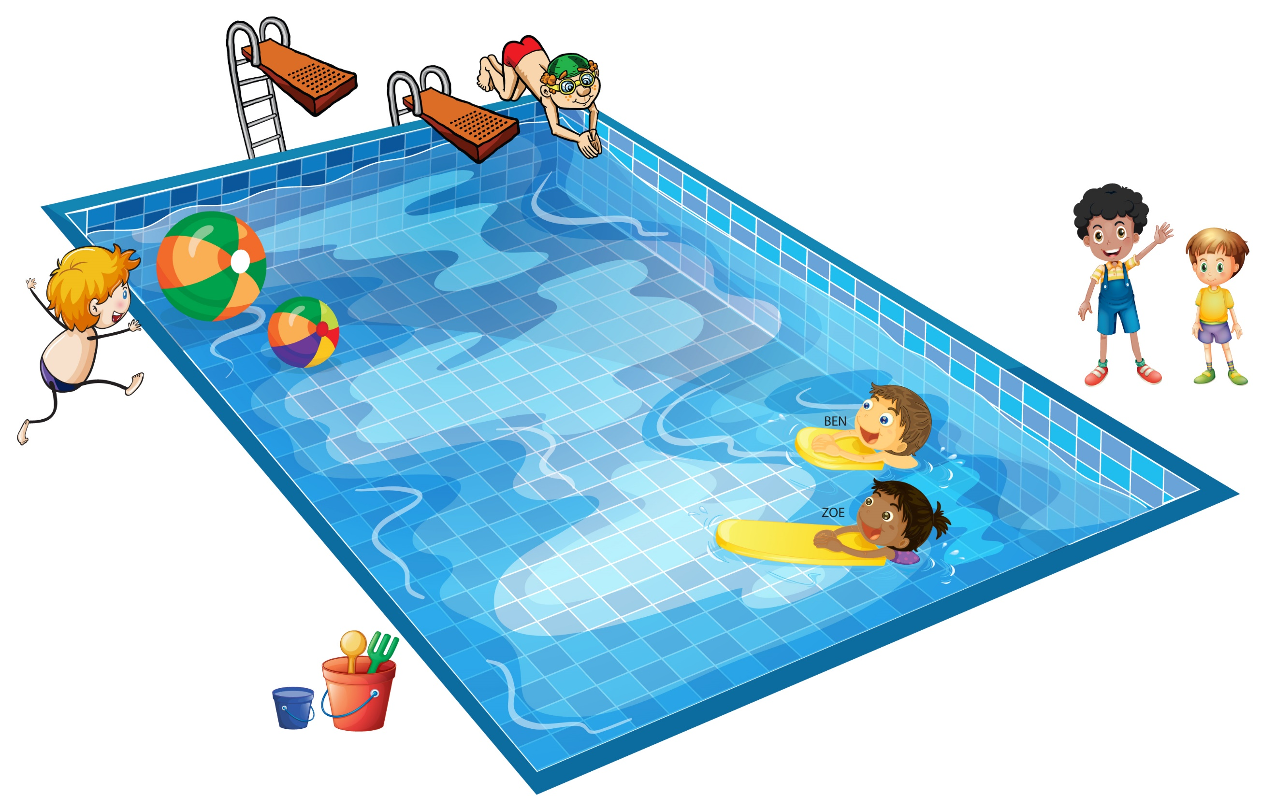

[](https://www.google.co.uk/url?sa=i&rct=j&q=&esrc=s&source=images&cd=&cad=rja&uact=8&ved=0ahUKEwjwwdv2j-_OAhUB1RQKHR-PDUoQjRwIBw&url=https://twitter.com/savellanbister/status/703352022259671040&psig=AFQjCNGFRi_qctU0_pGmuO02fHii5zzNww&ust=1472851906690806)



COMPETITION.

I would like the children to think of a format and name for our newsletter.

Think of a design, logo or name and we will have a vote in school. Entries in by Monday 12th please.



**Welcome to our new starters this term**.

*Mark Hulin-Taylor*

*Eva Bennett*

*Harry Bright*

Term Dates – 2016-2017

**Autumn Term 2016.**

Non pupil days: Thursday 1st September & Friday 2nd September.

Term Starts: Monday 5th September

Half Term: Monday 24th October – Friday 28th October

Term Ends: Friday 16th December.

**Spring Term 2017.**

Non pupil days: Tuesday 3rd January & Friday 17th February.

Term Starts: Wednesday 4th January

Half Term: Monday 20th February – Friday 24th February.

Term Ends: Thursday 6th April.

Non pupil day: Friday 7th April (Directed Teacher Day)

**Summer Term 2017.**

Term Starts: Monday 24th April

Bank Holiday Monday 1st May School Closed

Half Term: Monday 29th May – Friday 2nd June

Term Ends: Friday 21st July