
Dysgu am Fywyd - Learning for Life



Maesycwmmer Primary School
Tabor Road,
Maesycwmmer
Hengoed
Caerphilly
CF82 7PU
maepa@caerphilly.gov.uk
Twitter: @Mae5yschool





Welcome to Maesycwmmer Primary School
This brochure produced in consultation with the Governing Body provides parents with information on Maesycwmmer Primary School: its aims, curriculum, activities and routines.

Vision Statement
Dysgu am Fywyd – Learning For Life

Mission Statement
At Maesycwmmer Primary School we aim to create a stimulating environment that allows all of our pupils to learn and grow through diverse and challenging opportunities/activities, whilst developing skills that will enable them to thrive in an ever changing society.
Aims
- Through providing well-resourced classrooms and innovative and energetic staff we aim to create an ethos where all pupils feel a part of the school and all their voices are heard and valued.

- Our staff work together closely to develop a whole school approach to teaching that allows everyone to develop at a pace that suits their ability.

- Although we strive for children to succeed academically we are fully aware that children can reach excellence through differing and varied activities. Therefore at our school we aim to provide a broad and balanced curriculum, but endeavour to provide the children with a wide range of experiences that will allow them to express themselves academically, creatively or sporting.

- As well as the children we believe governors and parents play a leading role in taking our school forward. This link will allow us to make sure the school works together with the community continuing to develop the links that already exist.

- As a school in Wales we hope to develop the children’s understanding of our culture, heritage and history.

- Through providing our children with varied learning opportunities we hope to develop their own self-worth and give them a meaningful and happy start to their school life

- We aim for all our pupils to be Ready, Respectful, Happy and Safe in all situations and environments.

I would like to take to take this opportunity to welcome you to our school and we look forward to working with you and being part of your child’s development.
Mr. J.R.Harris Head Teacher

The Present Composition of our Governing body

CHAIR OF GOVERNING BODY

CB Cllr. R. Woodyatt

County Council Representation (3) – Appointed by L.E.A.
CB Cllr R. Woodyatt, Mr. L. John,
Teacher Governors (1) - Elected by the Teachers
Mr. L. Coupland
Non-Teaching Staff Governor (1) - Staff Member
Mrs. M. James
Parent Governors (4) – Elected by the Parents
Mr. G Kedward, Mr R Ap Hywel
Mrs. W. Howls
Co-opted Governors (3) – Appointed by the Governors
Mrs. S.M. Lewis, Mr G. O’Keeffe, Mr D George

Headteacher Governor – Ex Officio
Mr. J Harris
Minor Authority (1) – Appointed by Community Council
Mrs. Diane Williams

Staff
Headteacher: Mr J Harris  Deputy Headteacher: Mrs J Douey  Teachers: Miss R Evans, Miss K Toozer, Mrs E Thomas  Mr. L. Coupland, Miss S. Holmes  HLTA’s: Mrs M James and Miss L. Brideaux  T.A’s: Mrs H Jones, Miss J Johnson, Mrs T Williams,  Mrs. R. Morris | Secretary: Mrs S Arthur  Caretaker: Mr. M. Harries  Cleaner: Mrs A Smith  Lunchtime Supervisor’s: Mrs S Hutnik, Mrs M Harries, Mrs J Evans, Ms M Barnham  Kitchen Staff – Mrs B Jayne, Miss G. Smith
Pre-Admission Arrangements
All applications for a place at the school must go through the LA Admissions team. Parents are able to register an interest with the school but will have to complete and submit the forms to the LA as they allocate places. Before attending the school parents are welcome to visit and have a tour of the school. All new nursery/reception intake will be invited to a link up session before starting at the school.

Current School Organisation
In September 2019 there will be 6 classes, which include in our Foundation Phase, Nursery/Reception, Reception/Year 1 and Year 1/Year 2 classes. All classes in the school consist of two age groups, i.e. Yr 3/4,
Yr4/5 and Yr5/6.

Where year groups are split the needs of the child always determine class placement. Through detailed planning of work the teachers are able to meet individual needs. The class teacher is predominantly responsible for delivering the whole curriculum to their respective class using a combination of teaching styles to meet children’s needs and those of the curriculum.

Duration and Timing of School Day
Timings | Foundation Phase | Key Stage 2
Morning Session  Assembly  Break  Morning Session  Lunch  Afternoon Session  Break  Afternoon Session | 9a.m. – 10.15a.m.  10.15a.m. – 10.30a.m.  10.30a.m. – 10.50a.m.  10.50a.m. – 11.50a.m.  12p.m. – 1.15p.m.  1.15p.m. – 2.20p.m.  2.20p.m. – 2.40p.m.  2.40p.m. – 3.30p.m. | 9a.m. – 10.15a.m.  10.15a.m. – 10.30a.m.  10.30a.m. – 10.50a.m.  10.50a.m. – 12p.m.  12p.m. – 1p.m.  1p.m. – 2.20p.m.  2.20p.m. – 2.30p.m.  2.30p.m. – 3.30p.m.

All children should be on the school premises 5 minutes before the official start of the school day. Parents are reminded that no responsibility can be accepted for children on the school premises at any time prior to 10 minutes before the official starting time. The support of parents is appreciated for ensuring that their child’s attendance is both punctual and regular. During inclement weather, with no shelter now available on junior yard parents are reminded that children will only be allowed to enter buildings under supervision of staff.

Parents will be informed in advance of the dates of the seven staff training days to be taken by the school in this academic year. The dates of school events or Educational visits to be made will as usual be communicated to parents well in advance, through Newsletters, Pupil post and Twitter

Notice boards are provided for the parents of our pupils outside both building entrances and information can be seen on these In the event of the school having to be closed due to inclement weather, parents should always in the first instance, check CCBC website and our school Twitter.

TERM AND HOLIDAY DATES FOR 2019-2020
TERM | BEGINS | HALF- TERM  BEGINS | HALF- TERM  ENDS | ENDS
AUTUMN | Monday  2/09/19 | Monday  28/10/19 | Friday  01/11/19 | Friday  20/12/19
SPRING | Monday  6/01/20 | Monday  17/02/20 | Friday  21/02/20 | Friday  03/04/20
SUMMER | Monday  20/04/20 | Monday  25/05/20 | Friday  29/05/20 | Monday  20/07/20
Bank Holiday: Friday 8th May

School Meals
Meals, representing a balanced diet are prepared on the premises. Children who have a school meal have a choice of main meal and sweet. Presently £2.10 for September 2019 and when available Nursery lunch will be £2.50 per meal.

Payment of Dinner Money is taken on a Monday for the whole week. The L.A. will not allow the school to provide children with dinners on a credit basis. If a meal is missed for any reason, credit is given. Dinner Money paid for by cheque must be made payable to “Caerphilly County Borough Council” (C.C.B.C. is also acceptable) and must have your address written on the reverse of the cheque. Parents in receipt of benefits may be are entitled to apply for free school meals and the respective forms may be obtained from the school secretary.

Packed Lunches - Children may bring sandwiches for their mid-day meal and these are eaten in the dining hall [infant building] with the children having school meals. Healthy diets are promoted.
Going Home for Lunch - The school needs to know each Monday morning of any such arrangement. If not a regular arrangement, written confirmation from parents is required each time.
Free Breakfast Club – is available between 8.10am and 8.30am in infant building for all children. Please obtain forms from the school office.

All children remaining in school during the lunchtime are under the watchful supervision of the lunchtime supervisors, who are acting under instruction of the Headteacher. During the Summer Term and weather permitting the children use the school playing field as opposed to the yards. The supervisors are responsible for the maintenance of good behaviour and all incidents are reported to a member of staff.
No child is to be taken from the school at lunchtime unless a member of staff is informed.

Attendance
Punctual and regular attendance is vital for continuity and progression in terms of a child’s educational progress. The school acknowledges the commitment and support of parents that currently exists in this area. If a regular pattern of poor or unexplained attendance is detected, the Head Teacher will communicate his concern to parents or, if necessary to the Educational Welfare Officer for the school who visits the school throughout the term. Absence is currently recorded under two categories –Authorised or Unauthorised. Unauthorised absence is when the school receives no information or explanation for a child’s absence. Fixed Penalty Notices could be issued for regular unauthorised absences. Dental / medical visits can now only be recorded as present if the pupil is present at registration.

Please note a phone call on the morning of the absence or note prior to/following the absence is far better than unauthorised absences on your child’s annual school report.

Overall Attendance 2017-2018
94.8%
Unauthorised absences 0.9%

All pupils with 100% attendance for a term are rewarded with a certificate of achievement and a trip to the cinema. The positive incentives introduced, have seen a marked improvement on pupil attendance each year and we aim for this to continue

Leave of Absence/Holidays
Leave of absence during term time will be discouraged. Parents and carers do not have the automatic right to withdraw their children from school for an annual holiday and will be reminded of the effect that absence can have on a pupil’s potential achievement.

The school will consider any application for leave of absence and will only agree to authorise the absence in exceptional circumstances; parents and carers must apply in advance for permission for their child to have leave of absence.

Examples of exceptional circumstances include:

- Parent working abroad for a fixed, medium term period;
- Family are returning to country of origin;
- Parent returning from active tour of duty.

Parents and carers are advised that A Fixed Penalty Notice (FPN) may be issued by the LA when permission for a holiday or leave of absence has not been authorised by the school and exceeds 10 sessions. The Local Authorities Local Code of Conduct has more information on this.

Unless exceptional circumstances the Governing Body will not authorise leave of absence/holidays in term time if the child’s attendance is below 95%.

Emergency information
We need to have update addresses or telephone contacts where parents can be contacted quickly in the event of an emergency. On occasions, you will be asked to confirm or update this important information. If your child is taken ill or has an accident at school, we will endeavour to do our best to contact you. Failing this, we will act in the best interests of the child. For this reason medical information on all our children needs to be updated regularly.
If there are any changes please inform the school, especially mobile phone numbers.

Medicines
Mr. Harris retains all prescribed medicines in the junior building and Mrs. Thomas in the Infant building.
Written parental permission is required before the Head / Deputy / FP Leader is allowed to administer any medicine to a child.

In general, the following procedures should be adhered to with reference to all medicines.
- Parents bring medicine to school and administer to their own child.
- Requests can be made in writing to the Head Teacher with the name of the medicine, dosage, times of administration and duration of the treatment.
- All medicines should be clearly labelled with the child’s name and address, the dose and time of administration.
- Medicines should be delivered to the school and collected from the school by a parent or responsible adult.
- The medicine should not be repacked in a second container – it should be sent to school in the original container within which it was dispensed.
- The school does not regard propriety medicines bought by parents, in the same way as those above. i.e. prescribed by a family doctor / hospital.
- Unless prior arrangements have been made designated staff will monitor the pupils taking their medicine rather than administering it to them.

Nebulisers, Inhalers and asthma pumps are kept centrally in both buildings, and are readily available to them should they be needed. Pupil’s pump/inhaler must be quickly recognised, so must be marked with name and class. Parents must always inform us of any medical condition that is relevant to their child’s safety or that of others at school. This is very important.

School Uniform
This is an area we at school strongly agree with as it creates a very positive first impression of the school. We want our pupils to feel they have a smart uniform, comfortable to wear, and one they are happy to be seen in. Please make sure all you child’s clothing has their name written on the tag or sewn into the material.

Girls | Boys
Gold polo shirt /stitched logo [optional]  Maroon Sweatshirt / stitched logo [optional]  Grey Skirt  Summer wear – Red and White check dress or Polo shirt/shorts  Maroon infant Cardigan also available | Gold polo shirt /stitched logo [optional]  Maroon Sweatshirt / stitched logo [optional]  Grey trousers  Summer wear – Polo shirt/shorts
There is no need to wear Jewellery to school, but girls are allowed to wear a pair of stud earrings. No Necklaces are to be worn in school.
These items are now available at most supermarkets as well as Ruggerbug and CC Sports.

It is vitally important to ask parents to clearly label personal property with the name of their child and other relevant details. This avoids problems of identification when similar types of clothing are inadvertently misplaced. When other items of clothing go missing from time to time the school makes every effort to recover the lost property. Any lost property should be reported promptly. Unfortunately, however, the school cannot accept responsibility for any loss, as personal items are not covered by the school’s insurance. When money is required to be brought to school it is important that this is either given to the class teacher in the morning or the secretary especially if it relates to dinner money. Money should never be left in coat pockets, bags or classroom trays.

P.E.
T. Shirt, shorts or suitable clothing and plimsolls (clearly marked) should be worn for P.E. lessons.
- Both girls and boys prior to these lessons must remove all jewellery.
- Staff are not to be responsible for removal or looking after jewellery.
- Being unable to participate because of jewellery is NOT a valid reason.
- Non-participation requires a note from home. PE is a National Curriculum Foundation subject in which ALL pupils must participate.

The School Curriculum
The governors and staff agree that all pupils should have access to the following areas of experience:
Personal and social development, well-being and cultural diversity
Language, literacy and communication
Mathematical Development
Knowledge and Understanding of the World (Science, Geography. History)
Welsh Language Development – All classes are taught Welsh 2nd language. As well as teaching language patterns and vocabulary the use of everyday/incidental Welsh is encouraged to be used around the school and a daily basis.
Physical Development
Creative Development (Art, D/T, P.E)
Religious Education
Each of these aspects of learning includes particular concepts, knowledge, skills, attitudes and values that can be learnt, practised in context and applied in many parts of the curriculum and therefore we see to be relevant and purposeful to the child. As a school we aim to teach our pupils through various topics over the course of the academic year.

How do we deliver the curriculum?
Through working via an integrated approach, we hope to motivate each child and nurture the desire to learn more about the world and acquire knowledge with understanding together with the ability to apply it to a relevant situation. Facts will be taught, but not in isolation. They only become meaningful when their relationships with other facts are clearly seen. Self-evaluation by the child of on-going achievement is encouraged as an integral aspect of personal development.

Cultural and aesthetic experiences clearly play an important role in the school curriculum. Through music, art, physical education and drama, children learn to express their individual talents and interests and are given the opportunity to achieve recognition and success on an individual basis and as a member of a group or team. Group, paired and individual work are extensively encouraged within the curriculum. It is a fundamental aim of the school that all pupils irrespective of ability are encouraged and supported to achieve the highest possible standards that they are capable of. To this end the school’s curriculum needs to be broad and balanced, reflecting the school’s priorities and providing the necessary opportunities.

Additional Learning Needs Provision
Aims and Objectives of our Additional Learning Needs Policy are that every child at the school has a right to: -
- access to the National Curriculum
- have work differentiated tasks appropriate to their needs
- be given opportunities to grow both socially and emotionally with the objectives of developing self-confidence and self-esteem.
- have progress monitored, reviewed and evaluated on an agreed regular basis
- have parents informed on education and progress - both formally and informally.

Children initially identified by the class teacher as requiring additional support are dealt with promptly in consultation with the ALNCo and Head Teacher. As a direct outcome of this identification the child is placed at ‘Initial Concerns.’ A meeting is set up, where concerns are discussed with parents and recorded. Relevant information is gathered on the child, and development in the areas of concern closely monitored. This may lead at a later stage, if insufficient progress is been made, to School Action, or School Action Plus, where an Individual Educational Plans (IEP) are established by the classroom teacher in consultation with the ALN Co-ordinator and parents. Progress is closely monitored and reviewed with parents each term. If at any time we feel the need to, the school will call upon the expertise of external agencies such as the Educational Psychologist. Parents are informed of developments via the Head Teacher at all stages.
As the population of children requiring additional support is not constant, the school monitors changing needs through its ALNCo. Meeting the needs of all pupils including the most able is at all times the responsibility of their class teachers.

Homework
Children will be required to spend a modest amount of time at home on their Learning Log tasks. This is aimed at achieving personal targets set each term, reinforcing skills, concepts and knowledge gained at school and giving an insight to parents on present day approaches which in some cases will differ greatly from their school days.

Our home school reading link enables pupils to take books home to read on a regular basis. Parents are requested to encourage and support their children with their reading, helping them to develop the habit of reading for pleasure.
Parental support is essential in ensuring the success of both these initiatives

Swimming
Children in years 3, 4, 5 and 6 have swimming lessons in the Autumn, Spring and Summer terms. This is part of their Key stage 2 National Curriculum studies aimed at achieving the National Curriculum Standard and is not optional.

Extra Curricular Activities
The school offers a number of extra-curricular activities and these can change termly. If your child is interested in taking part please complete the consent forms when appropriate.

Equal Opportunities
Our aim is to provide opportunities for all children to acquire the knowledge, skills and understanding necessary to prepare them for the responsibilities and experiences of modern adult life. We are aware at all times of the necessity not to differentiate by gender, race or ability, but to give all our children the opportunity to take up all the experiences offered by the school. The school’s curriculum in both its content and delivery should also reject discrimination against pupils on grounds of sex, race, religion or ethnic background.

Collective Worship
Religious instruction must be given in every school. At the written request of a parent, any pupils may be wholly or partly excused from attendance at religious worship or religious education. Collective worship will take place on the school premises. However, on special occasions, we may arrange for it to take place off the school premises. We have a policy of introducing our pupils through lessons and visits to the places of worship of a wide range of religious denominations. We have no affiliation to any one religious group.

Sex Education
At present the Governing Body’s policy on Sex Education is that it does not form a statutory part of the National Curriculum and as such is not taught discretely within the school. The situation presently is that within Year 6 staff contribute by addressing topics appropriate to the needs and ages of the pupils in their final year and prior to starting comprehensive education. The inclusion of P.S.H.E. in the curriculum enables our pupils to focus more on those positive personal qualities we seek and admire in our peers, friend and ultimately our partners.

Charging for School Activities
Out of school educational visits are usually undertaken in support of the on-going curriculum. Schools are not permitted to make a compulsory charge for the cost of such visits, but parents are requested to make a voluntary contribution in order for such activities to proceed. The Governing Body has decided that if the vast majority of the overall cost of the trip is not met in this manner, the school has no option but to cancel the undertaking. The school is clearly dependent upon a high percentage of voluntary contributions being made by parents in order for valuable educational visits to take place.

The successful introduction of LA Music Service guitar tuition in Key Stage 2 is school funded. Whether parental contribution for guitar will be requested for 2019 – 2020, as is the case in most other LA schools is yet to be determined.

School Property
Where breakages or damage to the school building, furniture and equipment occur, or when the removal of graffiti is necessary, as the result of a pupil’s misbehaviour, a nominal charge will be made to the parents, or a proportional charge if more than one is involved. Defacing, damaging or losing books belonging to the school will lead to the full cost being charged for the replacement of the article involved.

Behaviour
At Maesycwmmer Primary the emphasis is on the positive aspect of pupils’ behaviour. All members of staff are responsible for maintaining good behaviour patterns within their own classroom and around the school itself. The school uses these 4 keys words to develop a positive approach to behaviour:
- Ready, Respectful, Happy, Safe.
These 4 key words are promoted throughout the school and have a positive impact on behaviour.
Bullying of any description has no place at our school. Pupils are encouraged to confide in any member of staff should they witness fellow pupils encountering what they feel is a form of bullying. All incidents are taken very seriously and are investigated

When misbehaviour does occur it is dealt with promptly, firmly and fairly. Should similar behaviour problems persist there are a number of options open to the school:
- The removal of privilege and imposed sanctions
- Involvement of parents and placement on an individual behaviour chart
- Outside agencies may be contacted in an effort to help the child conform to expectations
- Exclusion during lunch periods – especially where aggressive behaviour has been experienced at this time.
- In the case of serious misconduct the ultimate sanction of exclusion is an option available to the school.

Assessment
Assessment of pupils’ progress is undertaken as an on-going process from the Nursery through to the final year of Key Stage 2 and is part of the planning of work undertaken by teachers. In May all children will sit numeracy and reading tests from Year 2 – Year 6 as outlined by the Welsh Government. These are only indicators of achievement at a given point in time and by definition, a narrow measure of ability. No test can accurately predict a child’s future success, as this is dependent upon attitude, motivation, personality and intellectual ability. ‘Teacher Assessment’ of your child’s level of achievement is informed by evidence gathered over the academic year, teacher’s professional judgements and their personal knowledge of your child.
The LEA closely monitors the progress of our pupils through the annual target settings of cohorts against their actual attainment. They scrutinise samples of work/books and are also informed by the written reports of an external EAS System Leader who visits our schools in order to both offer support as well as observe lessons across the full age range.

National Tests

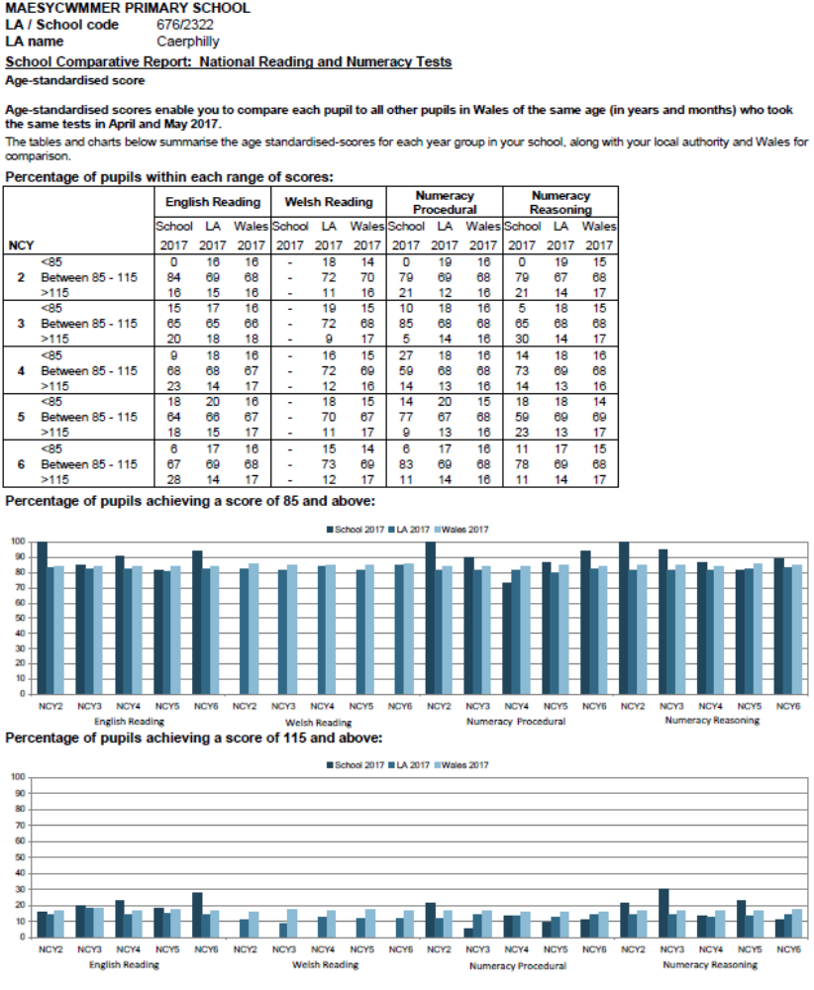

School Reports and Open Evenings
Open evenings are presently held twice a year – Autumn and Spring Term, with an option to discuss end of year reports in the summer term. At these meetings, every opportunity is provided for parents to seek clarification of the progress made by their child. An open door policy is run where parents are concerned about progress or other issues during the course of the year. The only request is that an appointment is arranged where possible. Written Reports are issued to parents in the summer term .It was felt that information would be more beneficial to parents at these times of the academic year and I encourage you to use these opportunities to discuss your child’s progress and how you can help.

Parental Involvement
Parents are at all times invited to take an active interest in their children’s education. Newsletters and Dates are sent home informing parents of pupils’ achievements and what is going on in the school at the time. A Parents Notice Board is also situated at the entrance of both buildings.
Parents are always welcomed into the school for a variety of activities, e.g. Class Assemblies, Sports Day, Christmas Concerts and sporting activities.
All parents receive a curriculum overview at the start of each term to inform them of the work their children will be undertaking. We also advise on ways in which they can support their child and the school in areas we seek to develop/improve i.e. Reading at Home.
Group reading, individual reading, educational visits, class projects, etc. are all made easier to undertake with the assistance of parents/ community members. We have been very fortunate in the quality and number of ‘Helpers’ to date, although I must point out that a DBS check has to be carried out on ALL adults before we can consider accepting your offer to help. – This is a statutory National and LA requirement.
Members of the local community are also invited into the school in order to either enrich the curriculum or share in aspects of school life, Grandparents talk of their experiences i.e. World War II, home and school life in the village when they were children.

Friends of the School Association
All parents of children attending Maesycwmmer Primary School automatically become members of this organisation.
The association was formed over a decade ago not only to benefit the school from fund raising activities but also to help develop more social links/contacts between the school, parents and members of our community.

This hardworking group organises events where staff and parents can meet. The success of these however, is determined by the support received from the parents of our pupils. Meetings are held regularly throughout the year. Should you wish to attend you will be more than welcome.

Links with Local Business Organisations
The school is always keen to further develop links in this area, which are beneficial to both our pupils and the local community. Local companies such as Maesycwmmer Newsagents, Link Financial, ASDA and Tesco are a few of those who have donated to the school over recent years. Links such as these we are always keen to develop. Should your company / employer / organisation wish to make similar contributions to our school, please contact the Head Teacher who will be only too willing to discuss the matter with them.

Access to School and LA Documents
Parents wishing to consult National Curriculum Documentation or school related documentation should contact the Head Teacher in the first instance, as copies are available for perusal at the school.

Complaints Procedure
Our school operates an ‘open door’ policy for parents if they have any pressing concerns. In the first instance a short discussion with the class teacher may resolve the issue. If the issue is not resolved the complaint should be taken to the Head Teacher. The LA has laid down a Complaints Procedure and this document is available for inspection at the school. The Home – School Agreement documents exist for both Foundation Phase and Key Stage 2. It is expected that these agreements will be accepted and entered into by all parents of pupils within the school.

Consent
We will always attempt to gain consent from parents for those activities as required. Currently in school we allow parents to take photographs of their children during school performances, but we do not allow videoing of any performance except those used by staff for pupils to view. Please make sure you have filled in the consent form when your child starts at Maesycwmmer Primary.

