Corporate Risk Assessment

Activity being assessed: Covid 19 Return to school |  |  |  |  |  |  |  |  |  |  |  |  |  |  |  |  | Risk assessment reference number: Covid 19 1  Risk assessment created on: 16/06/2020  Review date due: 24/07/2020 and ongoing  Reviewed: October 2020, January 2021, February 2021
Persons undertaking or affected by the activity
 | ☒ | Employees |  |  | ☒ |  | Contractor |  | ☒ |  |  | Public |  |  | ☐ | Service User |  | ☐ |  | Other
Hazard |  |  |  |  |  | Control measure |  |  |  |  |  |  |  |  |  |  |  |  |  |  |  |  |  | Likelihood  1. Very Unlikely  2. Unlikely  3. Likely  4. Very Likely  5. Certainty |  |  | Severity  1. Negligible  2. Minor  3. Medical Treatment  4. Major  5. Fatal |  |  |  | Risk Level  Likelihood x Severity = Risk Level
Spread of COVID-19 |  |  |  |  |  | General  - All relevant statutory building checks have been undertaken prior to staff being allowed to re-enter buildings.  - Special consideration has been given to whether employees who are considered to be in a higher risk category which make them more susceptible to Covid-19 as per Public Health Guidance should be permitted to come into work. Staff who are highly vulnerable are now working from home (January 2021) and will continue to do so until they are advised that thy no longer need to shield.  Important: For employees who are vulnerable and/or are Black and Minority Ethnic and are therefore considered to be in a higher risk category which make them more susceptible to Covid-19 and are concerned about returning to the workplace, a risk assessment tool has been developed by the Welsh Government which they can complete and share with their Manager. This can then be used as an aide in discussions with the employee to understand any concerns with returning to the workplace and to ensure appropriate control measures can be put in place for the employee to return to a safe environment.  The risk assessment tool can be accessed here and this has been sent out to all staff on return to school in January.  - All persons that are contacted via “Test, Trace, Protect” need to adhere to the guidance given.  Symptoms of Covid-19/ Symptomatic person  - All staff and volunteers are to be made aware of the symptoms of COVID-19 and watch for those symptoms in themselves and others – stay alert. Look for Flu like symptoms – high temperature, new constant coughing bouts and/or a loss or change to your sense of smell or taste.  - If any person/visitor/pupil is suspected of suffering symptoms they should be sent home immediately, or if this is not possible they should be isolated in a separate room (supervised as necessary) until they can be collected. In school this is either the Junior Office or the Infant support room.  - School will remind parents of pupils attending school as vulnerable learners/keyworkers of the importance of up to date contact details for parent/guardians. Person/visitor/pupil should self-isolate according to the guidance produced by Public Health Wales, and or NHS direct.  - Social distancing from the infected person must be exercised wherever possible to prevent the spread of the infection. Where this is not possible, the appropriate PPE must be worn. Refer to PPE section of this risk assessment.  - All potentially infected people will exit via the main entrances (junior and infant). Doors will be wiped down after the person has left. This will ensure all other primary routes are not potentially contaminated.  - If a symptomatic case needs to go to the bathroom while waiting to be collected, they should use the Headteacher’s cloakroom in the Infant Building and the staff toilets in the junior building. The bathroom must be cleaned and disinfected using standard cleaning products before being used by anyone else.  - Personal hygiene after contact with the symptomatic person must be exercised to ensure that the spread of the infection is controlled.  - All areas where a symptomatic person has entered are segregated until a deep clean (level 2) is carried out. If this is a classroom children will be moved into the meeting room until a deep clean of the area is carried out  - AMS cleaning services will be notified so they can arrange a deep clean (Level 2) to the affected areas if it is needed.  - A designated area (the outside bin store) has been identified where double –bagged contaminated waste can be stored for 72 hours until it can be disposed of safely with the normal waste. This waste will be dated when bagged.  - The equipment that the pupil/employee has been in contact with must be withdrawn from circulation and thoroughly cleaned and disinfected before being allowed back into circulation.  Access and Egress  - Gatherings at the main door will be discouraged. Parents will be asked not to stop in the school grounds after dropping children off.  - There will be a staggered entry and exit system for pupils being dropped at and leaving school.  - Coloured spots will be painted at key waiting points to ensure that parents wait at points that are 2m apart. These spots are at all doors to school as all doors will be utilised to reduce queuing. When children arrive at school they will be able to walk straight into class to prevent waiting by the door.  - Children will be collected from pre-identified doors.  - The caretaker and members of the senior management team will be in the entrance areas to remind parents to remain 2m apart and to ensure that the queuing/entry system is understood by all;  - All parents and guardians of children are advised on entry to ensure that their children are not symptomatic; if so then entry into the premises will be denied. Signs will be put up at all entrances to reinforce this message;  - Upon entry, each pupil will be required to sanitise their hands. Sanitising stations will be available at all entry points/in classrooms. Due to the high alcohol content, this will need to be appropriately supervised to prevent accidental ingestion by pupils. Hand sanitiser with high alcohol content should not be placed in direct sunlight, or near any heat source, as it is highly flammable. An up-to-date COSHH assessment must be available at site.  Social Distancing  - Social distancing must be maintained at all times, wherever possible, to reduce the risk of the spread of the COVID-19 virus. E.g. movement around school, staffrooms, children in classrooms, office staff, bursar, caretaker, etc.? Refer to “Neath Port Talbot check in, catch up and prepare for summer and September arrangements” and “Managing Movement around schools” documents.  - Each area of the school will be assessed prior to use, to ensure it is suitable to facilitate social distancing (e.g. number of pupils/staff/desks per classroom etc).  - Due to the size of some corridors within the building, it will sometimes be difficult to keep a distance of 2 metres when passing another employee. In order to reduce this problem and to limit the amount of time employees are in contact with each other, employees should not congregate or have discussions in corridors.  - Where possible non-contact activities should take place when children are in the activity area(s).  - Limit the use of play equipment / activities that may encourage close contact at frequent intervals. Play equipment must be cleaned thoroughly throughout the day with soapy water. Sand, Play Doh etc. must not be used.  - Careful consideration will be given for any employee/pupil requiring a Personal Emergency Evacuation Plan (PEEP) to return to work.  - In order to avoid the use of shared fridges and taps in staffrooms staff are encouraged to bring in their own food and drink in cool bags. Personal flasks could be brought in by employees for hot refreshments, again reducing the need to use communal facilities.  - The staff room has been assessed and only 6 staff are allowed at any one time. Alternative staffrooms are available in the Meeting Room, the Music Room and the PPA room. Again, only 6 staff should be in each of these rooms at any one time. In the infant building only 2 staff at a time should be in the small support room. Windows should be open.  - If communal equipment is used (e.g. fridge, kettle) general cleaning wipes have been provided, to allow staff to wipe down touch points (such as fridge door handle) after use. Staff encouraged to wash hands thoroughly after touching communal equipment.  - No sweets/snacks are to be brought into work for sharing between staff.  - Use of shared printers/photocopiers to be kept to a minimum. Only one person at a time should be within the printing/photocopying area.  Cleaning and Hygiene  - The frequency of wiping down of high-touch areas will be increased throughout the day. High-touch areas include bathrooms/ toilets (not the toilet bowls), railings, tables/ desks /chairs, toys, equipment, door handles, sinks, light switches, etc. Disposable gloves and disposable aprons should be worn when cleaning is taking place.  - Cleaning will take place on the Principle of “Teach Germs a lesson” by using the school cleaning colour coded system. A number of staff have recently been trained in this.  - SCREEN will be made up daily and to the correct dilution rates. Any unused product will be disposed of at the end of the day. An up-to-date COSHH assessment must be available at site.  - All potentially contaminated waste will be placed into a black bag, sealed and placed inside a second black bag and stored in an appropriate area away from all other waste. It should be date labelled and when 72 hours have passed it will be disposed of in the normal manner.  - All children and adults, including staff must wash/sanitise their hands on entry into the premises.  - Skin friendly cleaning wipes can be used as an alternative to hand sanitiser for small children and leaners with complex needs.  - Soap, running water and hand drying facilities are available in every toilet and in each classroom that has a sink.  - Hand washing must take place at regular intervals during the day. Signage will be placed in toilets, sinks, etc. to remind pupils/staff to wash for at least 20 seconds. Staff/pupils will be reminded of good handwashing techniques.  - Stocks of hand sanitiser on the premises will be monitored at regular intervals to ensure that stocks do not run out. Request / replace stocks when they are running low, not when they have run out.  - Hand sanitiser must be stored away from ignition sources such as, sunlight, heat, open flames, hot surfaces, sparks, etc. It must be stored in a cool place.  - If stocks of hand sanitiser have run out, ensure there is adequate hand soap and running water that can be used instead.  - A supply of disposable tissues will be available in each classroom. These are to be monitored and replenished regularly. Separate lidded bins for the tissues should be available in each classroom and other key locations around the site. The contents should be emptied daily.  - Pupils will be shown how to catch a sneeze or cough using their elbow or a tissue and reminded to then wash their hands.  - Additional advice can be found on the eBug Covid-19 website which includes materials to encourage good hand and respiratory hygiene.  - Where possible, we have provided separate toilets for different contact groups or reduced contact groups using the toilets e.g in the infant classes. Where this is not possible, we are ensuring that hand sanitiser is used before entering the toilet and that toilets are cleaned regularly. Learners are encouraged to clean their hands thoroughly after using the toilet  Use of face coverings for health purposes  - Adequate lidded waste bins are on the school premises for those who choose to use single-use face coverings.  - Face coverings should also continue to be worn by adults and learners in all areas of the school building outside of the classroom. The exception is at mealtimes and when they are outside, unless the outside are is very full.  - Staff are encouraged to wear face coverings in the classroom where social distancing is not easily achieved. However, this will be balanced with the needs of the children and communicating with them. There may be occasions when staff in classrooms chose not to wear 3 layer masks.  - Clear visors are available for staff for these occasions.  - Frequent putting on and taking off of face coverings is not recommended as this can risk contaminating hands and face. Therefore, if learners are outside for a short period it may be easier to keep face coverings on.  - Pupils should not wear face coverings when running round, playing football or other active games.  - Visitors to the school setting should use a face covering, including parents and carers when dropping off and picking up learners.  - The school will communicate quickly and clearly to staff, parents and carers and learners that the new arrangements require the use of face coverings in certain circumstances. This will include signage around the school.  - There are some circumstances where people may not be able to wear a face covering. Please be mindful and respectful of such circumstances, noting that some people may be less able to wear face coverings and the reasons for this may not be visible to others. Staff and learners may have a reasonable excuse not to wear a face covering if (for example):  - they are not able to put on or to wear a face covering because of a physical or mental illness, or because of a condition or impairment  - they are accompanying somebody who relies on lip reading where they need to communicate and you cannot access a clear face covering  - they are escaping from a threat or danger and don’t have a face covering  Personal Protective Equipment (PPE)  - When using PPE hands must be washed both before and after use.  - Staff who will be required to use PPE will be provided with information on how to don and doff it correctly.  - Staff using PPE should be familiar with the PPE Information poster at the bottom of this risk assessment.  - PPE for use when dealing with bodily spillages is in prepared packs that can be located in the infant and junior stock cupboards.  Routine activities  No PPE is required when undertaking routine educational activities in classroom or school settings. However, it is recommended that staff wear 3 layer face masks.  General clean of premises  Disposable gloves and disposable aprons must be worn.  Suspected coronavirus (COVID-19)  - Gloves, aprons and a fluid-resistant surgical mask should be worn if a child or young person becomes unwell with symptoms of COVID-19 and needs direct personal care.  - Eye protection should also be worn if a risk assessment determines that there is a risk of splashing to the eyes such as from coughing, spitting, or vomiting.  - A Level 2 clean must take place when cleaning the areas where a person suspected of having COVID-19 has been. The risk assessment identifies the PPE required when undertaking this activity as being disposable gloves, disposable apron, FR(IIR)SM and goggles.  Intimate care including administering first aid  - Gloves and aprons should be used when providing intimate care to a child or young person. This can include personal, hands-on care such as washing, toileting, or first aid and certain clinical procedures such as assisted feeding.  - Fluid-resistant surgical mask and eye protection should also be worn if a risk assessment determines that there is a risk of splashing to the eyes such as from coughing, spitting, or vomiting.  - Gloves and aprons should be used when cleaning equipment or surfaces that might be contaminated with body fluids such as saliva or respiratory secretions.  Movement around/use of premises  - Where possible only rooms with windows that can be opened will be used. These windows will be open throughout the day, although they can be adjusted if the weather is poor. For example: by opening fewer windows or a smaller amount.  - Appropriate doors will be kept open for ventilation if possible.  - Staff/pupils to be reminded to follow the one-way systems in place.  - Fans and hand dryers are not to be used.  - Play equipment / toys that require high levels of shared use will be used by only one ‘bubble’ of children. If there is need to share items will be rested for one week between uses. This includes items such as Lego, bricks, books, art materials etc  - Pupils from Years 2-6 will be provided with their own essential equipment in a pencil case;  - All soft furnishings/ toys will be removed as these are more difficult to clean/ sanitise.  - Shared equipment such a trikes / bike or other ride on toys, are wiped down and cleaned at regular intervals at the start / end and throughout the day.  - Activities that require physical contact should not be conducted. For example P.E. should focus on activities that can be done when social distancing e.g. Yoga, Simon Says, rounders, circuit training  - Movement around the school will be kept as low as practicable to minimise the risk of cross contamination in the school environment, and eliminate the need for a deep clean between classes.  - There will be no cash handled in school.  Meetings  - Face to face interaction will be reduced as much as possible. If a visit/meeting/work can be done via telephone/skype/teams etc. then this should be considered as the safest method. Otherwise consideration must be given to whether a 2 metre distance is achievable.  - Avoid non-essential travel around the building e.g. If you need to speak with someone in another part of the building, use the telephone, skype, ‘teams’ etc. to communicate with them.  - If meetings are necessary, the room should be assessed to determine how many people are permitted to enter meeting rooms whilst maintaining social distancing. If the room has windows these should be opened to improve ventilation.  Mental Health and Wellbeing  - Management will promote mental health & wellbeing awareness to staff during the Coronavirus outbreak and will offer whatever support they can to help.  - Health and Wellbeing during COVID-19 information is available via the home screen on the NPTCC intranet, which provides a wide variety of useful tools such as contact information for support services, online stress control classes etc.  Emergency procedures such as fire, first aid  - The emergency evacuation procedure has been reviewed and communicate to staff/pupils. No changes are needed.  - Ensure there are sufficient numbers of appropriately trained first aiders available. They should follow the training they have received and use PPE as detailed previously.  - Only deliver CPR by chest compressions and use a defibrillator (if available) don’t do rescue breaths.  - Practice good hygiene by washing/sanitising hands before and after administering first aid.  Vulnerable and Keyworkers schooling from January 2021 and February 2021 (Key Stage 2 only)  It still remains essential that we minimise contacts and mixing between people reduces transmission of COVID-19.  Pupils will be organised into Year Group bubbles for the purpose of providing schooling for vulnerable pupils and the children of keyworkers. These groups should be kept separate at all times.  If groups numbers exceed 20, consideration will be given to splitting them to make further groups. This will be balanced with the need to increase the number of days staff have to attend school to staff the provision.  The staffing rota will be organised to minimise mixing between staff and pupils. If at all possible, staff will work on the same days each week and in the same ‘pod’ of pupils. Each pod will have access to outdoor space and two classroom areas.  For children old enough, they should also be supported to maintain distance and not touch staff where possible.  Parents will drop off and collect children from the main junior door. They will wait 2m apart to drop off/collect pupils at the beginning and end of the school day. Parents/carers will be expected to wear face coverings on the school site, unless they are exempt.  All other routines will follow those set out throughout this risk assessment. |  |  |  |  |  |  |  |  |  |  |  |  |  |  |  |  |  | 2 |  |  | 3 |  |  |  | 6
Personal Protective Equipment
 |  |  |  |  |  |  |  | 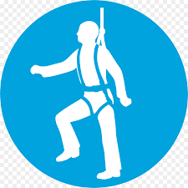 |  |  |  |  |  |  |  |  |  |  | 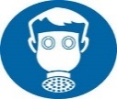 |  |  |  |  |  |  |  |  | Other
Aprons must be worn |  |  | Eye Protection must be worn | Head Protection must be worn |  |  |  | Safety Harness must be worn |  |  | Ear Protection must be worn |  |  | Safety overalls must be worn |  |  | Safety boots must be worn |  | Respiratory equipment must be worn |  | Hi Viz clothing must be worn |  | Protective  gloves must  be worn |  |  | Face Protection must be worn |  |  | ____________________________________________________________________
☒ |  |  | ☒ | ☐ |  |  |  | ☐ |  |  | ☐ |  |  | ☐ |  |  | ☐ |  | ☐ |  | ☐ |  | ☒ |  | ☒ |  |  | ☐
Additional risk information
In the event of an incident/accident, please contact your nearest first aider.
All incidents/accidents must be recorded on NPT’s Online Accident Reporting System.
Suitable information, instruction and training on how to use, store and maintain Personal Protective Equipment (PPE) correctly to be provided.
All staff to have regard for their and others health and safety at all times.

Please identify how this risk assessment has been communicated
Team brief / Team meeting | ☒
One to one | ☐
Email | ☒
Other (please specify: | ☐

Emergency Procedures
Contact name: | Helen Woodford/ Nicola Bridgman
Contact number: | 01639 635256
Contact number (out of hours):
Hospital: | Morriston
Emergency Services: | 999

Name:  Helen Woodford | Position:  Headteacher | Date:  16/06/2020

Risk assessments must be reviewed as a result of change in working practices / legislation or following an incident / accident
Reviews | Key
Review date : 17th August 2020 | Likelihood | Severity | Likelihood of Injury | 5 | 5Y | 10R |  | 15 | 20 |  | 25
Reviewed by: Helen Woodford | - Very Unlikely - This will probably never happen/occur  - Unlikely - Do not expect it to happen/recur but it is possible it may do so  - Likely - Might happen or recur occasionally  - Very Likely - Will probably happen/recur, but it is not a persisting issue/circumstance  - Certainty - Will undoubtedly happen/recur, possibly frequently | - Negligible - Minor injuries or discomfort. No medical treatment or measurable physical effects.  - Minor - Injuries or illness requiring on site first aid. Temporary impairment.  - Medical Treatment - Injuries or illness requiring hospital treatment.  - Major - Injury or illness resulting in permanent impairment.  - Fatal - Fatality. |  | 4 | 4 | 8 |  | 12 | 16 |  | 20
Review date : |  |  |  | 3 | 3 | 6G |  | 9 | 12 |  | 15
Reviewed by: |  |  |  | 2 | 2 | 4 |  | 6Y | 8 |  | 10Y
Review date : |  |  |  | 1 | 1 | 2 |  | 3 | 4 |  | 5G
Reviewed by: |  |  |  | 0 | 1 | 2 |  | 3 | 4 |  | 5
Review date : |  |  |  | Severity of Injury
Reviewed by: |  |  |  |  | Low Risk |  | Medium Risk |  |  |  | High Risk

Appendix 4
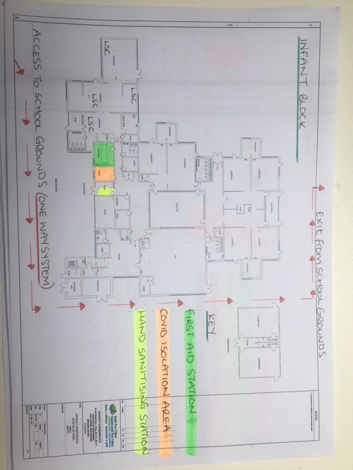
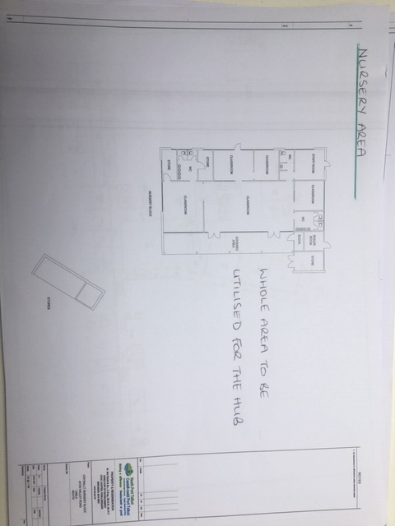
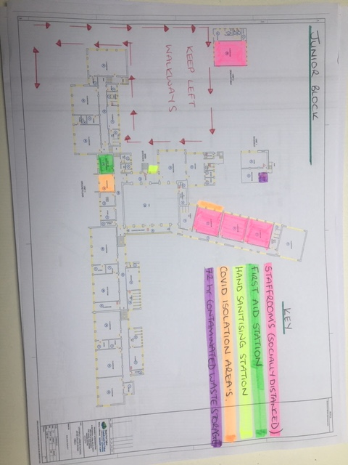
CAD drawings of p

