HOME WORKING PACKS: 6th July
5/6N and 6G
Dear Parents/Carers,
This week, in class, the children have been learning the following skills:
1) To use a written method to multiply 2 digit by 2 digit numbers
2) To mentally recall their times tables up to 12 x 12
3) To plan a story
4) To start sentences using adverbs
You can carry on with this work at home by trying some of the following activities. Remember to take some pictures and send them to us on Class Dojo/share on Hwb/Teams etc.
Daily Tasks!
These are really important to help support your child with their learning. If you are really busy please complete these tasks as a minimum:
- Hear your child read or read with your child for 10 minutes a day. Once they have finished reading, question them about what they have read e.g. what happened? How did the character feel? Why do you think they did that? What do you think will happen next? Where possible ask the children to find evidence in the story to support their answers.
- Practise your timestables making sure that your child can recall the answers quickly. If they are already confident with their timestables then ask them some division related facts e.g. 72 divided by 9
- Practise your spelling words everyday. You can have fun writing them BIG or small, in bright colours or with water and a paintbrush outside!
Research a famous artist of your choice and recreate one of their pictures | Look at the science investigation sent to you through assignments. Have a go at the investigation. Create an annotated diagram of an ear. Can you explain how we hear?
Create a factfile on j2e of natural landmarks (e.g. the Grand Canyon etc.). Include text boxes, images and different text types/sizes. Add a hyperlink to another page or website. | Look at the Flipgrids your teacher sends you. You can even make a Flipgrid of your own explaining or reading your work to send back!
Spreadsheets:  Look at the assignment titled ‘Spreadsheet recap’. Recreate the spreadsheet in your one drive using formulas to get the answers to each question. Attach your final spreadsheet to the assignment and hand it in. | Scratch  Look at your assignments. We have sent you instructions on how to create your own scratch game. Have a go at completing it and then email the link to the game to me.

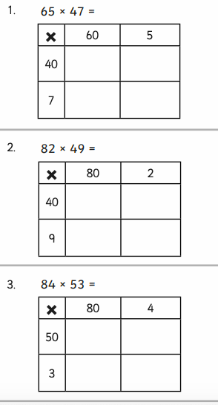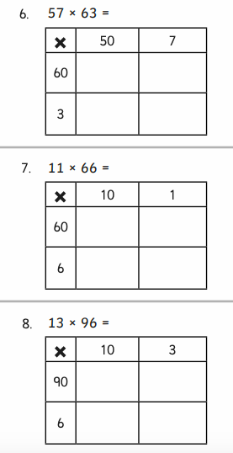
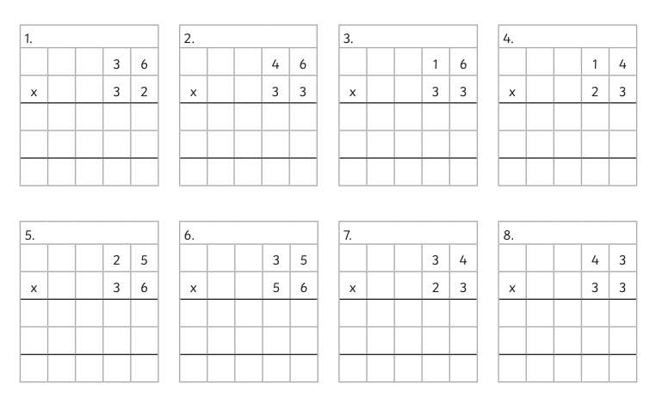
If you do not have your child’s Login details for Hwb, please let me know. I can provide them for you.

A guide to using Hwb can be found on the school website under the Curriculum Tab
The website address is: https://crynallt-primary-school.j2bloggy.com/

Websites to support reading:

Read, Write, Inc lessons are played daily at 9.30am on the YouTube Channel:

https://www.youtube.com/channel/UCo7fbLgY2oA_cFCIg9GdxtQ

https://www.bbc.co.uk/bitesize/topics/zprrd2p

Websites to support Maths:

https://corbettmathsprimary.com/

https://www.bbc.co.uk/bitesize/subjects/z826n39

https://www.thenational.academy/#

Websites to support Wellbeing:

https://www.elsa-support.co.uk/category/free-resources/

https://youngminds.org.uk/resources/school-resources/

ONLINE LESSONS FROM THE TEACHER:

This week your child’s teacher has produced 2 Flipgrids on Welsh and P4C. He/She has also produced 2 Explain Everything Lessons which will help your child to learn how to round numbers and use dialogue in their writing. These can be accessed through Team Assignments.

