HOME WORKING PACKS: 6th July
5/6N and 6G
Dear Parents/Carers,
This week, in class, the children have been learning the following skills:
1) To use a written method to divide with decimal remainders
2) To mentally recall their times tables up to 12 x 12
3) To write a short story
You can carry on with this work at home by trying some of the following activities. Remember to take some pictures and send them to us on Class Dojo/share on Hwb/Teams etc.
Daily Tasks!
These are really important to help support your child with their learning. If you are really busy please complete these tasks as a minimum:
- Hear your child read or read with your child for 10 minutes a day. Once they have finished reading, question them about what they have read e.g. what happened? How did the character feel? Why do you think they did that? What do you think will happen next? Where possible ask the children to find evidence in the story to support their answers.
- Practise your timestables making sure that your child can recall the answers quickly. If they are already confident with their timestables then ask them some division related facts e.g. 72 divided by 9
- Practise your spelling words everyday. You can have fun writing them BIG or small, in bright colours or with water and a paintbrush outside!
Y6: Write an acrostic poem about your time at Crynallt using the word ‘Leavers’  Y5: Write an acrostic poem about the school. Use the word Crynallt. | Design a new logo for the school. Think about what makes the school special and what it will tell others about the school.
Create a one page profile so that your Comprehensive teachers/Year 6 can find out about you. Look at the template shared through j2e. | Look at the Flipgrids your teacher sends you.  Y5: Create a flipgrid to tell everyone about your favourite memory from year 5.  Y6: Create a flipgrid to tell everyone about your favourite memory from your time at Crynallt
Write a paragraph about where you see yourself in 20 years. Think about what career you will have, whether you are married and have children etc. | Scratch  Look at your assignments. We have sent you instructions on how to create your own scratch game. Have a go at completing it and then email the link to the game to me.

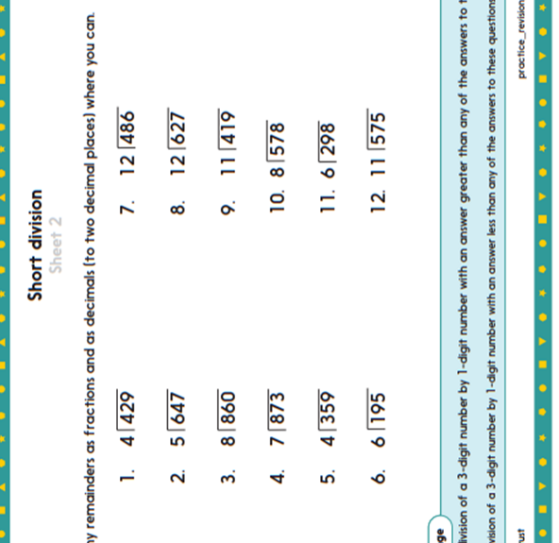

If you do not have your child’s Login details for Hwb, please let me know. I can provide them for you.

A guide to using Hwb can be found on the school website under the Curriculum Tab
The website address is: https://crynallt-primary-school.j2bloggy.com/

Websites to support reading:

Read, Write, Inc lessons are played daily at 9.30am on the YouTube Channel:

https://www.youtube.com/channel/UCo7fbLgY2oA_cFCIg9GdxtQ

https://www.bbc.co.uk/bitesize/topics/zprrd2p

Websites to support Maths:

https://corbettmathsprimary.com/

https://www.bbc.co.uk/bitesize/subjects/z826n39

https://www.thenational.academy/#

Websites to support Wellbeing:

https://www.elsa-support.co.uk/category/free-resources/

https://youngminds.org.uk/resources/school-resources/

ONLINE LESSONS FROM THE TEACHER:

This week your child’s teacher has produced 2 Flipgrids on Welsh and P4C. He/She has also produced 2 Explain Everything Lessons which will help your child to learn how to round numbers and use dialogue in their writing. These can be accessed through Team Assignments.

