Year 3 Home learning.
Dear Parents/Carers,
This week, in class, the children have been learning the following skills:
- Solving multiplication and division questions.
- To log on to J2e5 to complete a piece of work and share it with my teacher.
- To write a paragraph about ourselves.
- To complete a piece of art based on the story ‘Happy dreamer’.
You can carry on with this work at home by trying some of the following activities. Remember to take some pictures and send them to us on Class Dojo/share on Hwb/Flip grid.
Daily Tasks!
These are really important to help support your child with their learning. If you are really busy please complete these tasks as a minimum:
- Hear your child read or read with your child for 10 minutes a day;
- Practice counting in 2’s, 3’s, 5’s and 10’s. The more they practise the better!
- Practice writing the spelling words. You can have fun writing them BIG or small, in bright colours or with water and a paintbrush outside!
It’s almost time to move onto your next class can you write five things you would like your next teacher to know about you.  You could include your hobbies, family, favourite colour, favourite foods, favourite subjects and best friends. | Listen to the story Happy dreamer on flip grid. In the story the little boy likes to dream, what would your dream be for the future? You might want to be a doctor, firefighter, teacher, engineer, astronaut, musician, footballer. Draw a picture of your dream for your future and share it with us on flipgrid.
Listen to the story Tedi Twt a doli glwt yn yr ysgol, can you draw a day in school and label each part of the day using the welsh vocabulary. | Rosie and Rufus remind us that we have the right to an education. Can you design a poster telling your friends what you enjoy most about school?
Look at the multiplication and division fact family video on Flipgrid can you answer the questions at the end of the video. | Can you use lego, knex, building blocks to design your perfect school. What would you include in your design?
What are you looking forward to doing in the summer holidays? Can you write a list of all of the things you are looking forward to? | Can you design a healthy packed lunch/picnic, what kind of things would you choose? Draw your packed lunch/picnic and label it.
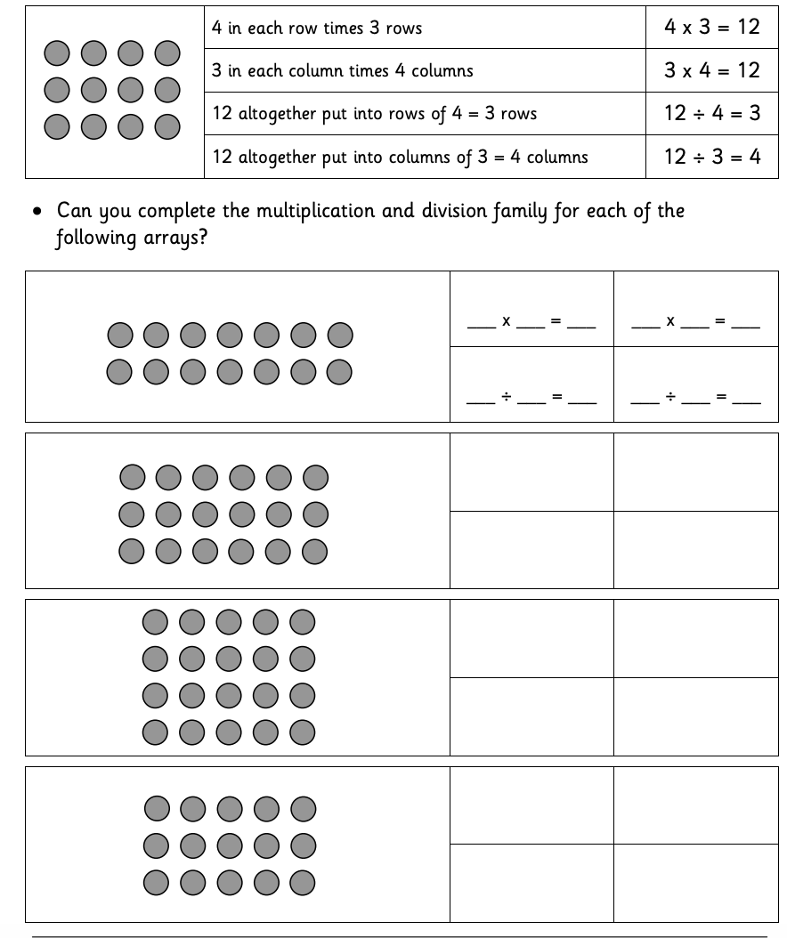
Multiplication and division fact families
Follow the link to a game to practise the skill: https://www.topmarks.co.uk/number-facts/number-fact-families

Spelling – Plurals
Continue practising last weeks patterns:
Adding s to words:
bugs, bags, boys, girls, legs

Adding es to words:
bunches, dishes, glasses, boxes, witches

New pattern:

Drop the y and add ies. E.g. baby – babies

babies
flies
berries
spies
pennies
families

If you do not have your child’s Login details for Hwb, please let me know. I can provide them for you.
A guide to using Hwb can be found on the school website under the Curriculum Tab
The website address is: https://crynallt-primary-school.j2bloggy.com/
Websites to support reading/spelling:

  - Read, Write, Inc lessons are played daily at 9.30am on the YouTube Channel: https://www.youtube.com/channel/UCo7fbLgY2oA_cFCIg9GdxtQ
  - You can also access free RWI e-books here: https://www.oxfordowl.co.uk/for-home/library-page?view=details&query=&type=book&age_group=&book=&book_type=Fiction&series=Read+Write+Inc.
  - Listen to David Walliams read every day here: https://www.worldofdavidwalliams.com/elevenses/
  - J2Spell on Hwb
  - BBC Bitesize: https://www.bbc.co.uk/bitesize/subjects/zv48q6f
Websites to support Maths:
  - Hit the Button: https://www.topmarks.co.uk/maths-games/hit-the-button
  - BBC Bitesize: https://www.bbc.co.uk/bitesize/subjects/z826n39
  - J2Blast on Hwb
  - Corbett Maths: https://corbettmaths.com/
Websites to support Wellbeing:
  - Cosmic Kids Yoga: https://www.youtube.com/channel/UC5uIZ2KOZZeQDQo_Gsi_qbQ
  - Health For Kids: https://www.healthforkids.co.uk/
  - Art Activities: https://www.tate.org.uk/kids?gclid=EAIaIQobChMIkr7NqJaa6gIViZntCh3qUQxZEAAYASAAEgKFhvD_BwE

ONLINE LESSONS FROM THE TEACHER:
This week we have produced 3 Flipgrids on welsh, art and literacy.
We have also produced an Explain Everything Lesson which will help your child to learn about multiplication and division fact families.

