HOME WORKING PACKS: 29th June
5/6N and 6G
Dear Parents/Carers,
This week, in class, the children have been learning the following skills:
1) To read and write numbers up 100,000
2) To order decimal numbers
3) To round numbers to the nearest ten, hundred and thousand
4) To identify what makes a good piece of writing (DADWAVES)
You can carry on with this work at home by trying some of the following activities. Remember to take some pictures and send them to us on Class Dojo/share on Hwb/Teams etc.
Daily Tasks!
These are really important to help support your child with their learning. If you are really busy please complete these tasks as a minimum:
- Hear your child read or read with your child for 10 minutes a day. Once they have finished reading, question them about what they have read e.g. what happened? How did the character feel? Why do you think they did that? What do you think will happen next? Where possible ask the children to find evidence in the story to support their answers.
- Practise your timestables making sure that your child can recall the answers quickly. If they are already confident with their timestables then ask them some division related facts e.g. 72 divided by 9
- Practise your spelling words everyday. You can have fun writing them BIG or small, in bright colours or with water and a paintbrush outside!
Create a powerpoint about an interest or hobby. Remember to use images, transitions as well as different colours and fonts on each slide. Also explore the special effects to see what other cool features Power Point has. | Grow your own rainbow.  Watch the video on how to grow your own rainbow then have a go at making your own. Take a photo and send it to your teacher.  https://www.youtube.com/watch?v=8iZCNnYewmk
Log onto HWB and use j2e to create a front cover for your book. Think carefully about your design and what makes a good front cover. It needs to grab a reader’s attention and stand out from the rest. | Look at the Flipgrids your teacher sends you. You can even make a Flipgrid of your own explaining or reading your work to send back!
Hwb Email  Write an email to your teacher or your friend explaining who your favourite Mr Men character is and why. Attach an image of your favourite character to your email. This can be done by copying an image into a word document and then attaching it. | Will it dissolve?  Watch the link below and follow the same steps to see if your materials dissolve, don’t worry if you can’t find the exact materials you can chose some of your own. Remember to record your results in a table and try to predict if each material will dissolve or not.  https://www.youtube.com/watch?v=gcxU2uXeh0c
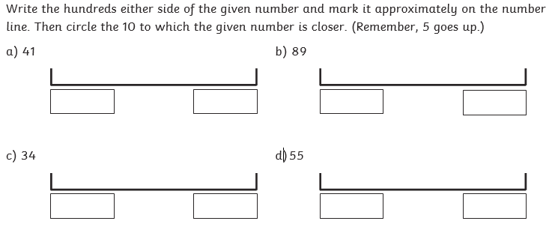
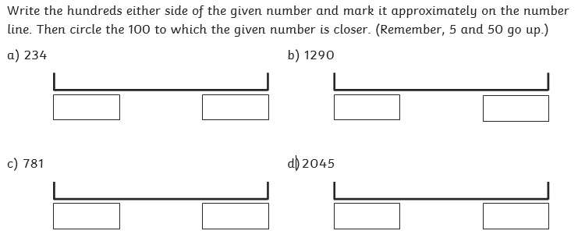

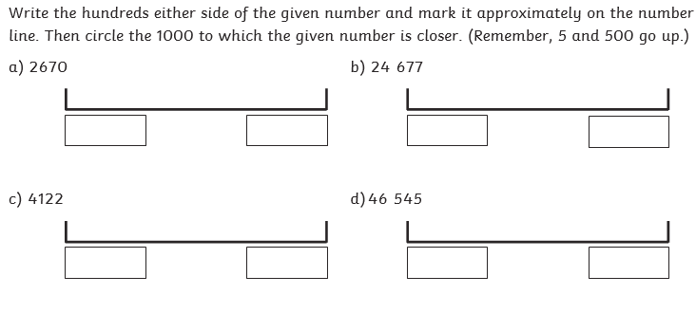
If you do not have your child’s Login details for Hwb, please let me know. I can provide them for you.

A guide to using Hwb can be found on the school website under the Curriculum Tab
The website address is: https://crynallt-primary-school.j2bloggy.com/

Websites to support reading:

Read, Write, Inc lessons are played daily at 9.30am on the YouTube Channel:

https://www.youtube.com/channel/UCo7fbLgY2oA_cFCIg9GdxtQ

https://www.bbc.co.uk/bitesize/topics/zprrd2p

Websites to support Maths:

https://corbettmathsprimary.com/

https://www.bbc.co.uk/bitesize/subjects/z826n39

https://www.thenational.academy/#

Websites to support Wellbeing:

https://www.elsa-support.co.uk/category/free-resources/

https://youngminds.org.uk/resources/school-resources/

ONLINE LESSONS FROM THE TEACHER:

This week your child’s teacher has produced 2 Flipgrids on Welsh and P4C. He/She has also produced 2 Explain Everything Lessons which will help your child to learn how to round numbers and use dialogue in their writing. These can be accessed through Team Assignments.

