Dear Parents/Carers,
This week, in class, the children have been learning the following skills:
- To find area by counting squares and multiplying length by breadth.
- To explore and create dialogue for a comic strip.
- To log on to TEAMS to complete a piece of work.
- To practise fielding and batting skills. 5T
- To improve footwork techniques (tennis) 5P
You can carry on with this work at home by trying some of the following activities. Remember to take some pictures and send them to us on Class Dojo/Share on J2E/Teams etc.
Daily Tasks!
These are really important to help support your child with their learning. If you are really busy please complete these tasks as a minimum:
- Listen to your child for 20 minutes a day and question their recall. Can they create questions for YOU to answer based on what they have read ?
- Practise their recall of tables especially x6,x7,x8, x9 (Chant, recite forwards and backwards, question out of sequence, randomly)
- Practise your spelling of high frequency words. (These will be on TEAMS) You can have fun writing them BIG or small, in bright colours or with water and a paintbrush outside!
- Visit https://www.teachitprimary.co.uk/reading-comprehension-ks2 to practise reading skills such as information retrieval and inference and deduction. There are different levels according to year group to choose from. Choose higher year group comprehensions if you want a challenge after Year 5.
Teams Task : What are the features of comic strips ? Research comic strips – find some examples and present them in J2E5 and blog to the school J2Webby. | Can you make a model (Lego/Sand/clay/salt dough/plasticine) of a favourite character from a comic strip ?
Find the perimeter of your garden. How much Astroturf would you need to cover your garden? Work out its area. Extra challenge – how much would it cost ??? | Look at the Flipgrids your teacher has placed in Assignments in TEAMs. You can even make a Flipgrid of your own to send back! Extend your responses – use the pause button if you need to , then continue!
Can you create some beach or garden art using materials you have gathered ?  What will you make ? | Around the House:  Create a game using materials from you garden for your family to play. For inspiration here is a good site:  https://www.diyncrafts.com/17772/home/35-ridiculously-fun-diy-backyard-games-borderline-genius
Big Maths  Days 1 to 10 can be found in the ‘files’ area of Teams | Nebula in a Jar Night  With the help of an adult  Create your own nebula in a jar.  https://masonjars.com/mason-nebula-jar.html

If you do not have your child’s Login details for Hwb, please let me know. I can provide them for you.
A guide to using Hwb can be found on the school website under the Curriculum Tab
The website address is: https://crynallt-primary-school.j2bloggy.com/
Websites to support reading:
Read, Write, Inc lessons are played daily at 9.30am on the YouTube Channel: https://www.youtube.com/channel/UCo7fbLgY2oA_cFCIg9GdxtQ
https://www.teachitprimary.co.uk/reading-comprehension-ks2
Websites to support Maths:
https://nrich.maths.org/
https://www.themathsfactor.com/ (FREE for 21 days !)
Websites to support Wellbeing:
Healthforkids.co.uk
Understood.org
ONLINE LESSONS FROM THE TEACHER:
This week the Year 5 teachers, Miss Todd and Mr. Parvin, have produced 3 Flipgrids on Welsh, reading a story (P4C) and Two Truths and a Lie.
An Explain Everything Lesson has also been created which will help your child learn how to use a calculator to work out cost in preparation for the next part of our Theme Park activity.

Please find below a Maths activity and a reading comprehension for your child. Again they can work in TEAMS. There will be a Word document for them to write their answers on and submit.

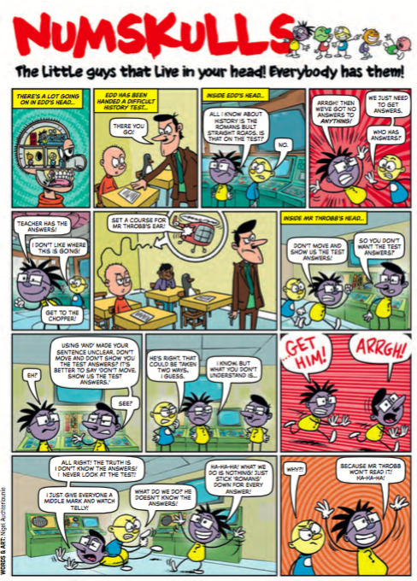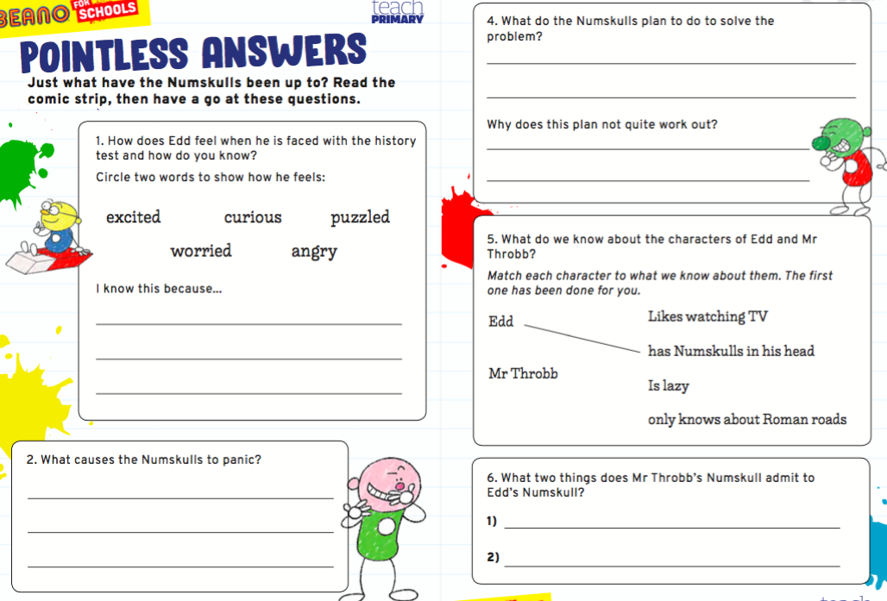

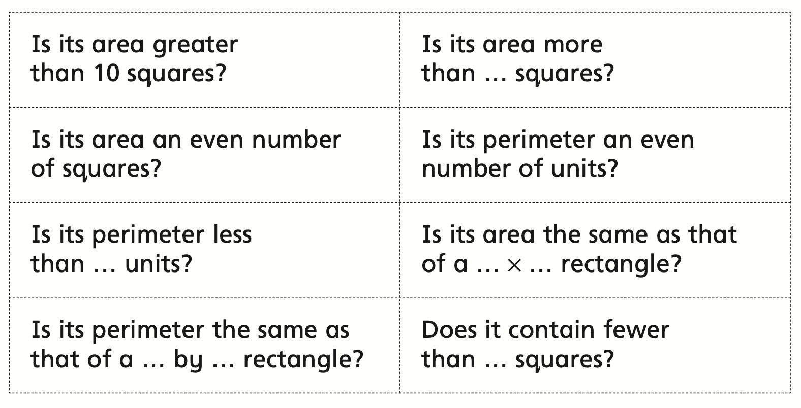
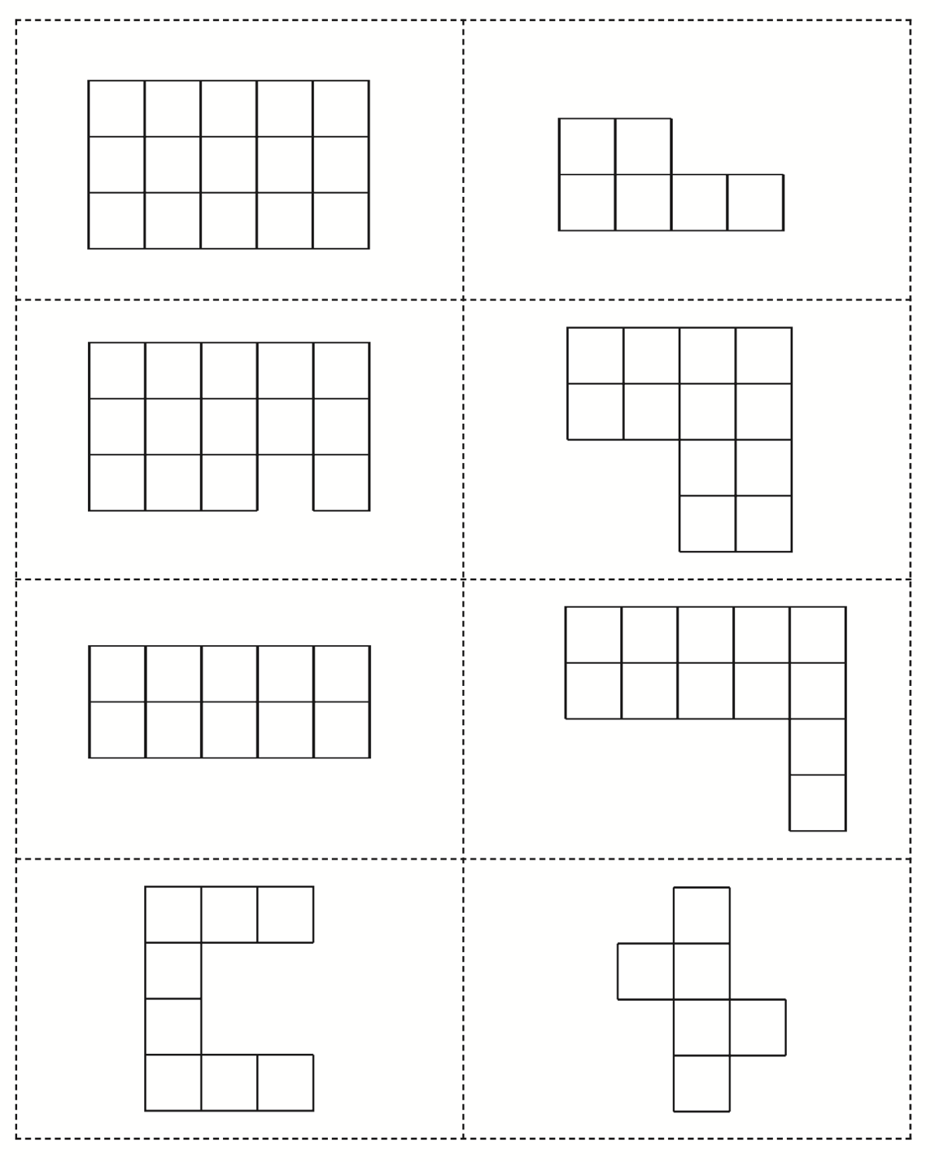
This activity has been sent to your child on Microsoft Team Assignments.
Please complete online ‘hand in’

