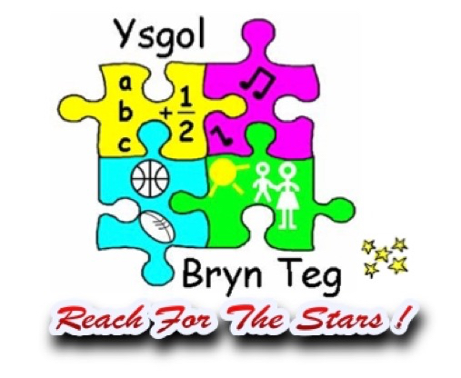

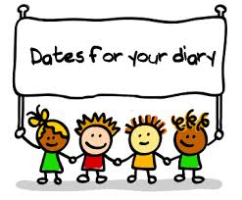

* 21st of April- School Photos
* 28th of May- Class Pirate Party- Children to come in dressed as pirates.

This term our theme will continue to be Land Ahoy! We will be exploring maps, learning about famous pirates and find out about their life at sea. We will be investigating which materials would make the best boats for the pirates to sail in.

In our Talk for Writing sessions we will be looking at the story ‘The Rainbow Fish’. We will be re-telling the story through actions, story maps and innovating it to create our own version of ‘The Rainbow Fish.

We will continue to develop our handwriting, spelling, reading and writing through our RWI sessions. Pupils will be focusing on reading red words, recapping and consolidating their knowledge of letter sounds to read unknown words. In maths this term we will be looking at capacity, addition & subtraction and also directions. This term during our PSE lessons we will be looking at ‘Relationships’ through our Jigsaw scheme.

Our right is from Article 28- You have the right to a good quality education.



**Important information**

* Please follow the one way system when collecting and dropping off your child ensuring you are wearing a mask.
* Only share a lift to school if it is completely necessary.
* Social bubbles are for school only
* Keep your child at home if they are unwell.
* There’ll be plenty of time for birthday parties and sleepovers but for now please ensure you’re doing everything to keep our wonderful school open, so we can continue face to face teaching for all.

**Daily reminders**

- Fruit

- Water bottle

- Coat

- Wellies (can be kept in school)

- Spare clothing (can be kept in school)

- Lunch boxes (Reminder that we are a healthy school, remember a spoon for yoghurts, pasta etc)

 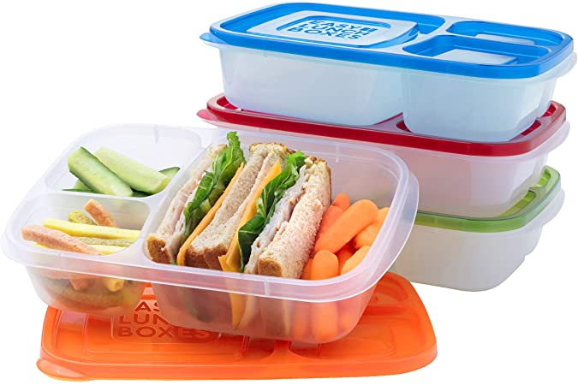 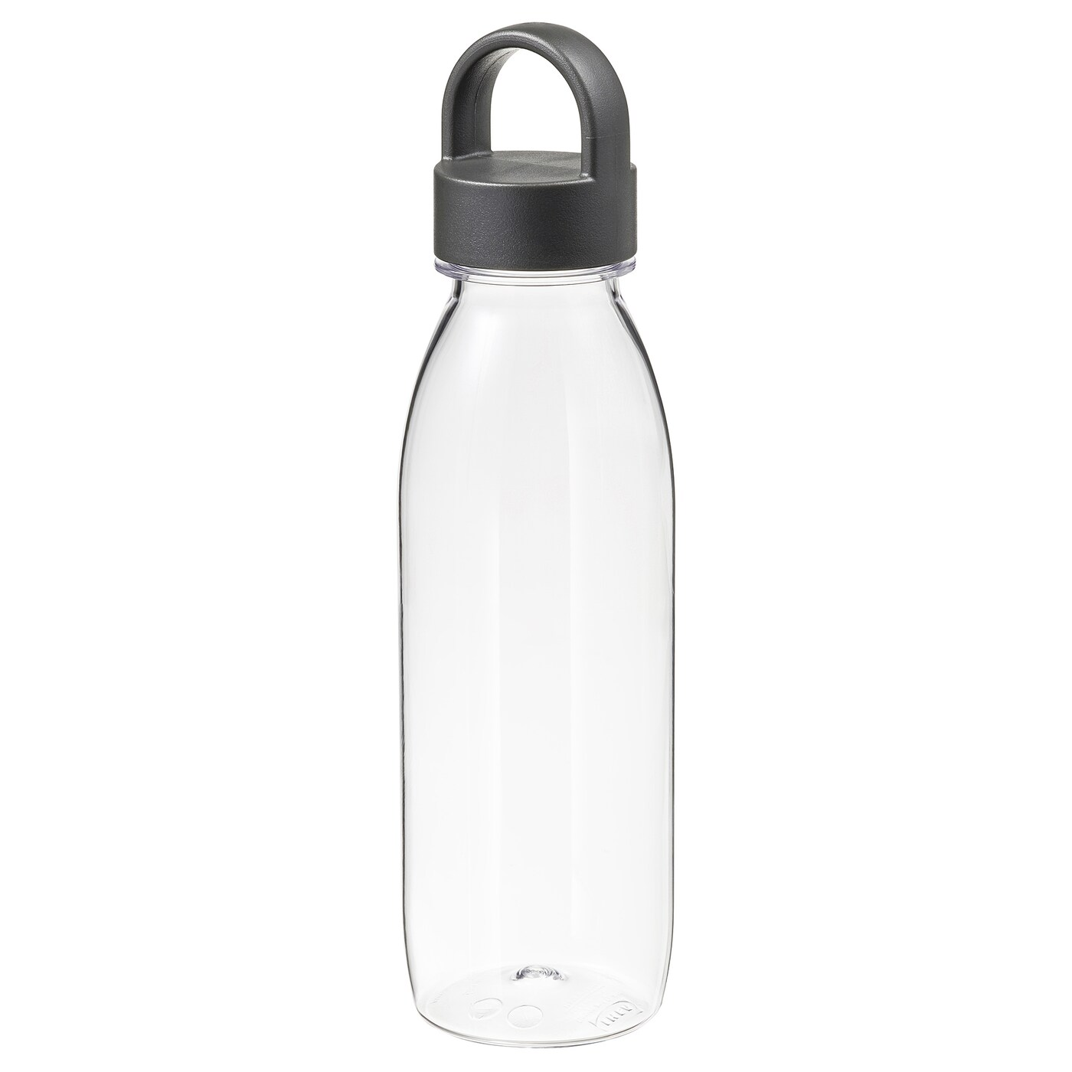

**Drop off and collection times**

**8:50-9:00- Drop off time**

**2:50-3:00- Collection time**

Please stick to these times

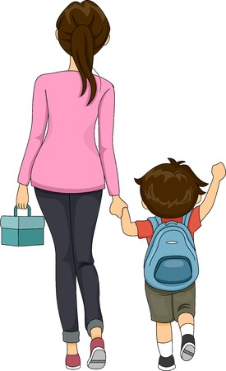

Thank you so much for your on-going support during this challenging time. If you ever have any concerns about your child, then please do not hesitate to contact myself or Mrs Williams

Phillipsc362@hwbcymru.net

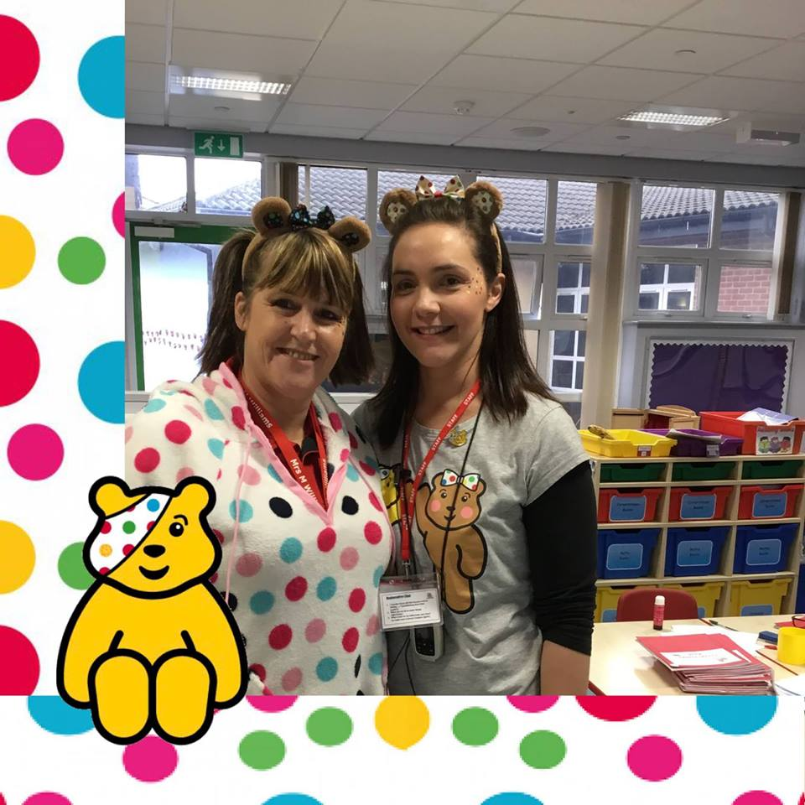

It’s Summer Term! Welcome back to our wonderful class. We hope you all had a lovely half term!

Miss Phillips and Mrs Williams will be teaching the pupils in class and we’ll be working together to give the best to all pupils in Dosbarth Wiwer.

Croeso i Dosbarth Wiwer