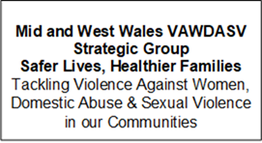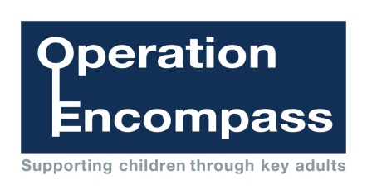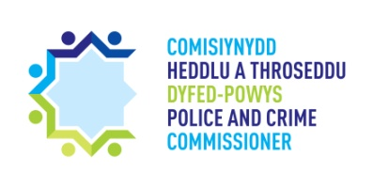



Dear Parent/Carer,

The school has been given the opportunity to take part in a project that will run jointly between schools and Dyfed-Powys Police. It is a county wide initiative across all schools in Carmarthenshire.

Operation Encompass is the reporting to schools, prior to the start of the next school day, when a child or young person has been exposed to, or involved in, any domestic incident.

Operation Encompass will ensure that a member of the school staff, known as a Key Adult, is trained to use the information that has been shared with them about the domestic incident. This is to ensure that a child is adequately supported and/or their families, who have been involved in, or exposed to, a domestic abuse incident.

We are keen to offer the best support possible to all our pupils and we believe this will be extremely beneficial for all those involved.

Signed

*G Jones*

Headteacher

Ysgol Bryn Teg