Junior Orienteering

Sampsons Wood

11th September

Sampsons Wood, Yeovil

ST 53822 15003 / BA20 2PZ
Our Junior Orienteering Group (JOG) runs weekly events
through term time aimed at juniors, families and those looking to
improve or train.
This is a great way to get out in the fresh air, get some exercise and
experience some of our wonderful countryside and parks.
You do not need to be a member and volunteers will be on-hand
to provide any help or guidance you may need. Courses are set
across four levels to cater for those who have never tried
orienteering through to those who consider themselves ‘seasoned’
participants.
Whether you walk the course or run, you are guaranteed to have
some fun.

Directions
Parking for the event will be in Yew Tree Park, off Lysander Road
(A3088) in Yeovil. The entrance to Sampsons Wood is a 3 minute
walk from the carpark and will be clearly signposted.
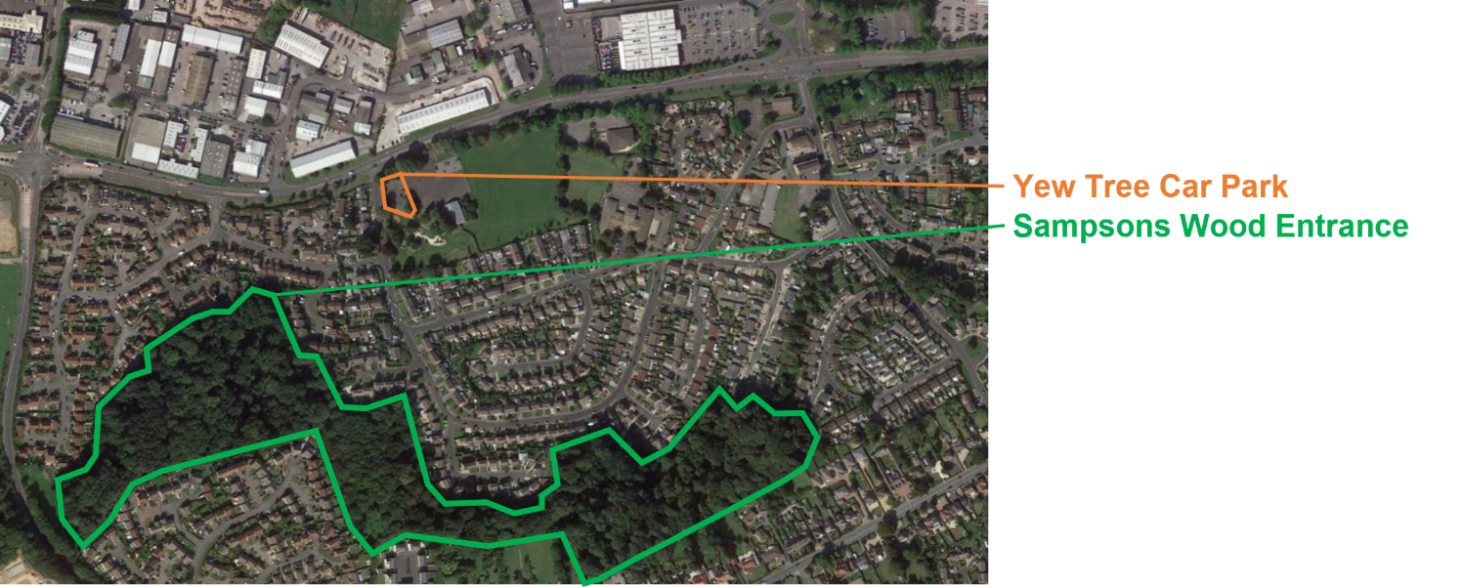

Costs
£1 per person
You will be provided with a map of the Wood and your chosen course together with a compass and SI ‘dibber’ (we will explain what this is if you do not know already….)

Times
Starts: 1400 - 1500
Course close: 1600

Other info
Visit the web page below to find out more details
and to register for the event.
Sampson's Wood - Quantock Orienteers

For more information contact:
Name: Judy and Roger Craddock
Phone number: 01823 323850
Email address: jandr.craddock@gmail.com
or visit: www.quantockorienteers.co.uk
