All Saints Church School
Ladies Walk, Montacute, Somerset, TA15 6XG
Tel: 01935 826626 Fax: 01935 825788
e-mail: office@allsaints.bwmat.org Head Teacher: Mrs Sharon Bowditch BAQTS

Monday 13th July 2020
Dear Parent and Carers
As we draw towards the close of a school year and an extraordinary year, I wanted to let you all know how incredibly proud I am to be part of the All Saints community along with you all. So much has been out of the ordinary recently and in many ways, it has been challenging. Prior to lockdown our teaching and learning through STEAM had focused on the importance of resilience and perseverance. As we have ridden this rollercoaster of experiences and emotions, I know that many of our children have shown these skills in abundance through their online learning and communication with their teachers. Throughout this period, I feel we have become an even stronger community. We are so much looking forward to meeting together again and getting to know our new Acorn Class, face to face, in September.
Please find below my plans for September following the recent Government Guidance sent out at the end of last week.
There are three sections to this letter, Protective Measures, Organisation of the school day and our Recovery Curriculum.
What does the Government say about opening schools to all in September?
The Government guidance shared last week requires all schools to assess their risk, and work through a system of controls. Schools will need to adopt measures that address the risks identified in their assessment. This will enable schools to deliver a broad and balanced curriculum for their pupils.
https://www.gov.uk/government/publications/actions-for-schools-during-the-coronavirus-outbreak/guidance-for-full-opening-schools
Protective measures we are taking in light of coronavirus (COVID-19)
First and foremost, it goes without saying that the safety of your child and of our staff is our top priority. We have been working hard, following the recent government guidance, to implement the systems of control required.
Some of the steps we are taking in readiness for reopening include:
- We will engage with the NHS Test and Trace process
- We will manage confirmed cases of coronavirus (COVID-19) amongst the school community and contain any outbreak by following local health protection team advice
- If anyone in the school becomes unwell with a new, continuous cough or a high temperature, or has a loss of, or change in, their normal sense of taste or smell (anosmia), they will be sent home and advised to follow ‘stay at home: guidance for households with possible or confirmed coronavirus (COVID-19) infection’, which sets out that they must self-isolate for at least 7 days and should arrange to have a test to see if they have coronavirus (COVID-19). Other members of their household (including any siblings) should self-isolate for 14 days from when the symptomatic person first had symptoms.
- https://www.gov.uk/government/publications/covid-19-stay-at-home-guidance
- Ensuring that pupils, staff and other adults do not come into the school if they have coronavirus (COVID-19) symptoms, or have tested positive in the last 7 days, and ensuring anyone developing those symptoms during the school day is sent home
- Keeping our children in class bubbles in and around the school
- Children will clean their hands regularly, including when they arrive at school, when they return from breaks, when they change rooms and before and after eating. Regular and thorough hand cleaning is going to be needed for the foreseeable future.

- Children are required to wash hands thoroughly for 20 seconds
- Before leaving for school from home
- When arriving at school - anti-bac soap
- Before handling food - anti-bac soap
- After toilet – anti-bac soap
- After break – anti-bac soap
- After Sport – anti-bac soap
- When leaving school - anti-bac soap
- Sanitiser stations are also placed around the school – entry to classrooms, school hall, office area, foyer and corridors
Parents can send in hand cream to offset hand washing issues. This is not to be shared and must remain in their bags and must be applied by the child themselves.
- The ‘catch it, bin it, kill it’ approach continues to be very important. Each classroom and all key areas around the school have lidded bins for the disposable of tissues to support pupils and staff to follow this routine. The teaching of this concept will be included in the introductory transition lessons when the school opens in September and has been heavily promoted during the lock down period and the 1st June reopening.
- Our enhanced cleaning schedule will continue, ensuring surfaces touched by children and staff are cleaned regularly and throughout the day, including tabletops, door handles and play equipment.
- Asking parents and carers to socially distance themselves from each other and from staff when dropping off and collecting their children to limit drop off and collection to one parent or carer per household.
- Consistent groups reduce the risk of transmission by limiting the number of pupils and staff in contact with each other to only those within the group. This has been used in schools in the summer term in recognition that children, and especially the youngest children, cannot socially distance from staff or from each other and this provides an additional protective measure. Maintaining distinct groups or ‘bubbles’ that do not mix makes it quicker and easier in the event of a positive case to identify those who may need to self-isolate and keep that number as small as possible.
- Each class will operate as a contained group (bubble). They will not interact with other class groups through the normal school hours.
Avoiding contact between groups
- No whole school worships in the main hall or church. Teams will be used to connect classrooms together.
  - Monday – Whole school led by SLT via TEAMS
  - Tuesday – Rev Annie Collective Worship
  - Wednesday – Class worship
  - Thursday - Key Stage Worship
  - Friday – Praise assembly led by SLT via TEAMS

- There will be a play and lunch time rota: Each class will stay in their own zone when outside.
- The playground will be split into two zoned areas. The field will also be split into two areas.
- Play time will run two sessions, 10:15am – 10:30 am and 10:30am – 10:45am
- Lunch time will also run two time slots. Acorn, Class 1 and Class 2 will eat in their classrooms at 12:00 – 12:30pm whilst Classes 3, 4, 5 and 6 play outside and vice versa. Acorn will rotate half a class split; half the class play outside whilst half eat and vice versa.

How will school manage suspected Covid-19 cases?

We will ensure all staff understand the NHS Test and Trace process and how to contact our local Public Health England health protection team. Staff members and parents/carers will need to be ready and willing to:

- book a test if they are displaying symptoms. Staff and pupils must not come into the school if they have symptoms and must be sent home to self-isolate if they develop them in school. All children can be tested, including children under 5, but children aged 11 and under will need to be helped by their parents/carers if using a home testing kit
- provide details of anyone they have been in close contact with if they were to test positive for coronavirus (COVID-19) or if asked by NHS Test & Trace
- self-isolate if they have been in close contact with someone who develops coronavirus (COVID-19) symptoms or someone who tests positive for coronavirus (COVID-19)
Anyone who displays symptoms of coronavirus (COVID-19) can and should get a test. Tests can be booked online through the NHS testing and tracing for coronavirus website, or ordered by telephone via NHS 119 for those without access to the internet. Essential workers, which includes anyone involved in education or childcare, have priority access to testing.
The government will ensure that it is as easy as possible to get a test through a wide range of routes that are locally accessible, fast and convenient. More details are yet to be provided by the Government ready for the start of Autumn Term.
Parents and staff should inform school immediately of the results of a test:
- if someone tests negative, if they feel well and no longer have symptoms similar to coronavirus (COVID-19), they can stop self-isolating. They could still have another virus, such as a cold or flu – in which case it is still best to avoid contact with other people until they are better. Other members of their household can stop self-isolating.
What happens if a Covid-19 case is positive?
We will take swift action when we become aware that someone who has attended our setting has tested positive for coronavirus (COVID-19). We will contact the local health protection team. This team will also contact schools directly if they become aware that someone who has tested positive for coronavirus (COVID-19) attended the school – as identified by NHS Test and Trace.
The health protection team will carry out a rapid risk assessment to confirm who has been in close contact with the person during the period that they were infectious, and ensure they are asked to self-isolate.
The health protection team will work with us in this situation to guide us through the actions we need to take. Based on the advice from the health protection team, we will send home those people who have been in close contact with the person who has tested positive, advising them to self-isolate
Further guidance is available on testing and tracing for coronavirus (COVID-19).
More detailed plans will be uploaded to our website this week. There is now a COVID-19 tab where you will be able to find Risk Assessments and all supporting documents for September opening. Please do read through the documents
Organisation of the school day
How will I know what time to arrive at school in the morning and at what time I will need to collect my child?
A staggered start will be in place for September. This will be a different organisation to the summer term as the numbers of pupils on site has increased.
Parents will once again be able to drive into the school grounds and park along the access road during the allocated drop off times. Please try to ensure only one parent/carer brings their child/ children onto site.
Once parked, parents should walk their child/children along the pavement which runs adjacent to the access road, always adhering to the social distancing rules. Please be considerate to others when using the access road; be prompt in returning to your vehicle and leaving the school site.

The two pathways leading from the access road to the main school building will become drop off 1 and drop off 2. Classes A – 3 will use drop off zone 2 and filter into classrooms following the pathway past Acorn Class and onto the playground. Classes 4 – 6 will use drop off zone 1 and filter around the school building, onto the top end of the playground and into classrooms (see map below). SLT, caretakers and TAs will position themselves along the two routes to guide children in the right direction.
New Acorn pupils will be sent a separate letter detailing their first two-week induction timings.

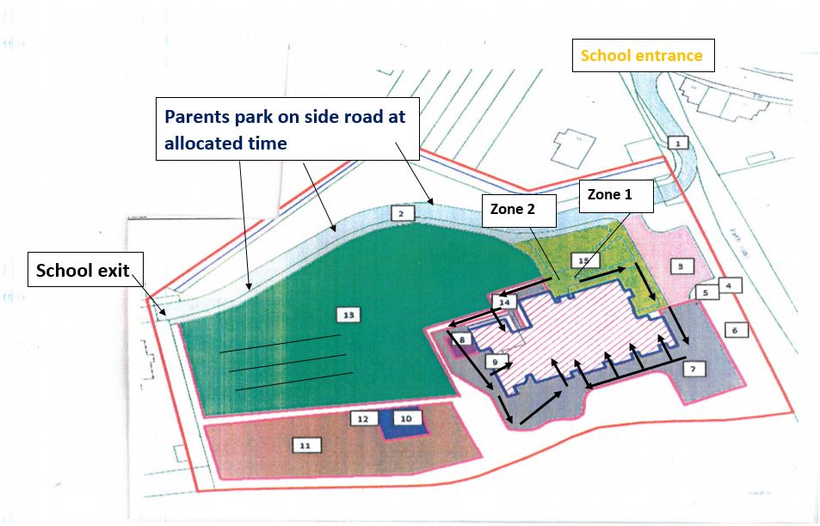

Class | Drop off | AM Location | Finish | PM Location
Acorn (21st Sept) | 09:00 – 09:10 | Zone 2 | 15:00 | Zone 2
Class 1 | 08:30 - 08:40 | Zone 2 | 15:05 | Zone 2
Class 2 | 08:40 – 08:50 | Zone 2 | 15:10 | Zone 2
Class 3 | 08:50 – 09:00 | Zone 2 | 15:15 | Zone 2
Class 4 | 08:30 - 08:40 | Zone 1 | 15:05 | Zone 1
Class 5 | 08:40 – 08:50 | Zone 1 | 15:10 | Zone 1
Class 6 | 08:50 – 09:00 | Zone 1 | 15:15 | Zone 1

Similarly, at the end of the day, children will walk back out using the drop off routes and SLT staff will ensure children walk safely to their parent/carer.

How will I communicate with my child’s teacher or other school staff?
Once again Mrs Sharp or Miss Duffy will be available each morning and at the end of each day. The ladies will be located in between the two drop off zones, under an event shelter. Should you have messages to give to teachers, the ladies will ensure these are received by the appropriate members of staff.
Communication with Class teachers will now be via the main school office email address,
office@allsaints.bwmat.org or by phone call. We are still avoiding paper communication and intend to only use ParentPay when asking for payment.

What if my children are in different bubbles? How will this work when arriving for drop off and collection times?
If your children are in different classes, and therefore they have different drop-off and pick-up times, please speak to Mrs Sharp who will help to organise a suitable arrangement with the Senior Management Team.
Wrap Around Care
Thank you to all those who responded to the Wrap Around Care Schoolzine request. We can see this provision is vital to many families and will therefore ensure we do our very best to run both Breakfast Club and Wrap Around as of Monday 7th September.
Breakfast Club will start at 07:45am and will cost £4.00 per session.
- Breakfast club will operate in the main hall
- Parents will drop off their children at the hall door
- Same hand washing and cleaning principles for main school will continue
- The hall will have 6 zones and the group room will also be used
- Each zone will hold a different year group which will act as a protective measure
- Each zone will have a tables and chairs set up
- Pupils will sit side by side and facing forwards, rather than face to face or side on
- Food and drink will be served, and children will be able to eat in their zones
- Adults will remove plates and cups
- Classes and individuals will have their own play/ creative equipment
- Walkways will provide space for children to use should they need to exit and use the toilet facilities
- Windows will be open for ventilation
- Children will be taken a group at a time to their classrooms as the appropriate timings.

Wrap Around Care after school club will start as soon as school finishes for each class and will close at 17:30pm. We now have to allow for robust cleaning measures to be put in place after Wrap Around finishes in order for all equipment, tables and chairs, floors and toilets to be cleaned ready for the morning.
- Wrap Around Care after school will follow the same protective measures as Breakfast Club. Wrap Around will be held in the school hall, however children will also be able to use the playground. Staff will take out no more than four groups who will play separately in their own class zone.
- A snack and drink will be provided
- Costings will be - £10.00 for one child. £18.00 for two siblings and £21.00 for three siblings.
- Children are to be picked up at the hall doors exiting on to the car park area.
Mrs Sharp will be adding a Breakfast Club and Wrap Around Care provision form to the SZapp ‘forms and documents’ tile. Please use this to book provision for September.
Uniform at All Saints
Uniform can play a valuable role in contributing to the ethos of a school and setting an appropriate tone. From September 2020 All Saints children will be expected to come to school dressed in the appropriate school uniform as shared on our website.
Uniforms do not need to be cleaned any more often than usual, nor do they need to be cleaned using methods which are different from normal.
What can children bring to school?
Do bring to school | Do NOT bring into school items that are unnecessary
A clearly labelled lunch box (if bringing your own lunch)  A snack for break time if KS2 | Do not bring in pencil cases or any other type of stationary – school will supply this
Do wear school uniform (named) | Do not bring any type of toy
Do bring a clearly labelled drinks bottle
Do bring a clearly labelled PE kit
Do bring a clearly labelled sun hat
Do bring a clearly labelled coat and wellington boots
Do bring all your belongings in a school bag
Do bring labelled sun cream as long as your child can apply it themselves

Recovery Curriculum
How will teachers plan for missed learning?
As mentioned in my previous letter, due to the nature of recent events, our children will have had a wide range of experiences in relation to their learning. Our ‘Recovery Curriculum’ will help provide a base line of learning by recapping and developing key skills and knowledge that all children will experience. The intention being to prepare all children for the next steps in their learning journey.
Over the course of the next week documents will be completed by teachers and then posted on our website, under the Covid-19 tab, to show areas of priority catch up learning. These will be working documents and will be added to over time.

Teachers have been asked to analyse the progressions of skills and knowledge for each subject and to identify objectives using the following key:

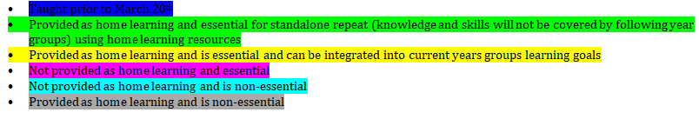
The outcome of this analyses will then be discussed during teacher to teacher transition meetings.

The Recovery Curriculum Plan Overview for the Autumn Term will also be shared under the Covid-19 tab. This document drafts out the next phases, including assessment tracking for our recovery programme.

The ‘Recovery Curriculum’ will run alongside the new curriculum for each class. Identified gaps will either be taught discreetly or amalgamated alongside the current year group National Curriculum objectives. We will also be re-visiting objectives from the previous summer term.

As of September, we will be able to accept home learning books back on site. Please can children bring these into school on their first day back. The children’s home learning will be used within lessons so that children can share work completed as objectives arise in planned lessons.
I hope this very long letter provides you with an overview of what September will look like. We are all looking forward to having all our children back at the heart of All Saints, we have missed those who have been unable to join us. It has been heart-warming to see children who have been home learning coming back into school for their shuffle up session, running up the hill to the marquee as if they have never been away. So many smiles from both children and parents.
I will write again at the end of the week with my final thoughts for the term and any further information.
As always, with prayers and the warmest of best wishes to you and your families.

Headteacher
Mrs Bowditch

